Benefice Profile

Upper Wylye Valley Team

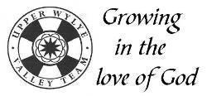

Team Rector

Contents

Further information and timeline | 1
Foreword - A statement from The Bishop of Ramsbury | 2
Welcome & Introduction | 3-4
Our Churches  Our Team and Who We Are  Our Strengths & Challenges  Our New Team Rector - Job & Person Specification  The Upper Wylye Valley Team Area  Life in Our Church Community  Life in our villages  Conclusion | 5  6-7  8-9  10-11  12  13-16  17  18
Further information and deadline
If you would like further information, would like to discuss any points relating to the position, or would like an informal chat, please do not hesitate to contact:
- Venerable Alan Jeans, Archdeacon of Sarum
(adsarum@salisbury.anglican.org and Mobile: 07891 651211)
- Reverend Clifford Stride on behalf of Upper Wylye Valley Team
(cgstride@btinternet.com and 01985 850941‬)
The closing date for applications is 9 January 2024.
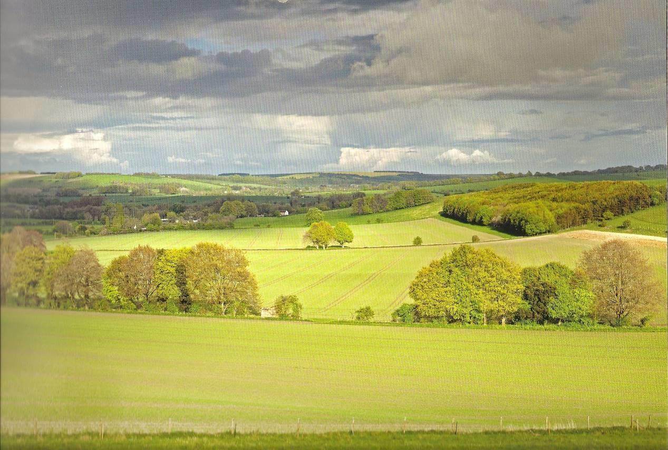
©Chris Lock

Welcome!

Thank you for your interest in the post of Rector for the Upper Wylye Valley Team, part of the See of Ramsbury in the Diocese of Salisbury. This is a super opportunity for imaginative rural ministry within one of the most attractive parts of Wiltshire.

The ancient see of Ramsbury, covering much of that county, is rich in spiritual heritage, from the cathedral city of Salisbury and the valleys of its five rivers, up to the Marlborough Downs. God is in this place – even though many know it not – and it offers an enriching context for ministry and mission today.

I am looking for devoted and visionary clergy, who can inspire and guide our communities in making Christ known. While this can appear a timeless landscape, our parishes are constantly changing and face all the challenges and opportunities of life in the 2020s. Because of this, the church must also change in order to grow, renewing its traditions for the contemporary situation. The Upper Wylye Valley Team is set within the Deanery of Heytesbury, where there will be ongoing support and conversation about how benefices might best be structured in order both to grow and offer our clergy sustainable and rewarding ministry.

These are, then, times of transition for the market town and village churches of Wiltshire, which I sometimes liken to the oak trees of the Savernake Forest near my home, which gradually join their root systems to survive individually. Churches must likewise learn how to be collaborate ‘beneath the soil’ in order to flourish above ground in their own particular setting.

In the Diocese of Salisbury, we place a high value on the encouragement and pastoral support of our parish clergy and, should God guide you to serve here, you will become part of a committed and collaborative team.

Please contact the Ramsbury office if you need any assistance with your enquiry and be assured of my prayers as you seek the Lord’s will for your future.

Sincerely in Christ,

WELCOME

Thank you for your interest in the Upper Wylye Valley benefice and we hope that you will read on.

We are prayerfully seeking a Rector who has a call to rural ministry and can lead our benefice into the next stage of our ministry and mission.
The mission statement within our logo is ‘Growing in the Love of God’. That is our endeavour, and we would welcome the help and support that an enthusiastic Team Rector would bring.

We are a group of eight parishes and ten churches, similar in many ways but each with their own characteristics whose vision is to be open, welcoming, growing and inclusive, living within the love of God and sharing God’s life and love with others.

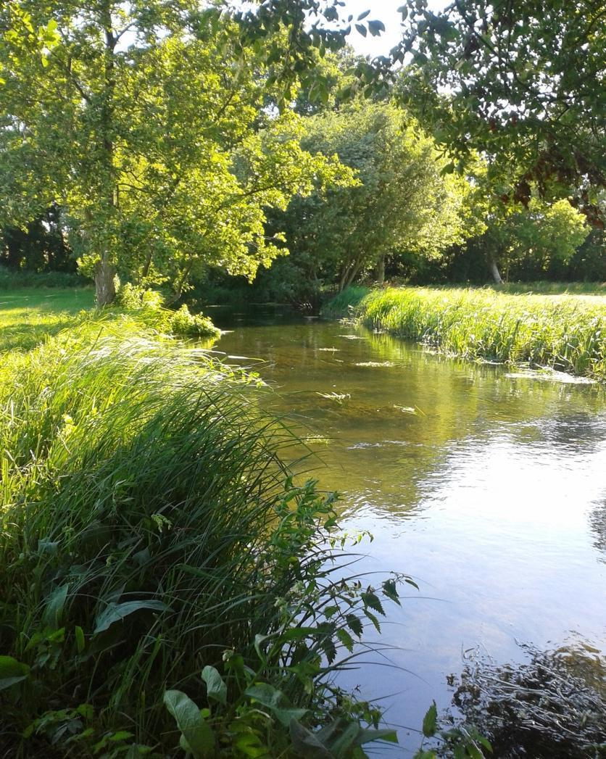

The prospect of being the Rector of ten churches might seem daunting and yet we believe this is an exciting opportunity for growth – growth in active worship and mission for the church community and for a new Rector moved by the Lord to deliver His will in this place. There has recently been much discussion across the congregations and the PCCs about how we can play our part in growth, through substantial support of the Rector and achieving mission ambitions - in all cases working as a team following our vision. Precise details need to be formulated under the leadership of the new Rector, but the principal points that have been identified are:-

- A willingness across the Benefice for change where needed
- Support achieving the Rector’s desired balance between ministry, mission and management through the provision of appropriate administrative support, including the setting up of a dedicated Parish Office.
- Recruiting and training more Lay Worship Leaders (LWLs) and Lay Pastoral Assistants (LPAs)
- Employing a wider variety of services where the laity will play a major part
- More effective use of IT, social media and other forms of communication
- Consideration of new models for PCCs and how the PCCs could work together.

Do not remember the former things or consider the things of old. I am about to do a new thing; now it springs forth, do you not perceive it? I will make a way in the wilderness and rivers in the desert.
Isaiah 43. 18-19

OUR CHURCHES
The team area is relatively compact. Its spine is the A36 in the Wylye Valley in Wiltshire, lying between Warminster to the north and Salisbury to the south. The map below shows our 10 churches that lie within our 8 parishes: St John in Sutton Veny; All Saints in Norton Bavant; St Peter and St Paul in Heytesbury; St James in Tytherington; St Margaret in Knook; St Augustine in Upton Lovell; The Blessed Virgin Mary in Boyton; St Peter in Codford; St Cosmos and St Damian in Sherrington and St Mary in Codford.

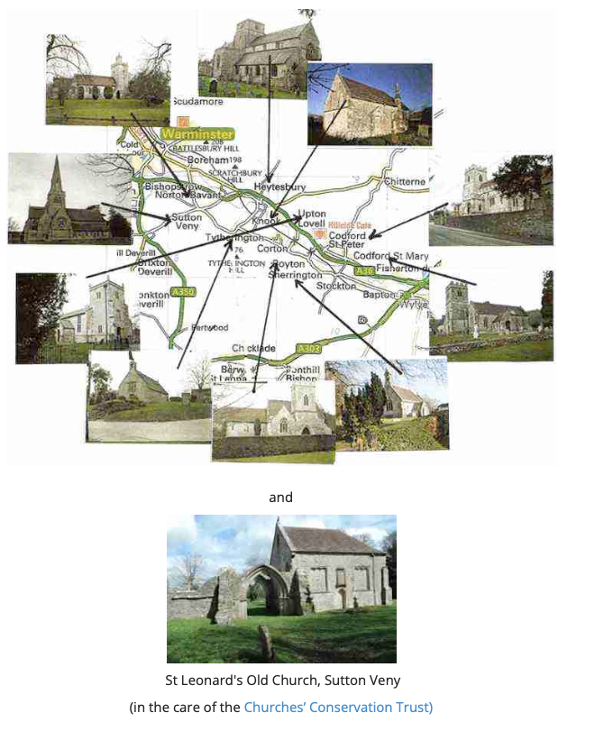

Pictures, a short history and a description of the character of all our churches and their associated villages, together with contact details for Churchwardens, can be found on the upperwylyevalleyteam.com website.

I was glad when they said to me, let us go to the house of the Lord.'
Psalm 122:1

OUR TEAM AND WHO WE ARE

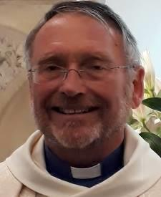
Our Church community, based on electoral roll information, is about 360 and has been led thus far during the vacancy by our Team Vicar, Revd Clifford Stride. He was appointed in 2016 and lives in the Vicarage in Codford, which he occupies on a house-for-duty basis. He will retire at the end of February 2024 and it is assumed that the recruitment of his successor would await the arrival in post of the new incumbent.
The Team Vicar is supported by our associate priest, Revd Jonathan Hiscox (who conducts services on two Sundays a month only, due to full-time work commitments) and our Licensed Lay Minister, Katherine Venning, who leads non-Eucharistic services, takes funerals and runs the Team Choir. There are six enthusiastic Lay Worship Leaders (LWLs) and four Lay Pastoral Assistants (LPAs). One LWL is currently undergoing training for Licenced Lay Ministry. The whole team is supported by a part-time Team Administrator.
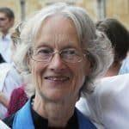
Jonathan Katherine

We cannot overlook the unsettling effect of another vacancy so soon after the last in 2018, compounded by the COVID 19 pandemic and by the tragic sudden death of one of our most active retired priests. We wish every success to Revd Trudy Hobson, who served as Team Rector between July 2019 and November 2022, before moving on to her new role as Army chaplain. As a Team, we are encouraged that we continue to provide an ambitious number of services of all styles from BCP to Fresh Expressions (e.g. Café Church), led by both clergy and laity. We have volunteers for ‘Open the Book’ in our three thriving church primary schools. We remain actively engaged in Heytesbury Deanery, including maintaining our 50-year link with the church in South Sudan; a linkage that was fostered by the recent visit of three Sudanese bishops, together with their wives, following the 2022 Lambeth conference.

Encouraged by engaging with the Salisbury Diocese /CPAS ’THRIVE’ initiative over the last two years, our clergy, LWLs and LPAs have been considering some fresh approaches to rural ministry as well as helping to keep mission in the forefront of our decision making and a standing item on our PCC agendas.

Living in such a beautiful rural area lends itself to embrace the well-attended seasonal festivals and to make use of outdoor services that attract the wider community .

The Covid pandemic provided its challenges but also opportunities. The importance of churches as places of prayer and tranquillity was recognised and the buildings were kept open to the maximum extent that the regulations allowed. Online Zoom services were quickly established and, endorsing the view that church needs to go to where people are rather than expecting them to come to church, numbers attending the weekly services often exceeded the aggregate of normal individual services. Mercifully the medical impact of Covid was very light and the pervading response was generally gratitude for our ability to weather the effects of lockdowns in a relatively safe, rural environment. Post Covid, the ability to work from home where possible has resulted in lasting changes and it is refreshing to see some new, young arrivals in our villages capitalising on this. In church terms, things have returned to near normal. Zoom services were continued for some time after restrictions were lifted but were discontinued once it became apparent that the majority wished to worship in person rather than online.

Consistent with the aim to care for everyone in our villages, church members were actively involved in each village’s response to community support during the Covid pandemic and, as often happens, there is frequently a crossover between a broad range of community and church-based activities. The weekly community café in Codford and the monthly equivalent in Sutton Veny, are run by both churchgoers and non-churchgoers. Similarly, the hope is that our Table Talk sessions in Lent and Advent, which took place in local pubs, might have pricked more than curiosity in the other regulars present at the bar.

We recognise that some of our parishes are struggling to find enough volunteers to serve on their PCCs and most have one churchwarden at present. All our churches have to date continued to pay their share in full and, in several cases with the support of a Friends of the Church group, to maintain the fabric of our ancient and historic buildings. The mix of parish-based and Team organised activities seems to work. Collaboration and the exchange of best practice between parishes is increasing and this helps to spread the load. The need to ensure that we help reduce the burden on the Team Rector is foremost in our minds and the number of PCCs should not be seen as a problem as we are used to laity officiating when the Rector is not available to attend.

Blessed is the one………………. whose delight is in the law of the Lord and who meditates on his law day and night. That person is like a tree planted by streams of water, which yields its fruit in season and whose leaf does not wither - whatever they do prospers.
Psalm 1: 1-3

OUR STRENGTHS
1. A supportive team of clergy, LWLs, LPAs and laity looking forward to working under the leadership of the Rector with full support from Heytesbury Deanery and Salisbury Diocese.
2. Friendly congregations looking forward to the leadership of their Rector but wanting to give him or her ample time and space to get to know us.
3. Mission to the young via the three church Primary Schools through Open the Book, collective worship and serving as foundation governors.
4. A willingness to form groups to address pan-benefice issues. This offers the potential for the Rector to retain flexibility over attendance at routine PCC meetings.
5. Devolved groups that meet as necessary, namely the Churchwardens, Treasurers, the Worship & Families group, LWLs and LPAs.
6. A Team Choir led by the Licensed Lay Minister and some excellent organists.
7. The support of a part-time Team Administrator.
8. Our generally sound finances with share payments up to date and, in several instances, supportive Friends groups resulting in well-maintained buildings and some exciting projects to improve church facilities for use by both church and community.
9. Our positivity, demonstrated during the vacancy and our resilience and adaptability shown during Covid.
10. A rural area of outstanding natural beauty, but within easy reach of cities including Salisbury and Bath with some good local schools at both primary and secondary level.
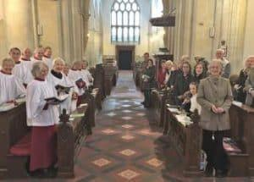

OUR CHALLENGES
1. The small pool of licensed clergy to support the Rector.
2. Our faithful congregations are getting older and a bit smaller.
3. Becoming better at praying together and becoming better disciples and followers of Jesus.
4. Sharing the good news with those who have no knowledge of the gospel by meeting them where they are, for example visiting their homes and the church being more visible outside of the buildings.
5. Turning the affection our parishioners hold for our church buildings into faith and worship, so that they are no longer on the fringes of the church community.
6. Providing regular collective worship at three church schools and maintaining Open the Book. Engaging with the young once they have moved up to secondary school and reaching out to a generation of parents who have not known faith.
7. Encouraging more LPAs to assist with pastoral care and to be the eyes and ears of the clergy.
8. Managing our limited time available and using our God-given gifts effectively.
9. Encouraging younger people to join our PCCs and, in time, to take on responsible roles.

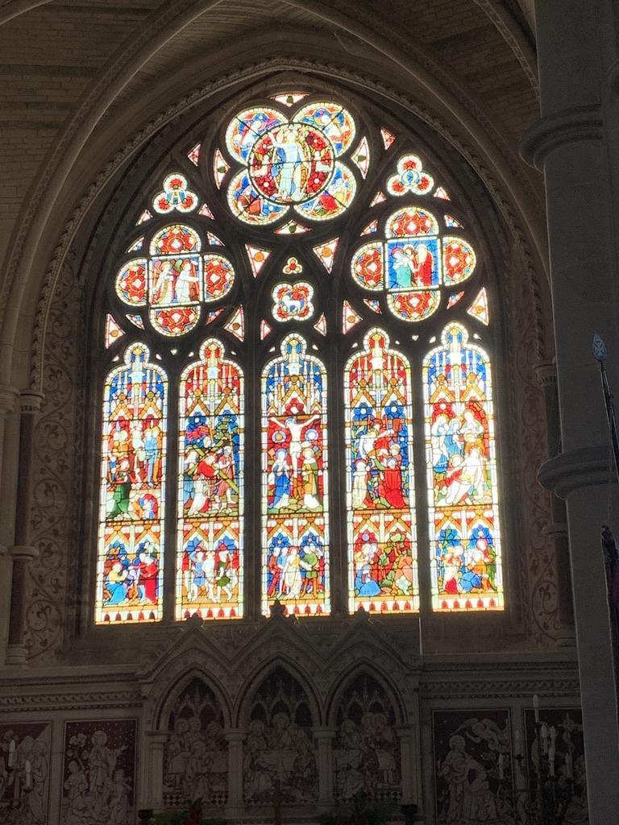

Now there are varieties of gifts, but the same Spirit; and there are varieties of services, but the same Lord; and there are varieties of activities, but it is the same God who activates all of them in everyone. To each is given the manifestation of the Spirit for the common good.
1 Corinthians 12.4-7

OUR NEW RECTOR

Job Description

In the light of our acknowledged strengths and challenges, we have identified five areas which we would like our new Rector to prioritise.

We are seeking someone who will;

- Help us to grow spiritually both as individuals and communities, to develop our knowledge and application of Scripture and to develop our Christian life. To lead us in our witness to the love of God in Christ and our proclamation of the Good News of the Gospel.

- Enable and encourage us to be the people of God in the Upper Wylye Valley and lead us to prayerfully work together to find a clear vision and plan for the future ministry, mission and growth.
Support and develop existing successful ministries and continue to foster a sense of unity between our parishes, encouraging us to work together across the Team on common successes and problems.

- Lead our ordained ministers, LLM and our teams of Lay Worship Leaders and Lay Pastoral Assistants and enable them to work effectively both in our Church worship and activities and within our wider communities.
Actively encourage all lay people to recognise and develop their own gifts and to use them in ministry and service to God and their neighbours.
Empower and support churchwardens to be effective within their own parishes as well as facilitating the sharing of best practice and coordinating common activities across parishes.

- Be willing to make a commitment to live alongside us in the Upper Wylye Valley, to get to know us and care for us. To be happy to participate in the wider social life of our villages and to help us all to be a visible presence of God’s love to all who live and work in the Upper Wylye Valley.

- To take an active role in sustaining and building on the existing good links between our three church primary schools and be happy to take regular collective worship.
To be prepared to take on an active role as a Governor of at least one school.
Be shepherds of God’s flock that is under your care, watching over them—not because you must, but because you are willing, as God wants you to be; not pursuing dishonest gain, but eager to serve; not lording it over those entrusted to you, but being examples to the flock.
1 Peter 5.2-3

Person Specification

We are hoping that the successful candidate will possess the following attributes:

- An energetic and enthusiastic leader of God’s Church in our villages, ideally with leadership experience in ministry.
- Will be a person who is confident in their Christian faith and whose ministry is grounded in prayer and worship.
- Have some understanding of the joys, challenges and demands of a multi-parish, rural benefice, be a confident facilitator and able to work with people of many backgrounds.
- Will be approachable with a warm, outgoing personality and be at ease in meeting and getting to know all members of our communities.
- Have clear communication skills and be an effective team builder - drawing on the gifts of all involved to meet the needs of the benefice.

We would like our Rector to

- enjoy leading worship and preaching the good news of Jesus Christ.
- challenge us all to deepen our faith and discipleship
- be comfortable with traditional liturgies but also keen to help us make worship attractive and accessible to those unfamiliar with formal services and music.
- help us draw in those on the fringes of our churches, especially all those who only attend services at Christmas, Easter and rural celebrations, including younger families
- be willing to carry out pastoral visiting in homes and to meet with people informally at their work or through social events.

In compiling this benefice profile, we have endeavoured to consult widely to elicit views on the qualities and skill sets that parishioners consider to be important in our next Rector. The Word Cloud below attempts to convey that there are some recurring themes.

THE UPPER WYLYE VALLEY TEAM AREA
The Team area is just 6 miles long and 1½ miles wide, running down the Wylye valley with Salisbury Plain to the north and the chalk downs and forestry of Great Ridge to the south. The villages vary in size from Codford (with almost 1000 residents) to Sherrington (about 60). Most of the benefice lies within the Cranborne Chase Area of Outstanding Natural Beauty (AONB).

According to the 2021 census, the total population in the Team area is about 2,800 adults and 475 aged 18 and under. There are three good Church primary schools (in Codford, Heytesbury and Sutton Veny) with a total of approximately 370 pupils. Most move on to the large and successful secondary, Kingdown School, in Warminster, or alternatively they can gain places in an excellent choice of schools in Salisbury.
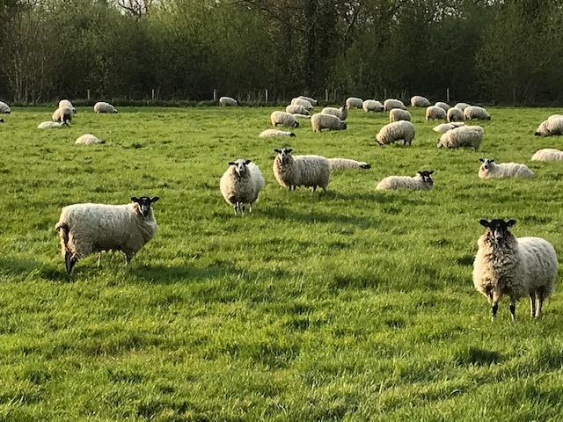
Farming is an important activity. The farms are mostly large. However, employment in farming is relatively small and there is some housing tied to the industry. There are a growing number of small businesses operating from industrial units, mainly around Codford and Sutton Veny. These employ a significant number.

Some of our residents are employed by the Army around Salisbury Plain, others commute or work from home. Accommodation is mixed, ranging from social housing to large properties. House prices are high and even with a significant quantity of social and private rented housing, there is still a shortage of housing for the young, who may have to move into Warminster or other local towns to find somewhere to live. More low-cost housing is needed in these villages and there are pockets of real rural poverty requiring social support. There is a fair proportion of retired people.

Codford and Heytesbury have local shopping facilities, including Post Offices. The other villages either make use of these or travel the relatively short distance to Warminster, the nearby, medium-sized town.

Further general information, extracted from a range of data sets, about Wiltshire and the Warminster Community area (including the Joint Strategic Needs Assessment) can be found via the link below:
https://www.wiltshireintelligence.org.uk/cajsna/warminster/

LIFE IN OUR CHURCH COMMUNITY
SERVICES
The current timetable of services is available on the website. It encompasses a wide variety of styles of worship, from the Book of Common Prayer through Common Worship to Fresh Expressions and we hope our new Team Rector will be happy to continue with this variety as well as encouraging us to experiment with other forms of worship that would strengthen the benefice. Regular services have generally small but committed congregations. At Christmas, Easter, Harvest and special occasions such as Jubilees our churches are well attended. Remembrance Sunday is an important day in our calendar, especially as our nearness to Salisbury Plain military training area means we have a high number of serving and retired military personnel. We have strong historical links with the Australian and New Zealand armed forces and mark ANZAC Day in our churches and schools. There are beautifully maintained ANZAC cemeteries in Sutton Veny and Codford which are the settings for a dawn service on ANZAC Day in Codford and Sutton Veny school’s annual ANZAC service.
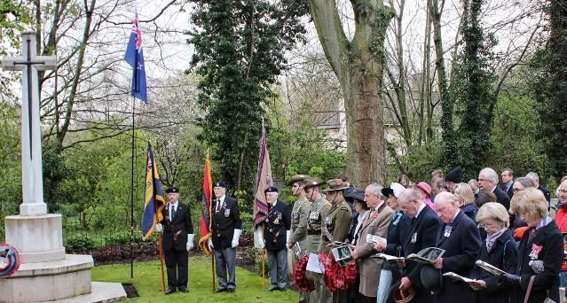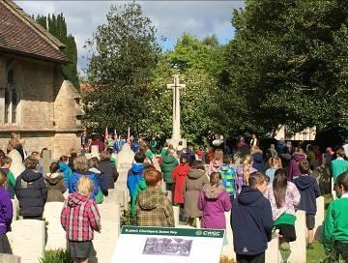
ANZAC Commemorations
As rural parishes, we enjoy making the most of Plough Sunday and Rogation Sunday. Together with Messy and Muddy church experimentation, these are usually family focussed services, outside or in a barn, with plenty of visual aids in the form of tractors, animals and grain stores. They give us important contact with a wider group of parishioners than the more traditional services and link well with our periodic Café Church when people meet for breakfast and an informal service in Sutton Veny village hall. In all the above our LLM, the team of six LWLs and the four LPAs provide enthusiastic support to the Team clergy and to individual parishes and there is an exciting opportunity to develop these roles further.

We recognise that for many people their only experience of church is for Occasional Offices and we are alert to the need to make sure that their experience at these events encourages them to return. The statistics for mission figures for 2022 are shown below.

Baptisms 16
Weddings 3
Wedding Blessings 0
Funeral service in Church 21
Memorial service in Church 8
Funeral Service in Crematorium 14
Committal of body in Church 11
Committal of ashes in Church 12
Total Services 85

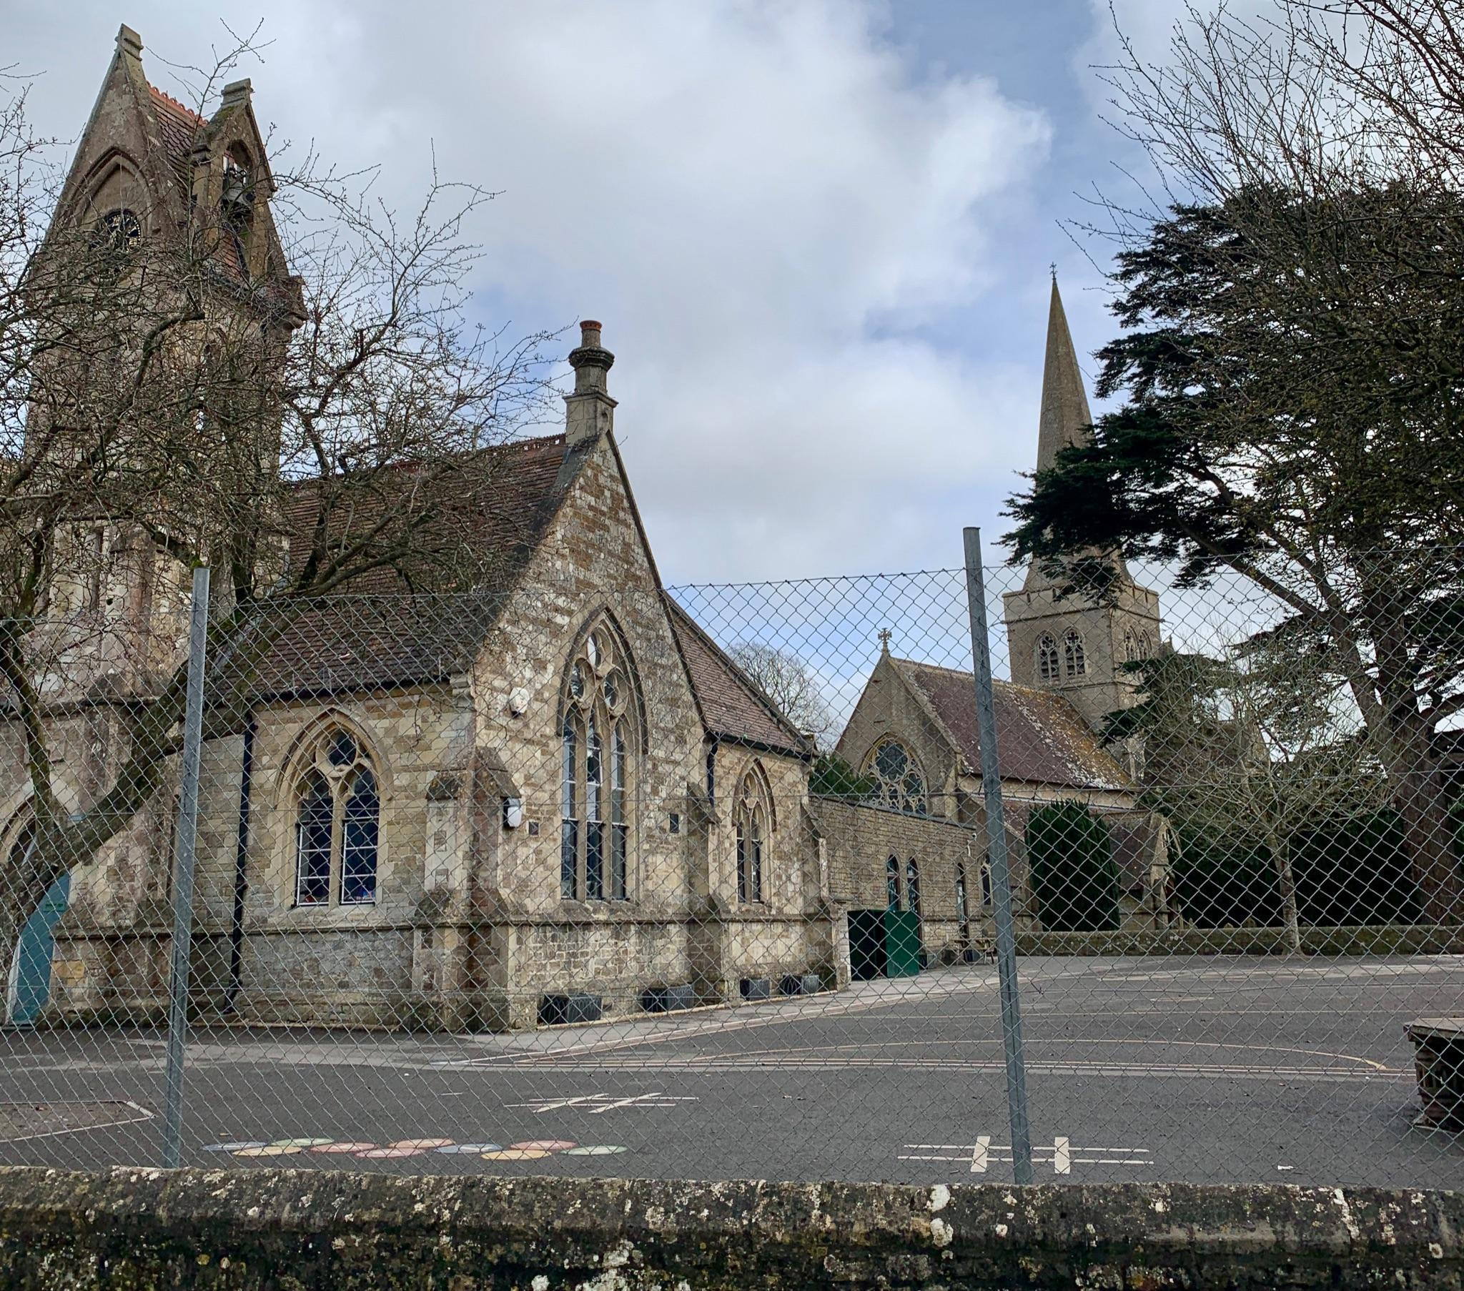
SCHOOLS
There are three church primary schools in the benefice, Sutton Veny (VC), Wylye Valley (VA) and Heytesbury (Acorn Trust). The link between parish and school is important to both sides. The schools welcome regular visits from the clergy for collective worship and from the dedicated Open the Book teams in each school. We hope our new Rector will foster these links and take an active part in school life. We are pleased to welcome the children into their village churches for routine services as well as occasional events such as Experience Easter and Experience Harvest.

MIDWEEK ACTIVITIES
Throughout the year we have regular midweek activities including a Julian prayer group, Bible Study groups and more informal house groups. The programme varies with the season so that we can include Advent discussions, Lent lunches, Holy Week and Maundy Thursday services and can make use of the light evenings and better weather of the summer for Pimms and Hymns, concerts and evening gatherings. Community cafés meet weekly in Codford and monthly in Sutton Veny and a knit and natter group meet in Ginny’s Cafe in Boyton. During the autumn and winter months, there is a monthly Men’s Fellowship Breakfast meeting in a local pub with visiting speakers and the Friends of the Churches hold occasional fundraising evenings with speakers on a wide variety of topics.
The choir meets weekly under the capable leadership of Katherine Venning and, while the distribution of experienced bell ringers is patchy across the parishes, encouragement can be drawn from the recent recruitment of eight enthusiastic learners who practise twice a week. Church members are often prominent within their village activities, giving the church good links within the community.
ADMINISTRATION
We are one team but currently our ten churches are overseen by eight PCCs. This arrangement is under review and active consideration is being given to the benefits of a multi-church PCC (or PCCs) supported by individual, but less formal, Local Church Councils (LCCs).
Each church has its own character and traditions, which we respect and value within the unity of a team structure. The ministry team, consisting of the licensed clergy and the Licensed Lay Minister meet to plan worship and compile the monthly rota of services. Licensed Lay Worship Leaders meet to plan services and the LPAs meet as required to share best practice. The PCC treasurers also have their own team meetings. The need for appropriately strong administrative support for the Team Rector is clearly recognised and the team treasurers have agreed to provide funding for what is required. The details of the administrator’s role and working arrangements can be reviewed by the new Team Rector.
COMMUNICATIONS – WEBSITE, SOCIAL MEDIA & NEWSLETTERS
The importance of good communications is fully appreciated. The UWVT website is maintained in-house by a volunteer. Parish News is a monthly publication distributed free to every house in the benefice and is available on the Upper Wylye Valley Team website. The monthly Sutton Veny Village Newsletter is also delivered free to every house in the village and the Ashton Gifford Community News serves the Codford area on a subscription basis. Social media (Facebook, Twitter etc) are channels that offer potential but are not currently exploited.
BUILDINGS AND SURROUNDINGS.
Eco Church – Since 2016 four of our churches have registered with Eco Church, the A Rocha UK charity’s award scheme for churches in England and Wales that want to demonstrate that the gospel is good news for God’s earth. Three have attained the Bronze standard and Codford St Mary has Silver.
Projects - Keeping our beautiful ancient churches comfortable, useful and welcoming without ruining the planet is a challenge, but Norton Bavant have recently completed a project to update their fabric and facilities and provide toilet and catering space. Having completed major repair and restoration work to its roofs and chancel, Heytesbury Open Place project seeks to introduce community-friendly facilities in the form of a meeting room, toilet, and servery. Sutton Veny and Codford St Peter’s churches are also engaged in similar facility enhancement projects; currently at the design stage with implementation dependent upon successful fundraising.

BEYOND THE BENEFICE BOUNDARIES.
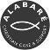
Church members are involved in wider ventures such as prison ministry, Warminster Food Bank, Cornerstone Advice Centre or Alabaré, a local Christian charity supporting the homeless. Through the Salisbury Diocese link with the Sudans we link with Maridi Diocese in South Sudan. As well as financial support we have been pleased to host the South Sudanese Bishops here on occasions and in the past a member of the ministry team spent a month visiting Maridi and the Chaima Christian Institute with which we have special links. Enthusiastic local historians ensure that we have a steady stream of visitors from Australia and New Zealand to the ANZAC cemeteries, they bring a fresh perspective on our shared history and are welcome visitors to our churches.

THE HOSPITAL OF ST JOHN in Heytesbury High Street was founded as an almshouse in 1472. It is now home to 50 residents living independently in 30 units and is run by a board of trustees. It has a part time chaplain who is not part of the Upper Wylye Valley ministry team.

Is anyone among you in trouble? Let them pray. Is anyone happy? Let them sing songs of praise. Is anyone among you sick? Let them call the elders of the church to pray over them and anoint them with oil in the name of the Lord.
James 5. 13-14

LIFE IN OUR VILLAGES

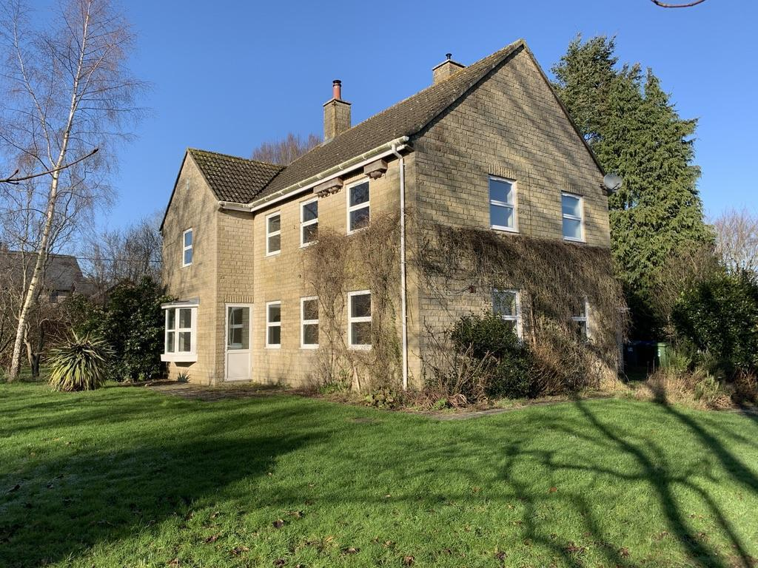
Currently let out on a commercial lease during the vacancy, the Rectory is a four-bedroomed modern house on a quiet back lane in Sutton Veny. As well as two reception rooms and kitchen, there is a separate study. To walk along the road to the very popular C of E primary school and St John’s takes all of a minute. The Rectory’s good size garden also has a rear gate leading to the playing fields (perfect for dogs), the village hall, the school and the church. The village hall is active in putting on events like barn dances and quizzes and is used as the venue for two of the Friends of Churches groups to run events such as talks and suppers.
The nearest shop is in the next village of Heytesbury. Otherwise, Warminster has Waitrose, Morrisons, Iceland and Lidl supermarkets and plenty of other smaller shops of every kind and a regular country market.
The Vicarage in Codford, behind St Peter’s Church, is the base for the Team Vicar. Codford has two churches and its amenities include the GP Surgery for our area (with excellent doctors and nurses), a veterinary practice, a theatre with regular amateur productions and films, a large village hall with social club, a playing field with tennis courts, a pre-school, the primary school, as well as the Budgens shop, post office and garage/filling station. The pub is currently operating as a tea shop, but the village hall has a bar.
The other villages in the Team have many other facilities including the primary school, a popular pre-school and a pub in Heytesbury, a pub each in Corton and Upton Lovell, the Ginger Piggery (Ginny’s Cafe and craft shops) in Boyton and the smaller village halls in Corton, Upton Lovell and Norton Bavant.
As stated above, there is an excellent GP surgery with a pharmacy in Codford and other surgeries in Warminster. The main hospitals are in Bath, Salisbury and Southampton with smaller hospitals in Warminster and Frome. There is a nursing home in Sutton Veny and several other care and residential homes nearby.

There are secondary schools in Warminster and Westbury, and a wide choice in Salisbury. There are also independent schools nearby.
Throughout the Team area there are numerous village events and several special interest clubs and societies. Many villages have their own websites, newsletters and fact sheets and some have active WhatsApp Groups. The Wylye Valley sits within a vibrant artistic community which hosts a number of literary and musical festivals including the popular biennial Wylye Valley Art Trail which highlights the extraordinary amount of talent locally.
There is a two-hourly bus service along the A36 to Salisbury and, in the other direction, to Warminster and Bath. Less frequent buses run on the ‘back road’ connecting with Warminster and Salisbury. The train service from Warminster, north to Westbury, Trowbridge and Bath, and south to Salisbury and Southampton is hourly, and there are regular trains to London and further afield from Salisbury (to Waterloo) and from Westbury and Bath (to Paddington). There is also a good and fast coach service to London that stops in Codford and Warminster.
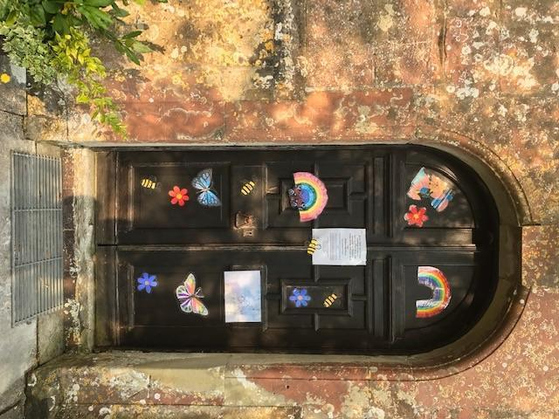
Upton Lovell church door during Covid
CONCLUSION

We conclude by encouraging you to come and visit us, informally at first and then through an interview. Ultimately, we place this great matter in God’s hands:

TEAM PRAYER OF THE UWVT 2023 AT A TIME OF VACANCY
Heavenly Father, we thank you for the ministry of Trudy Hobson, our previous Rector and we pray for your presence and blessing upon her. We ask now that you will help us to share responsibility, grow in faith, love one another, care for those in need, reach out to others and welcome newcomers. Lord Jesus, guard and grow this church as we serve you together in this period without a rector. Please guide those who are seeking the right minister for us and those who are seeking the right church for their ministry, so that together we may discover your way for the future and see your kingdom grow. Amen.

THE DIOCESAN VISION

We aspire to live up to the five priorities of the new diocesan vision of Making Jesus known.

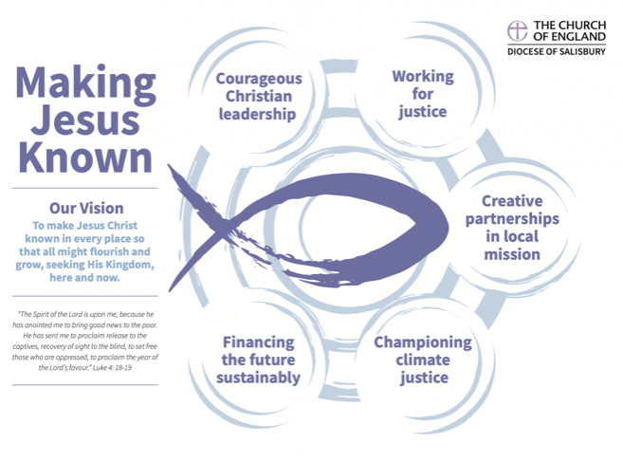

Jesus said, 'Go therefore and make disciples of all nations, baptising them in the name of the Father, and of the Son and of the Holy Spirit, and teaching them to obey everything that I have commanded you. And remember, I am with you always, to the end of the age.'
Matthew 28: 19-20.

