+

The post of
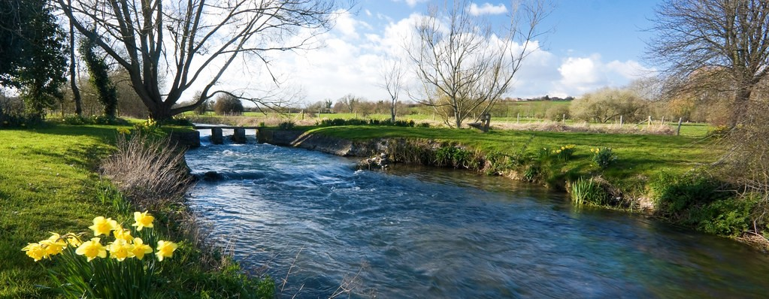
Team Vicar for the Chalke Valley Benefice 2023

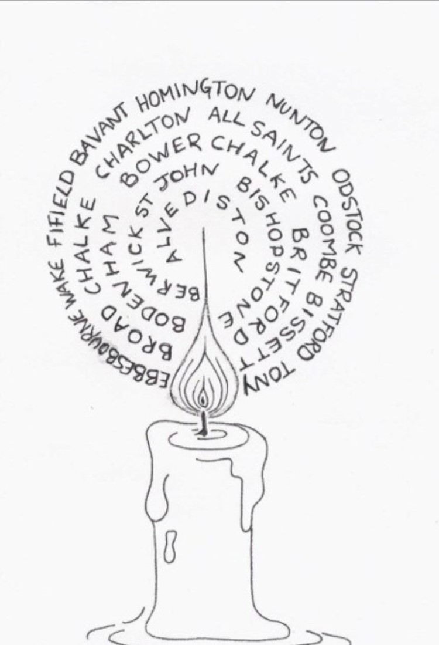
Welcome
Thank you for your interest in our post of Team Vicar in the Benefice of Chalke Valley.

We are a group of churches seeking to grow in Christ, rooted together with our communities. We are extremely fortunate to live and worship in a rural area just a stone’s throw from the city of Salisbury.

Chalke Valley Benefice
Team Vicar Post

Is God calling you to this role?
We are seeking a Team Vicar to join us here in the beautiful Chalke Valley. You will be a member of our Benefice clergy team undertaking routine ministry throughout the Benefice but with specific responsibility for the churches in the western end. Our committed and well-motivated lay people will be eager to support you in this.

This vacancy has arisen because the previous holder of this post, Revd Dr Ruth Howlett-Shipley, has been appointed as our Team Rector.

You will:
- Appreciate and have enthusiasm for Rural Ministry.
- Be a team player with the ability to work collaboratively with both clergy and lay leaders.
- Be a community priest engaging actively with life in our villages.
- Provide pastoral support for a group of parishes within the Benefice.
- Be a visible presence and provide ministry in the local church primary schools.
- Place value on the importance of occasional offices.
- Lead worship across the Benefice.
- Be enthusiastic but sensitive when introducing new ways to show God’s love with our community.

Desirable Attributes:
- PASTORAL – approachable and accessible to everyone in your care.
- BOLD - not afraid to challenge us to step out in faith and step into our giftings.
- INNOVATIVE - willing to explore fresh expressions of church, with both discipleship and mission in mind.
- BIBLICALLY KNOWLEDGEABLE - able to demystify the Bible - we want to learn from you.
- A MENTOR – able to lead us but encourage us to be leaders too.
- A TEAM PLAYER- comfortable working alongside other clergy, supporting others and accepting support where necessary.
- CHILD FRIENDLY– creative and engaging with children.

Contents
Our Vision
Our Benefice
Our Church Life
Our Valley Life
Your Home Life
Further Information & Appendices

Our Vision

Our shared vision in the Diocese of Salisbury is ‘To make Jesus Christ known in every place so that all might flourish and grow, seeking his Kingdom, here and now.’

As a family of churches in the Chalke Valley Benefice, we seek to grow in Christ, rooted together with our communities. We aspire to be salt and light in our villages by serving all our neighbours and listening to their voices.

We aim to share the Gospel by our example, wholeheartedly engaging with our neighbours and deepening our own faith by offering belonging, support and comfort.

We want to use and build on the skills and interests of our congregations and clergy, to bring God's life-enhancing love to those who live around us.

"Neither do people light a lamp and put it under a bowl.
Instead they put it on its stand, and it gives light to everyone in the house."

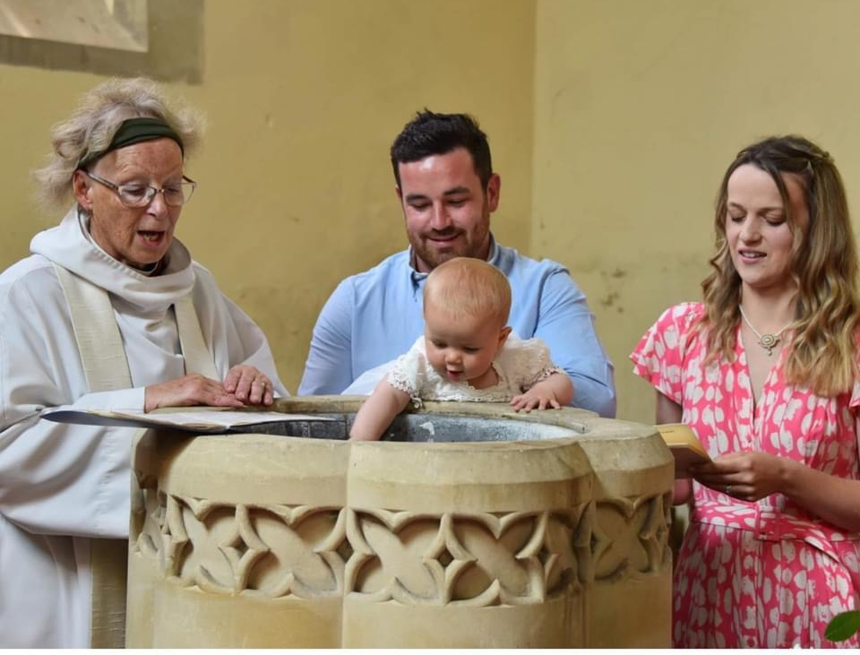

Our Benefice
Overview
Our Benefice comprises 14 rural churches in 9 parishes set along 17 miles of the River Ebble before it joins the River Avon (see appendix 3 &4). As our clergy lead services in all our churches and will, on occasions, be involved in activities throughout the Benefice, the use of a car is essential. We are part of the Chalke Deanery within the Diocese of Salisbury. Our Benefice team is:

Team Rector – The Revd Dr Ruth Howlett-Shipley
Team Vicar – YOU?
Team Vicar (NSM) – The Revd Canon Jenny Taylor
Employed Administrator – Emily Broomhead
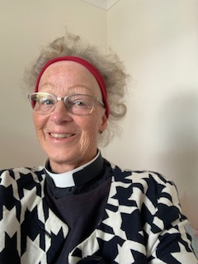
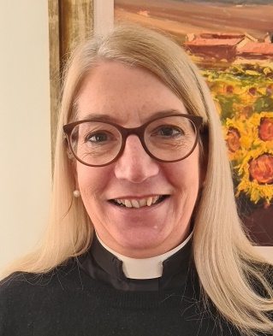
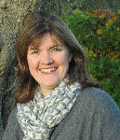

The clergy team meet weekly to provide a collaborative and supportive ministry for all of the Benefice. We are also supported by the ministry of retired clergy, Lay Worship Leaders and Lay Pastoral Assistants in leading Sunday worship and providing pastoral care in our communities.

Governance
Our Team Council is a legally constituted body made up of the clergy and representatives from each parish. It is the main decision-making body in the Benefice and helps to reduce the burden on individual PCCs by overseeing the spiritual activity in the valley and assisting in the legal requirements for our parishes such as safeguarding and health and safety issues. Each parish has its own PCC to oversee the work of the local churches. We are exploring ways of reducing the PCC workload to suit local situations.

Buildings and Finances
Our historic churches are valued by our communities and are supported both financially and by volunteer engagement in their upkeep. All our parishes have paid their latest Parish Share and the church buildings are generally in good repair, some having recently had major refurbishments.

Deanery and Chapter
As Team Vicar you will belong to the Chapter of the Chalke Deanery. Currently there are 8 stipendiary and 2 non-stipendiary clergy members along with a small number of retired clergy, Licensed Lay Ministers and the Deanery Lay Chair. The Chapter has a monthly meeting and Communion Service. The clergy value this regular coming together for theological discussion and mutual encouragement, given the geographical spread of the Deanery.

Our Church Life

We have been united as a Benefice for more than 20 years and have found great joy in being small congregations but also part of a much larger family. Our approach to worship is fairly traditional but having unity, without uniformity, we are able to approach our worship in a variety of different ways (see appendix).

Beyond our regular Sunday worship and pastoral involvement, ‘church’ for many families happens in our three church primary schools where an active and regular chaplaincy is provided by clergy and lay volunteers involving children, parents and staff. Open the Book currently visits regularly in one of our schools.

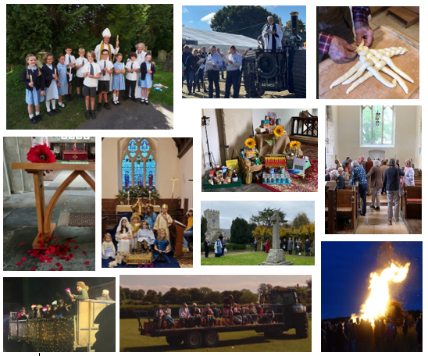

Fellowship

We have a number of groups that meet regularly in fellowship and discipleship.
Lent Projects
Each Lent our Benefice raises funds for a chosen charity, alternating between UK and overseas charities. With a common cause to work towards, we have raised as much as £20,000 to achieve our objectives.

Bible studies/Home groups
A safe place to ask questions and go deeper. There is no set programme. Group leaders choose what to study. Over Lent we share a common study course.

Lee Abbey
A biennial opportunity for those who wish to join together for a residential break away at Lee Abbey in Devon. A time for fellowship, worship and teaching, when our church family can really get to know God and each other better.

Informal Worship
Lay led fresh expressions of church are hosted occasionally in different churches within the Benefice, with the aim of offering a more relaxed style of worship and teaching.

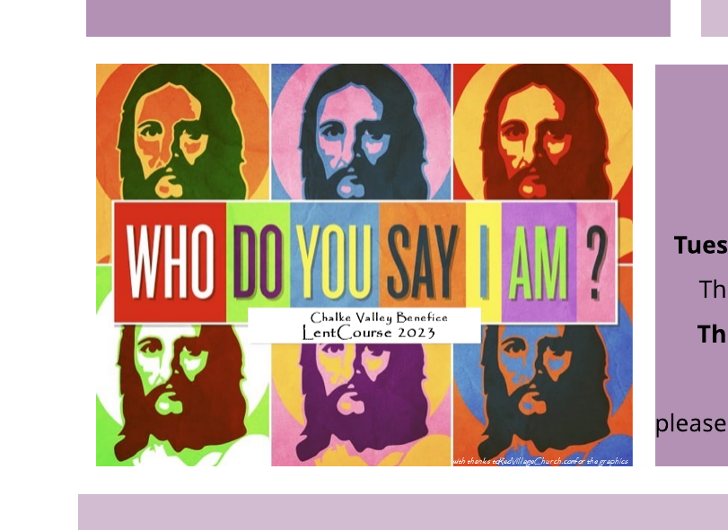

Wellspring
A group of around 35 Christians that meets weekly during term time for worship and Biblical teaching. It is lay led, but visiting clergy are warmly welcomed. This group has been the instigator of many activities including the men’s breakfasts, Lee Abbey weekends, suppers and a highly successful charity, CRESS.

Visionary groups
A group of Christians from across the Benefice attended the CPAS run Thrive course and have continued to meet to encourage the development of lay leaders and community outreach within the Valley.

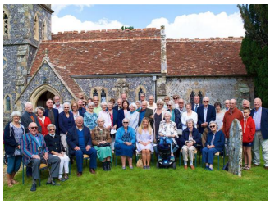

Outreach
Rural ministry offers us effective and fun ways to share the love of God through the many events in our villages and churches. It is through these events that we can really be salt and light to our friends and neighbours.
Easter
We hold a number of outdoor services including: a Dawn service, an Easter egg hunt, a retelling of the Easter story in poetry and re-enactment and an Easter trail set out across a local farm.

Harvest
With a number of farms in the Benefice, our harvest celebrations are an important festival. They are a great opportunity to share our gratitude for God’s generosity with our community.

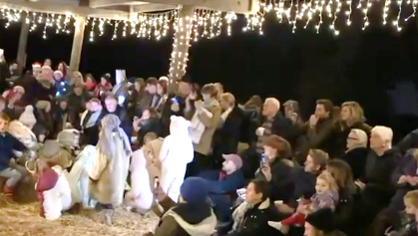
Christmas
Some of our parishes hold outdoor carol services and door-to-door carol singing remains a popular tradition in our villages. More than 100 people gathered together last year and joined in our most recent Cowshed Nativity held on a local farm.

Sharing the Good News
In addition to our Benefice Website, we have a lively weekly e-Bulletin Church News which reaches the whole community. A number of our villages have their own website and magazine where our church news can be carried.

The Salisbury-Sudans Partnership
Our Diocese has been linked with the Anglican Church in Sudan and South Sudan for 50 years. This link features prominently in our benefice mission and outreach.

Christian Relief and Education in South Sudan (CRESS) is our ‘home grown’ charity. It has supported over 80 children through education, provided assistance in setting up a medical clinic, funded many to attend agriculture and small business training and enabled the clergy to attend national conferences.

The Chalke-Cueibet Partnership is the charity through which our deanery plays its part in the diocesan link. Annual visits to Cueibet by our clergy and laity to run clergy training, building a primary school and providing bicycles have been ways in which we have supported local development.

.

Community events
Several of our churches have been adapted for wider community use, including: concerts, plays, music practice, barn dances and even a ‘pop-up pub’.
Regular coffee mornings, a monthly ‘Golden Lunch’ and Teas provide support and friendship for the senior members of our communities.

Valley Life
The collective population of the Valley is about 4,000 people, with villages ranging in size from just 20 to around 600. Whilst employment was originally in farming and agriculture, our population is now quite diverse. Many professionals, commuters, young families and retirees now choose to make their ‘forever’ homes in our villages, whilst our long-standing residents and small community of travellers ensure that we retain our links with the past. Families can often trace their connections with the area for many generations, providing an historical stability that is most welcome.

Whilst outwardly affluent, beneath the surface there are those who struggle to make ends meet – a situation that has become worse with the rising cost of living. Fortunately, there is a very strong sense of shared community ensuring a good support network for those in need.

Facilities
Happily we don’t have to travel far to meet our health and recreational needs. There’s much to get involved with right on our doorstep.
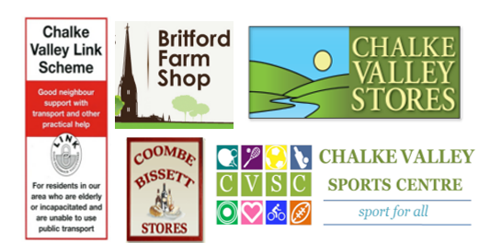
Medical care
There are GP surgeries in Broad Chalke, Salisbury, Wilton and Downton.
Both NHS and private hospitals are within the Benefice.

Chalke Valley Link Scheme
This is a community run scheme to transport those unable to use public transport to essential appointments.

Shops
There are three shops: a farm shop in Britford, a community run shop in Coombe Bissett, and a community run shop and ‘hub’ in Broad Chalke

Food and Drink
There are seven pubs within the Benefice, all are welcoming and serve excellent food, although we all have our favourite one.

Entertainment
Village hall film nights, concerts, singing groups, book clubs etc abound throughout the Valley, as do the seasonal pantomimes.

Sports
Chalke Valley Sports Centre is home to several sports clubs, including football and tennis. Yoga and Pilates classes are held at several of the village halls and, of course, there are the village cricket clubs.

There’s a lot going on

Alongside the necessities of life, our Valley offers much for family and community living. From the nationally recognised Chalke Valley History Festival to our intervillage football match, there is plenty to enjoy and share with friends.
Ebblefest
An annual festival of music, food and fun that raises money for our churches and local charities and brings people together.

The Chalke Valley History Festival
Evolved from a local literary festival, this is now a nationally recognized annual event now held in Broad Chalke.

Open Farm Sunday
Nunton Farm Dairy welcomes over 2000 people in to watch the dairy farm in action. Including milking demonstrations, tractor rides, ice cream vans and all sorts!

Berwick St John Country Fayre
Held every 2 years, this wonderful gathering of steam engines, vintage agricultural machinery and rural crafts draws huge crowds and raises funds for our local Hospital’s charity, The Stars Appeal.

Village Pantomimes
All-age community events are always a sell-out. One cast had an age range from 8 to 73.

Other events
Bonfire night in Charlton-All-Saints, regular car boot sales, New Year’s Eve inter-village football match, village fetes, flower festivals, cream teas...and so much more

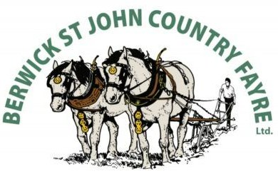

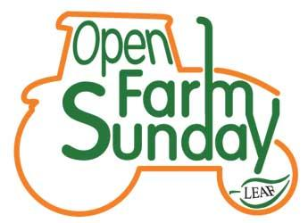

Home life
The Rectory
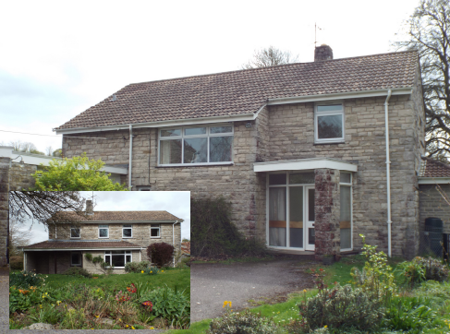
We recognise that where you live will be important to you. As Team Vicar you will live at The Rectory is situated centrally in the Benefice in the large and highly acclaimed village of Broad Chalke. Within easy walking distance are all the village amenities, including the Church, the Hub Community Shop and Post Office and the Queen’s Head Pub. The four-bedroomed house is modern, comfortable, easily managed and is suitable for a family or an individual. It stands in a medium-sized, easily maintained garden with arable fields behind and facing towards the village.

Schools
There are three primary schools in our Benefice (Longford C of E primary, Coombe Bissett C of E primary, Broad Chalke C of E primary) and a good selection of other schools nearby. In Salisbury we also have a variety of private schools, 2 grammar schools and several highly regarded secondary schools just a short bus ride away.

Transport links
There are Bus services into Salisbury and to the local secondary schools. There are good A road links and rail services to the cities of Southampton, London, Bath and Bristol. Our nearest airport is in Southampton.

The City of Salisbury
The beautiful city of Salisbury is just a few miles away. Known for its stunning cathedral, Salisbury is also home to Sarum College, where there are a number of theological courses to enroll on for personal study and continued professional development. The Royal School of Church Music is also located in Salisbury, so there are ample opportunities to be involved in Diocesan activities. The city has everything you need: a range of high street shops, boutique coffee shops, a leisure centre, restaurants, parks and a brilliant theatre. For those with a desire for a greater variety of shops, West Quay Shopping Centre and Ikea are just 40 minutes down the road in Southampton.
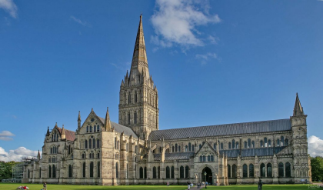
Further Information

We hope you’ve enjoyed reading about our Benefice and the exciting opportunities we have for you here. As you can see, this role gives you a unique chance to work with and be supported by an established team, whilst growing and developing your own areas of ministry. Alongside your diverse work as Team Vicar, we invite you to share with us the pleasure of living in a fun and friendly community.
Our hope is that you too may become rooted in this place.

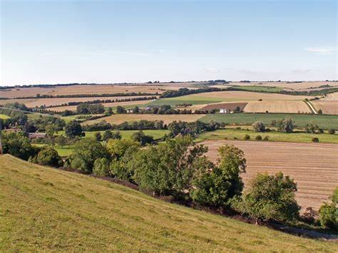
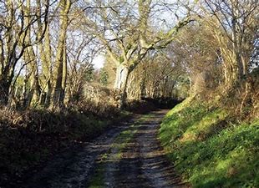
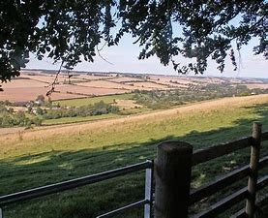

If you would like further information, or to discuss the post in more detail, please contact:

Lynne Archer - PA to the Venerable Alan Jeans, Archdeacon of Sarum
lynne.archer@salisbury.anglican.org
07917 912185
or
The Revd Dr Ruth-Howlett-Shipley
01722 697022

Appendices:

Appendix 1 – Rectory Footprint
Appendix 2 – Sample Monthly Service Rota
Appendix 3 – Our Churches and Villages
Appendix 4 – Benefice Map

Appendix 1 – Rectory Footprint

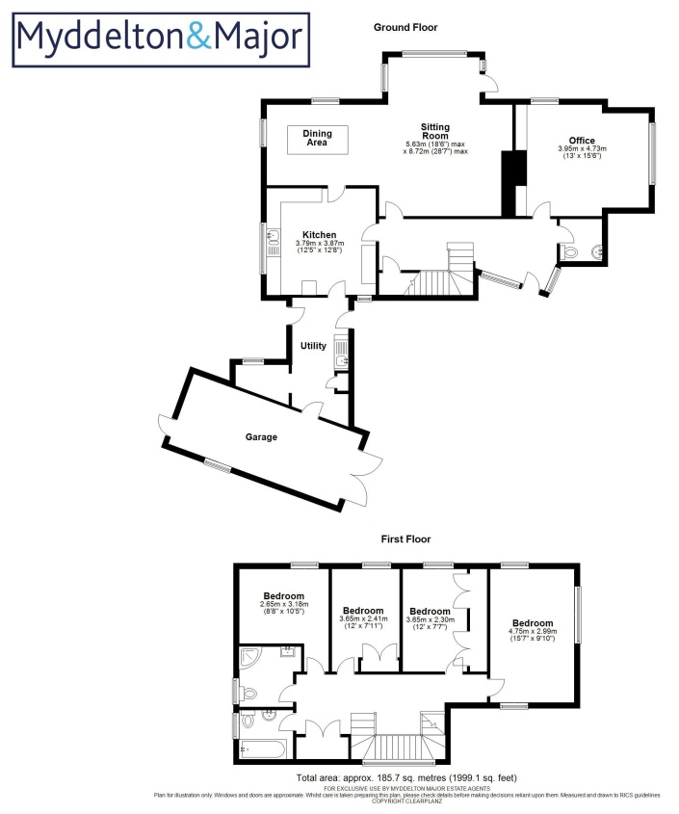

Appendix 2 - Sample Monthly Service Rota

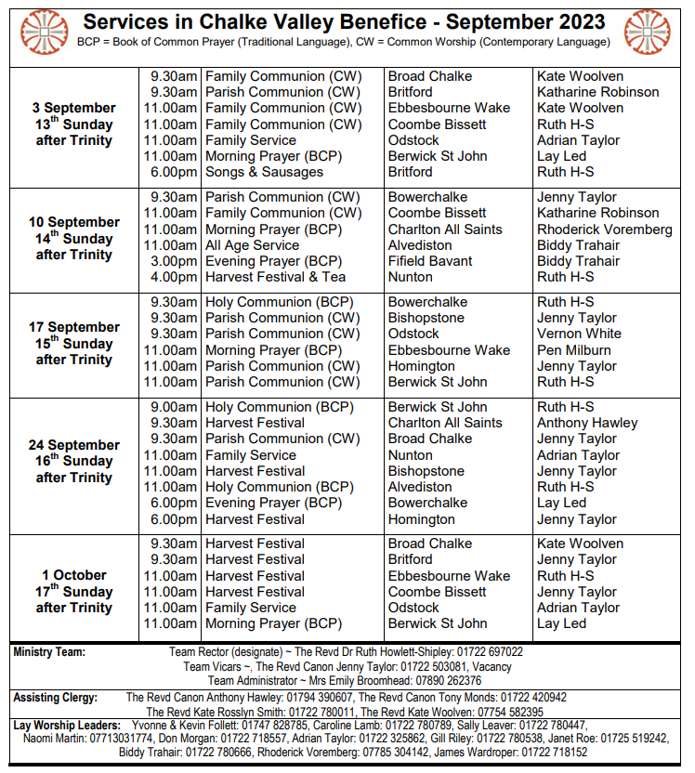

Appendix 3 – Our Churches & Villages
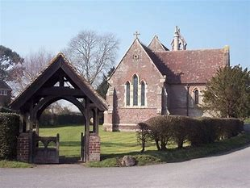
All Saints
The ancient village of Britford (pop 560) is 1 mile south
of Salisbury, with beautiful views of the Cathedral from
the water meadows. It is a small community with no shop,
but proud of a very successful cafe with delicious
homemade food. Longford castle is at the southern end of
the village, there is a fish farm and two other farms and for centuries the sheep fair was held in Britford.
Longford C of E Primary school serves children from the surrounding area. There are a few families in Britford with children but most of the residents are retired.
Charlton All Saints (pop 290) is a small, friendly village,
made up of a caring community of individuals. It is situated in the River Avon valley, surrounded by Longford Estate farm
land and by water meadows. All Saints Church was
consecrated in 1851. Horatio 3rd Earl Nelson was the
church's founder and patron. During the year, several social events are arranged in the church, central and the only
‘public space’, which are enthusiastically supported and
enjoyed by residents of this and neighbouring villages.
Charlton All Saints

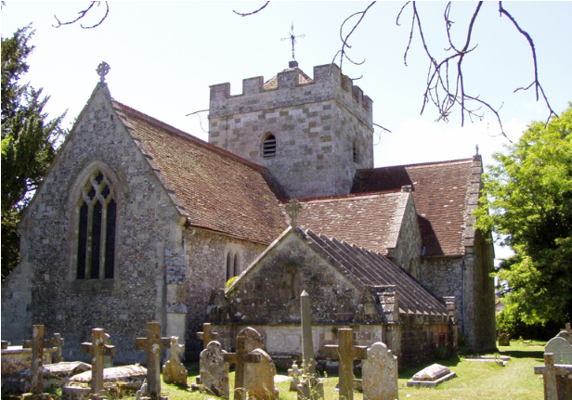
St Peter, Britford

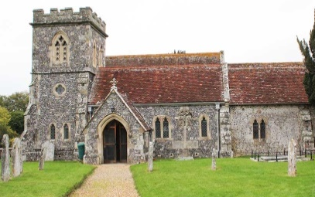
ONB (pop 550), short for Odstock, Nunton, and Bodenham, is a charming community nestled towards
the eastern end of the picturesque Chalke Valley on the eastern edge of the Chalke Deanery.
The civic parish boasts two churches, two hospitals
(Salisbury District and New Hall), two pubs, a village hall,
a nursery school, a dental centre and a local ‘milk hut’
where fresh milk from the 800 dairy cattle that roam the village fields is sold, and Longford castle.
The villages collaborate frequently, pooling their
resources and creative abilities, particularly for the
annual Christmas ‘Review/Panto’ which is always a
sell-out. The summer Ebblefest, a combined fete and
music festival, draws people from a wide area and raises funds for local charities and churches. In the summer months, car boot sales provide regular competition to
church services! The Nunton field is used by the
local football clubs during the winter.
St Andrew, Nunton
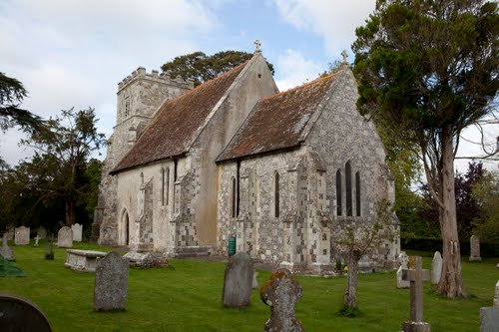
St Mary, Odstock

Coombe Bissett is a medium sized village on the cross roads where the valley East- West road meets the Salisbury-Blandford road. Homington is a little over one mile down the valley road, easy walking distance across Homington Down. The villages (pop 690) are both extremely friendly. Coombe Bissett enjoys the prominence of the church of St Michael and All Angels and benefits from an excellent village shop, small church primary school and a pub. Homington is a much smaller village, with its pretty church of St Mary. There are a few families in both villages.
The sense of community, within the two villages is
extremely important and you will always find a friendly
face and someone to pass the time of day with. Social
coffee mornings take place in both churches, monthly in Homington and weekly in Coombe Bissett. There is also a
well-used village hall. Care and help for the sick or elderly
is important and available with the villages also having
their own Link service where volunteer drivers will
transport those in need to hospital or surgery. A country
bus service runs along the Chalke Valley and into
Salisbury, usually via the hospital.
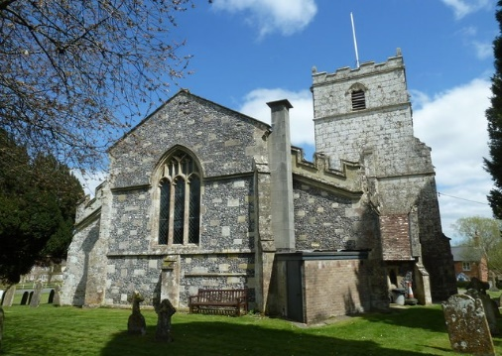
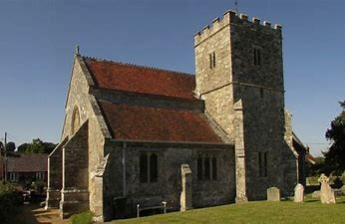
St Mary, Homington

St Michael & All Angels, Coombe Bissett

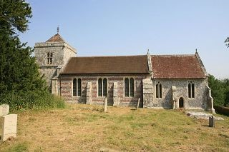
Set in the middle of the Chalke Valley, Bishopstone (pop 684) is a thriving village community with a good mix of young families and retired residents. Whilst lacking an obvious ‘centre’ there is plenty going on in the village, with a well-used village hall that hosts a wide range of events, from Moviola nights to a lively playgroup. There is also a village pub, popular with families, and a recently improved village playground. The church sits approximately one mile from the rest of the village, in a beautiful riverside setting. The village is in catchment for both Coombe Bissett and Broad Chalke primary schools. Stratford Tony (pop 55) is a small hamlet, alongside the river Ebble. Its delightful church in the care of the Churches Conservation Trust is used for an annual evensong in the summer and the occasional wedding!

St Mary & St Lawrence,
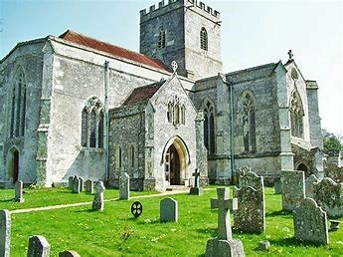
Stratford Tony

St John the Baptist, Bishopstone

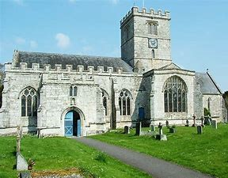
Broad Chalke (pop 650) sits centrally in the Benefice and has a
good mix of age-groups. There is a CofE maintained primary school, a
sports centre, a village hall where WI, Flower Club, Film Night are each
held once a month and Teddybears (for mums, babies and toddlers)
once a week, and a pub – The Queen’s Head.
The jewel in our crown is The Hub – a shop (Chalke Valley Stores)
and Coffee Shop, situated in the URC building. There are 7 working farms and several small businesses. The village also hosts the internationally famous Chalke Valley History Festival.
All Saints, Broad Chalke

Bowerchalke (pop 280) is a ribbon development, nearly two miles from end to end, set in the Cranbourne Chase Area of Outstanding Natural Beauty, with farms surrounding it. It has a stream fed from a spring that rises in the natural basin that joins the Ebble River and supports a fish farm. It is, in the main a close- knit community of all ages. The “outstanding” Broad Chalke School is a draw for those with young children. There is a monthly farmers market in the Village Hall, and other community events provided by Church and Village Hall supporters.

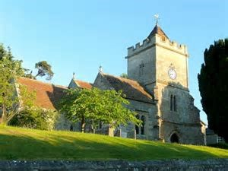
Holy Trinity, Bowerchalke
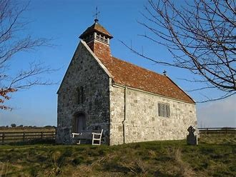
These 3 villages have distinct characteristics but combine for some activities.

Ebbesbourne Wake (pop 210) is the largest with most houses around the centre, but some are outlying and West End joins Ebbesbourne and Alvediston. The Horseshoe pub is very popular, while the Village Hall is a centre for all 3 villages. It hosts the 'Alvewake' fête, flower show, film club, concerts and special occasions like the Coronation Tea. Farms are mainly arable and livestock pasture, with a commercial shoot. Ebbesbourne shares a Parish Council with Fifield.
To the east, there is evidence in field contours of the medieval village in Fifield Bavant (pop 22), deserted due to the plague. Now there are 12 dwellings: Manor Farm House, the former rectory and 10 farm cottages. Some of the farm buildings are let as stables and workshops. The farm is mainly arable with grazing and a shoot. Cont……
.

St Martin, Fifield Bavant
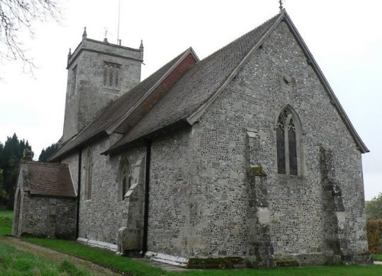
St John the Baptist,
Ebbesbourne Wake

cont…
Alvediston (pop 80) to the west is the most scattered village with clusters of houses. Following a recent fire at the 'Crown'Inn, the church provides a venue for concerts and special events, eg. a Coronation exhibition of local activities and interests. Sheep farming predominates, with some arable, livestock and a race horse stud.
Almost all houses are permanently inhabited; there are council houses in Ebbesbourne and farm cottages at affordable rent in all the villages.

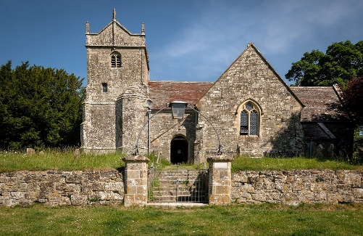
St Mary, Alvediston

Berwick St John (pop 250) is the westernmost village in the Chalke Valley, and the Benefice. Nestled amongst the chalk downs, the River Ebble rises here. It is a rural community, with four working farms and associated businesses including a blacksmith. There is a pub and Village Hall, both well supported.
Berwick is renowned for its community spirit, from street parties for national events to its Harvest Supper and Fete. Above all, it is the home of the biennial Country Fayre, founded by village steam enthusiasts and now a huge event which last year raised over £63,000 for the Salisbury Hospital Stars Appeal.

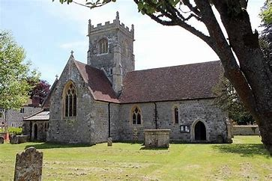
St John the Baptist,
Berwick St John

