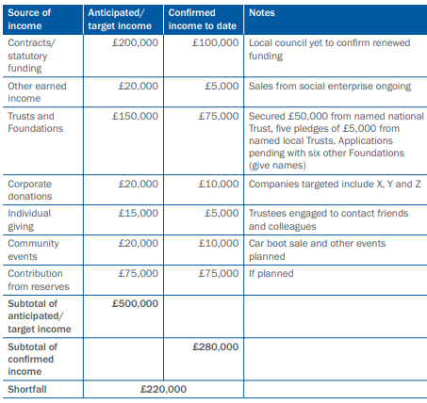

Source of income | Anticipated/Target Income | Confirmed income to date | Notes
Contracts and statutory funding
Other earned income
Trust and Foundations
Corporate donations
Individual giving
Community events
Contribution from reserves
Subtotal of anticipated/target income
Subtotal of confirmed income
Shortfall

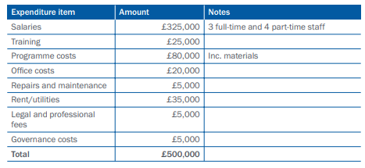

Expenditure item | Amount | Notes
Salaries
Training
Programme costs
Office costs
Repairs and maintenance
Rent/Utilities
Legal and professional fees
Governance Costs
Total

