Salt for the earth, light for the world
  - A theological reflection on our emerging vision and priorities

Who is this vision for?

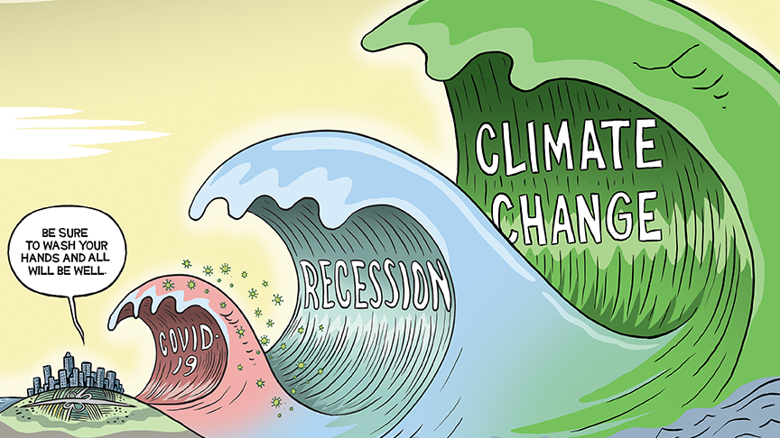
The Canadian artist Graham McKay published the first version of this cartoon on 11th March (the day the WHO declared a pandemic) and the second (adding the third wave) in May. His picture has been revised, used and adapted as a symbol of the questions the whole world is facing in the next decade.

A small city is threatened by the huge waves of the pandemic, a recession and climate change. Some would add a fourth wave, a new industrial revolution which will fundamentally alter the role of work in our society.

As we seek to develop a new vision for the Church of England in the 2020s, one of the key questions will be: who is this vision for?

The world is asking profound questions at the beginning of this new decade about what it means to be human. The first wave of COVID 19 raises questions about the fragility of life, the worth of every person and of mortality. The second wave of recession raises questions of justice and fairness, diversity and inclusion in an unequal world. The third wave of climate change and biodiversity raises questions of sustainability and care for the earth. The fourth industrial revolution raises questions of purpose and the role of fruitful work in human flourishing.

The Church of England has a vocation to be a Church for all people in all places. We are seeking now to develop a Christian vision for every person and a Christian vision for the world.

The heart of our vision and the heart of our message therefore need to speak to these four great questions of our age. We must not be like those in the picture who are saying: “Be sure to wash your hands and all will be well”. Our diagnosis and our prescription must be adequate to the task before us and the times in which we live. We must not be focussed only on Church structures or internal questions in a time of such deep crisis. We must be faithful to a vision of God’s kingdom and of hope: “If anyone is in Christ, there is a new creation” (2 Cor 5.17).

A Christ-centred, Jesus-shaped vision

For this reason, our vision as a Church must inspire and energise those who are seeking hope and new life within the Church and within our wider society. It must not be a series of technical fixes or solutions: “Be sure to wash your hands and all will be well”. Nor must it be a series of internal strategies, tasks or targets which will increase the burden on clergy and congregations without a corresponding increase of resources: a command to build more bricks without straw.

For these reasons, we are proposing a fundamental and life giving shift in our common vision and strategy from a task centred approach to a Christ-centred, Jesus shaped approach to our life and calling from which certain priorities and tasks will flow.

Over the last four decades the Church of England has attempted to shape a common purpose around the mission of God: to become a more mission shaped Church. This has been a fruitful and necessary journey and part of the wider global movement to recover God’s mission as the overflow of God’s life in the world.

With hindsight, in each decade the Church, guided by the Spirit, has put the stress on different aspects of the five marks of mission (in the 80’s on Faith in the City; in the 90’s on the Decade of Evangelism; in the 2000’s on fresh expressions and in the 2010’s on the quinquennial goals). But our focus on the mission of God has led us to focus more and more on tasks. There is now a weariness in our common life and parishes and dioceses have become wary of new initiatives and strategies.

There is however a deep thirst in the Church and in the world for theological and spiritual renewal to refresh the Church and to equip us to address the great questions of the age. Like the hard working Christians in Ephesus, the risen Christ is calling us back to our first love (Rev. 2.4).

To centre our life again on Christ is the key to the renewal of the life of the Church and in God’s mission. Through Christ we are drawn into the mystery of God the Trinity. Christ is the one who shows us the Father and sends upon us the life giving Holy Spirit. Christ is the one through whom creation comes into being and is sustained and the one who shapes the life and character of the Church. Christ is the one who through his Spirit, brings fruit: the harvest of justice; the harvest of new disciples and the harvest of a Christ like character.

Therefore we must not use the beginning of the new decade simply to exchange one set of tasks (the quinquennial goals) for another (the five marks of mission). Our calling is to return to the centre: to set before the whole Church again a fresh vision of what it means to follow Christ and to be formed into his likeness together. We need to remember again whose we are. In the words of Scripture and of our ordinal: the Church is the Body of Christ, the people of God and the dwelling place of the Holy Spirit.

As the world grapples with the deepest questions about what it means to be human in this key decade, as a Church we need to return to remarkable message of the incarnation: we believe that Almighty God, maker of heaven and earth, took flesh and lived among us, “full of grace and truth”. In the life of Christ, in Christ’s saving death and resurrection, in the mystery of his incarnation, we find the resources to address the deepest questions of mortality, justice, sustainability and purpose.

Simpler, Humbler, Bolder

The life of the Church is be centred around the life and character of Christ. At every stage in the process of developing this vision, this Christ-centred, Jesus shaped vision in the has been affirmed more and more clearly. The three qualities we seek: to be a simpler, humbler and bolder church flow directly from this vision and are already giving energy to many different conversations.

These three qualities are rooted in the beatitudes in Matthew 5.1-10: the most appropriate watermark for our vision picture and to take as our key text for the next decade. The beatitudes are almost the first words Jesus speaks in the gospel of Matthew. They offer a perspective of affirmation (blessed) to a church which is overfond of criticism. They offer a perspective of hope and abundance in eight beautiful promises to a church often tempted to despair and to plan from scarcity. They offer the broad horizon of the kingdom of heaven (at the beginning and at the end in the pictures of salt and light which follow) to a church which is too apt to turn inwards and focus on our own life. The beatitudes remind us that every local Church is the grace filled community of the baptised. The beatitudes help us see that the local church in the diocese and the parish is not a problem to be solved.

The beatitudes offer a portrait of Christ in eight beautiful qualities: a portrait which Matthew goes on deliberately to unfold in the chapters which follow. It is, first, Jesus who is poor in spirit, who mourns for the needs of the world, who is meek and hungry for justice. The beatitudes therefore offer to us a portrait of what it means to be fully human in a complex and ever changing world: to be fully human is to be merciful and to be people of integrity. The beatitudes are not addressed to individuals but to the community of the disciples (5.1): a community of peacemakers, resilient in the face of difficulties. The beatitudes are therefore a blueprint, a vision, for the character and life of the Church.

The marks of mission of the Anglican Communion which are right at the centre of the picture, also flow from the whole ministry of Christ and from the beatitudes. The mission of the Church is the mission of Christ. We are to proclaim the kingdom, to teach and baptise, to respond with loving service, to transform unjust structures and to safeguard the integrity of creation because this is what Jesus is and does in God’s world both in his earthly ministry and in and through the life of the Church.

Our call to be a simpler, humbler and bolder church is therefore rooted in the beatitudes. To be simpler means to be pure in heart; to set mercy at the centre and as our highest aim. To be humbler means to be poor in spirit, to be meek, to mourn for the needs of the world. To be bolder means to have the courage to hunger and thirst for justice, to seek peace and reconciliation, to stand our ground when we face opposition.

The Five Marks of Mission:
The mission of the Church is the mission of Christ
- To proclaim the Good News of the Kingdom
- To teach, baptise and nurture new believers
- To respond to human need by loving service
- To transform unjust structures of society, to challenge violence of every kind and pursue peace and reconciliation
- To strive to safeguard the integrity of creation, and sustain and renew the life of the earth

Missionary disciples, younger and more diverse, mixed ecology

The three priority areas flow in turn from placing Christ at the centre and from these three qualities as we respond to God’s call in this place and time and from where we now find ourselves.

Each flows from the central calling to become a more Christ-centred, Jesus shaped Church. We believe we are called to be a Church of missionary disciples, building on all that we have learned over the last decade through Everyday Faith, Growing Faith and Setting God’s People Free, because we see Jesus in the gospels calling and sending missionary disciples to transform the world in the power of the Spirit. All are called to live in this gracious and life giving rhythm of coming together to be with Jesus and being sent out (Mark 3.14).

We are called to be a Church which is younger and more diverse because we see Jesus calling young and old, rich and poor, women and men and the Church from earliest times as a community in which there is no distinction between different races or backgrounds or gender.

We are called to be a Church in which a mixed ecology is the norm because we are learning that if Church is what happens when people encounter the risen Jesus, there is plenty of room for diversity of rhythm and style. To reach a diverse nation we need to be a diverse church both in our membership and in the range of manifestations of what it means to be the Body of Christ.

To be formed in the likeness of Christ

It is always a temptation to rush from the articulation of vision to the development of strategy, particularly in a time of national crisis. But the Church should resist this hurry to arrive. If we discern together that we are called to be a more Christ-centred, Jesus-shaped Church, simpler, humbler and bolder then our next step must not be, like Martha, to rush to prepare the next course. Rather the Church will need space and time and courage to rest, to listen, to be with Jesus, to capture a fresh vision, to gaze again on the face of Christ. This is the calling of every Christian, every local Church and every diocese as we discern together our next steps in this journey.

Above all, any work of pruning for the sake of greater fruitfulness will require faithful listening to the Spirit and great gentleness, love and hope for the Church.

“Now to him who, by the power at work within us is able to accomplish abundantly far more than all we can ask or imagine, to him be glory in the Church and in Christ Jesus to all generations, for ever and ever. Amen”.

Steven Croft
15th November, 2020

The Rt. Revd. Dr. Steven Croft is the Bishop of Oxford and is theological consultant to the vision and strategy process.

McKay has a fascinating article on the journey and adaptation of the original two wave cartoon here: https://mackaycartoons.net/2020/03/18/wednesday-march-11-2020/
In more technical language: our Christology needs to shape our missiology which needs in turn to shape our ecclesiology.
Colossians 1.15-20 and 3.12-14
For justice see Isaiah 5; for disciples see Luke 5; for the character of Christ see Galatians 5
1 Cor 12.27; 1 Peter 2.1, 1 Cor 3.16
Echoing the Preface to Mission-shaped Church (2004) by Rowan Williams

