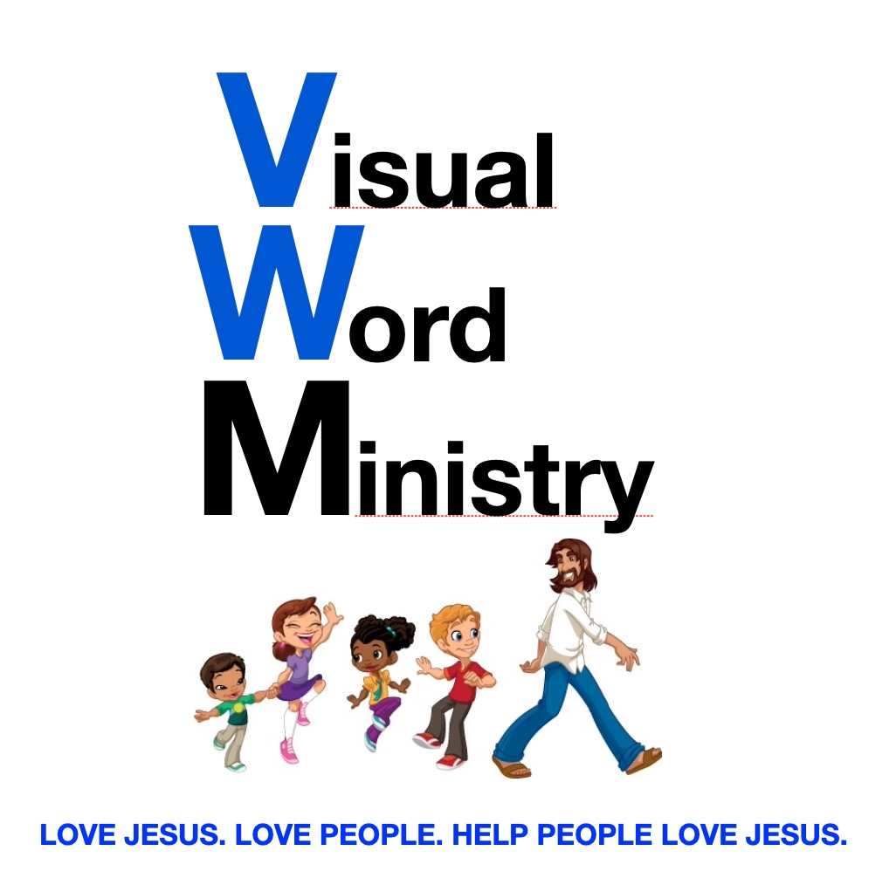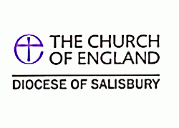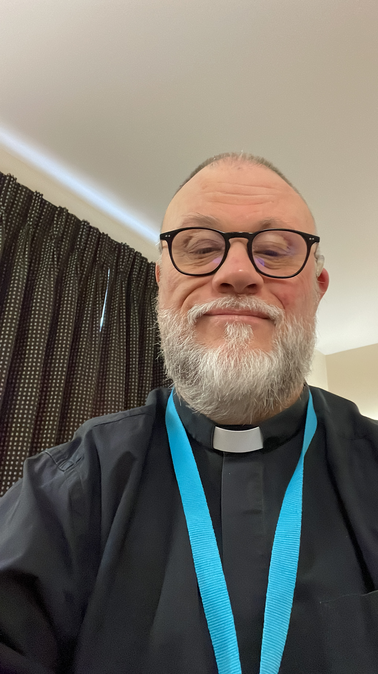

**We meet online via Zoom on Sunday afternoon at 2.30pm. To ask to join, please contact Revd. Neil**

Where to meet?

**Fortnightly Bible Study in BSL**

**We meet via Zoom on Wednesday at 2.30pm every 2 weeks.**

**Zoom Details:**

**Meeting ID: 255 100 1505**

**Passcode: DeafPray**

**COFFEE MORNINGS**

**Deaf Coffee Morning on second Tuesday (11.15am – 2pm) every month at:**

**TROWBRIDGE**

**(TO BE CONFIRMED SOON)**

**Visual Word Ministry is a place to hang out with each other and with God and is conducted in pure BSL with an English voice-over translation for hearing non-signers. We welcome hearing BSL users as well.**

**It is vital that we learn together about God and the Bible. We will do our best to meet the spiritual and emotional needs of deafblind people as best as we can.**

### **Licensed by the Diocese of Salisbury as Chaplain to the Deaf Community.**

🙞 🙜

**Rev. Neil Robinson**

#### **Deaf Gatherings in or around Salisbury**

# **Other information**

## Visual Word Ministry

Deaf Chaplaincy Service

**Rev. Neil Robinson, a Deaf priest (left)**

**Q: What is Deaf Chaplaincy Service for?**

**A:** *It is being available for all people with various levels of hearing loss ranged from profound deaf with BSL to mild hearing loss, including people who are deafblind.*

**Q: What kind of chaplaincy does it offer?**

**A:** *Funeral service. Christening service. Wedding service. Pastoral Care. Confirmation classes. School Visit. Hospital visits. All is accessed by BSL. Interpreter is available if a hearing family needs one. Deaf Awareness course is available for hearing people.*

**Q: What is the Deaf Chaplaincy’s motto?**

**A:** *The presence of a Deaf chaplain inspires each individual’s heart, soul and mind.*

**Q: What is the contact detail for the Chaplain to the Deaf Community?**

**A:** *My SMS number is 07717 055219 and my email address is* [deafpriest@icloud.com](mailto:deafpriest@icloud.com)

## **Questions & Answers**

Hello. My name is Neil Robinson. As an ordained Church of England priest, it is my pleasure to have an opportunity to minister to your needs as deaf or hard-of-hearing people.

I am a profoundly deaf BSL user so I am able to communicate with anyone. I am happily married to Helen, who is also profoundly deaf. We both use cochlear implant processors.

From time to time, you may need someone to pray for you about certain situations you are experiencing. It is important that you should go to hospital if you are seriously ill or in need of urgent medical assistance. If there is a need for a funeral service or baptism service in BSL, please contact me directly using the contact details at the right side. I will go and assist you in any way I can, regardless of time or location.

It may take you a while to get to know me better. If you fancy a chance to meet me, I would love to get to know you.

# A bit about Neil!