DIOCESE OF SALISBURY
CLOSURE OF CHURCHES

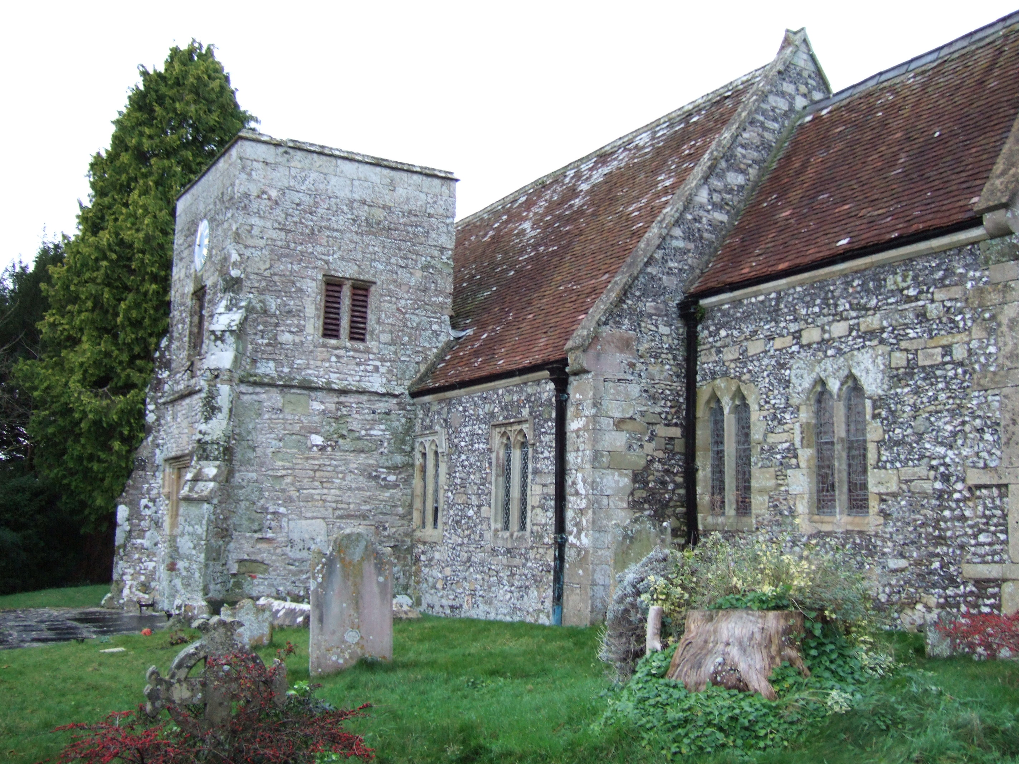

NO BISHOP OR COMMITTEE EVER CLOSES A CHURCH

THEY ONLY DECLARE OFFICIALLY THE CONCLUSION TO WHICH YOU IN THE PARISH HAVE COME

THESE ARE THE QUESTIONS YOU NEED TO ASK WHEN DECIDING ABOUT CLOSURE

DO WE WANT TO KEEP THIS CHURCH?

DO WE PUT THE CHURCH TO REASONABLE USE?

CAN WE JUSTIFY THE EXPENSE OF THIS CHURCH IN THE LIGHT OF WHAT WE CAN AFFORD AND OF THE PRIORITIES FOR OUR PARISH?

ARE FUTURE DEVELOPMENTS LIKELY TO INCREASE THE USE OF THIS CHURCH?

This leaflet will help to explain the implications of closure. It should be used as
part of your consultations with the Rural Dean and Archdeacon, and not in isolation.

A. WHICH CHURCHES?

Any consecrated Church building which is no longer required as a Parish Church or a Chapel of Ease may be declared closed for regular public worship under the Pastoral Measure 1983 [as amended] and the Dioceses, Pastoral and Mission Measure 2007. Two distinct processes are involved:

Stage I - A Pastoral Scheme [Declaration of Closure]

Church building declared to be closed by a Pastoral Scheme under the Measure. The Scheme closes the Church for worship and only in exceptional cases [for example where a use has already been decided] goes on to deal with the future of the building.

Stage II - A Church Buildings Disposal Scheme

A Disposal Scheme under the Measure will either provide for the building to be put to some suitable alternative use, or in certain cases provide for its preservation by the Churches Conservation Trust, or for it to be vested in the Diocesan Board of Finance or provide for it to be demolished.

B. WHAT ARE THE EFFECTS OF A DECLARATION OF CLOSURE?

Immediately a building is declared closed for public worship it enters a so-called "use-seeking period” of up to two years while its future is considered:

[1] Financial Liability: During the "use-seeking period" ownership of the building is vested in the Diocesan Board of Finance and financial responsibility is transferred from the Parochial Church Council to the DBF which is then responsible for insurance and essential maintenance. Incumbents and PCCs should, however, continue to keep a close watch on the building to guard against vandalism and deterioration of the fabric.

[2] Contents: Responsibility for safe-keeping of the contents passes from the Parochial Church Council to the DBF. Under no circumstances are any contents allowed to be removed without the express consent of the DBF via the Diocesan Furnishings Officer. Although the building remains subject to Faculty Jurisdiction until the Disposal Scheme comes into operation, the DBF has authority to move the contents to a place of safe keeping. After consultation with the Incumbent and the Diocesan Advisory Committee, the Furnishings Officer makes recommendations to the Bishop for the future of the contents [including monuments] - either their retention by the Parish Church; or their retention in the closed building, on loan; or disposal as appropriate. Church communion plate is normally retained by the Parish Church.

[3] Divine Worship: Occasional acts of worship are permitted during the "use-seeking period" with the consent of the Bishop and the Incumbent, but usually the insurance risk, the state of repair, or the disconnection of electricity makes this impossible.

[4] Churchyards: Only the Church building is affected by a declaration of closure. The churchyard is not affected in any way at this stage.

C. WHAT CAN BE DONE WITH THE BUILDINGS?

A Disposal Scheme [Stage II] may provide:

[1] After consultation with the Church Buildings Council [CBC] for the building to be appropriated to a suitable alternative use and sold by the Church Commissioners. Examples of a wide range of possible uses are: a Church for another denomination; Church hall/Church offices; School chapel; social centre; general community use; educational and cultural; craft industry; library'; residential; public monument; offices; museums and warehouses.

[2] If no suitable alternative use can be found and the Church Commissioners, after consulting the CBC, agree that the building is of sufficient architectural or historic importance it can be preserved [generally with its contents intact]:

[i] By the Department of Culture, Media and Sport in exceptional cases;

[ii] By the Churches Conservation Trust. The Trust is permitted to allow occasional services, eg Dedication Festival and Harvest Festival [usually two per year]. The building ceases to be licensed for weddings. It is not generally available for baptisms and funerals, although these may be held in the building provided the consent of the Trust and the Bishop is obtained by the Incumbent on each occasion.

[iii] By remaining vested in the DBF who can hold, use or let the property for such use as may be agreed.

[3] If no suitable use can be found and the building is not to be preserved it must be demolished. See also E [3] below.

[4] Sale Proceeds:

[a] Buildings and land: under the Measure two-thirds of the proceeds are payable to an appropriate Diocesan Account and one-third to the Church Commissioners [mainly for the benefit of the Churches Conservation Trust]. Where a Church is closed in order to permit a new Church to be provided within the same benefice then the net sale proceeds [or part proceeds as necessary] are applied to defray the cost of such provision.

[b] Contents: on the direction of the Bishop any proceeds are normally retained by the DBF to help defray the cost of the closure process [insurance, storage etc] but occasionally on the recommendation of the DBF a proportion of the proceeds can be paid to the PCC to defray recent costs of expenditure on contents, for instance for organ repairs.

[5] The Disposal Scheme [Stage II] may also make provision for the future of the churchyard. What is appropriate will vary from case to case.

If the parish wish to retain it for future burials, rights of way will be granted for access to the building and for its maintenance. [At some future date the churchyard can be disposed of separately, or alternatively it can be closed and maintained by the Local Authority in the usual way].

If the churchyard is to be disposed of with the building it will be included in the Disposal Scheme. Strict regulations apply over disturbance of human remains and removal of headstones. A measure of continued public access can be reserved for the tending of graves etc.

D. HOW IS A CHURCH CLOSED?

STAGE I

[a] Decision by Diocesan Mission and Pastoral Committee in consultation with Parochial Church Council and others that the building is no longer required on pastoral grounds, leading to proposals signed by the Bishop.
TIMING - 6 months or more

[b] The Church Commissioners make a Pastoral Scheme for closure after further consultation. The Scheme when confirmed makes the church legally closed for regular public worship and vests it in the DBF.
TIMING - 6 to 12 months

STAGE II

[a] "Use-seeking period" during which the Diocesan Re-Use of Closed Churches Group seeks to find a suitable alternative use and usually places the property in the hands of Agents, seeking outline planning consent where appropriate.
TIMING - up to 2 years.

[b] Proposals for new use made to the Church Commissioners who, if they approve the use and necessary plans, make a Disposal Scheme. This is normally done only after a purchaser or new occupier has been identified.
TIMING - 6 to 12 months, often a good deal longer.

[c] Legal procedures i.e. lease or conveyance etc.
TIMING - the length of time depends on the complexity of the total situation.

E. IS PLANNING PERMISSION NECESSARY?

[1] A Church building in use is exempt from listed building control. This exemption is lost when the building is formally declared closed for regular public worship.
[Stage I].

[2] Planning permission is necessary for change of use and for structural alterations to the building. Listed building consent is also necessary in appropriate cases, after the declaration of closure.

[3] Listed building consent is not required when a building is demolished under the authority of the Disposal Scheme [Stage II]. [Section 2 - Redundant Churches and other Religious Buildings Act 1969, as amended by Schedule 23 of the Town & Country Planning Act 1971].

[4] A proposal for demolition will in certain circumstances be referred to the appropriate government Minister inviting a Non-Statutory Public Inquiry to be held.

F. DO PURCHASERS OF CLOSED CHURCHES EXPERIENCE UNUSUAL DIFFICULTIES?

[1] Uses can be restricted by the cost of repair of the building; cost of conversion to a new use; cost of continuing maintenance; suitability of the structure for another use; propriety of the proposed use for a former Church; and above all the necessity to obtain the approval of detailed plans by several Church authorities as well as by Planning Authorities.

[2] The length of time for procedures to be followed through can result in impatience and frustration leading to the withdrawal of a prospective purchaser.

[3] A prospective purchaser risks heavy expenditure on scheme details and plans before knowing whether his purchase is to proceed.

[4] Vandalism between closure and sale is a high risk.

G. COMPENSATORY GRANT

In appropriate cases and on the recommendation of the Archdeaconry Mission and Pastoral Sub-Committee, a grant may be made to the PCC where a parish church has been closed. An example would be where a PCC has recently incurred major expenditure on the provision or maintenance of an artefact, amenity or resource in the closed church, or needs to substitute such elsewhere.

H. WHERE CAN ADVICE BE OBTAINED?

STAGE I [Declaration of Closure]

[a] The Archdeacon

[b] The Secretary to the Diocesan Mission and Pastoral Committee, Church House, Crane Street, Salisbury, Wilts SP1 2QB Tel: Salisbury [01722 438650]

STAGE II [Disposal]

[c] The Secretary to the Re-use of Closed Churches Group, Church House, Crane Street, Salisbury, Wilts SP1 2QB Tel: Salisbury [01722 411933]
[BUILDINGS AND LAND]

[d] The Diocesan Furnishings Officer, Church House, Crane Street, Salisbury, Wilts SP1 2QB Tel: Salisbury [01722 411933]
[CONTENTS]

Salisbury Diocesan Board of Finance
Church House
Crane Street
Salisbury July 2010
Wilts SP1 2QB [Revised]

