

Guidance notes for LLM Ministry Agreement

Licensed Lay Ministry is a vocation before God and carries significant responsibilities of service to the people of God. As a member of the ministry team within a benefice, an LLM has a key relationship with their Incumbent/Priest-in-Charge, which needs to be based on trust, openness and mutual accountability. Underpinning this relationship, the Bishops’ Regulations for Reader Ministry strongly recommend a written agreement between the LLM and their incumbent which should take into account:

- the particular expression of the individual’s ministry
- the role of the LLM in the local ministerial team and in relation to the PCC
- the arrangements for post-admission training and attendance at LLM meetings
- the balance between their commitments as LLM and the requirements of their family, work and leisure
- the arrangements for reimbursement of expenses incurred through performance of the LLM’s duties
- the arrangements for regular meetings between LLM, clergy and other staff

Pages 2-4 of this document offer you a possible template for such an agreement.

Purpose and Scope of a Ministry Agreement
An agreement is aimed at formalising the role LLMs play in sharing with the incumbent and the local team in the work and worship of the parish/benefice. It should reflect the time, gifts and skills an LLM is willing to offer so the PCC and congregations clearly understand the scope of the role with realistic expectation.

Support for any Lay Ministry from the parish is essential. The important factor should be that the experience, skills and training of an LLM are utilised in a realistic way, where there is mutual understanding on all sides.

The agreement should be regularly reviewed by LLM and Incumbent together. In Salisbury Diocese we recommend that this should be a part of the Annual Review process, and on the arrival of a new incumbent, or if there is a significant change of responsibilities. For parishes in vacancy Rural Deans are requested to complete the ‘incumbent’ sections, please.

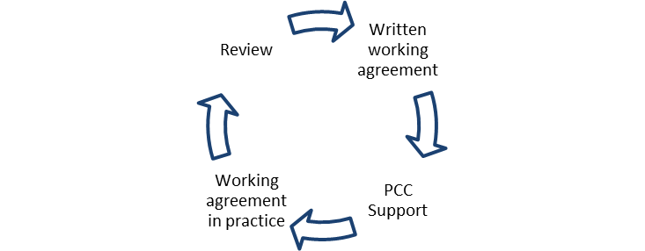

Template for a Licensed Lay Ministry Agreement

Benefice:

This agreement is the result of discussion between
Licensed Lay Minister:

Incumbent/Priest-in-Charge:

Date:

PERSONAL INFORMATION
What significant responsibilities does the LLM have outside their ministry?
In particular, mention any family or work commitments which may constrain the LLM’s availability for ministry, and any specific days they are not available for ministerial commitments.

What factors related to health need to be taken into account? Eg age, disabilities requiring accessibility provision or conditions affecting ability to carry out particular tasks of ministry.

MAKING JESUS KNOWN
Within the Diocesan Vision to make Jesus Christ known in every place so that all might flourish and grow, seeking His Kingdom here are now, what will the LLM’s particular contribution be as:

An Enabler of Mission?

A Teacher of Faith?

A Leader in Church and Society?

GROWING FAITH
What engagement will the LLM have with children, young people and/or schools?

OVERSIGHT AND INITIATIVE
In what areas will the LLM have oversight of the ministry of others?

In what areas will the LLM be encouraged to create their own ministry?

Other areas of involvement or particular focus for the LLM’s ministry (e.g. Bible study groups, community outreach, baptism/wedding/confirmation preparation).

REGULAR COMMITMENTS
What regular commitments will be expected of the LLM to support the activities listed above?
(Include expectations regarding meetings and services, ensuring that the total commitment
is reasonable bearing in mind the LLM’s ‘Personal Information’ given above.

What involvement is the LLM expected to have with funerals and bereavement ministry?

SUPERVISION AND MEETINGS
How often, and at what times, will the LLM meet with the Incumbent to discuss the LLM’s ministry and responsibilities? (This discussion should range wider than rotas, duties etc. In addition, a review of the LLM’s ministry and of this agreement should be undertaken on an annual basis)

How often will the LLM meet with a wider ministry team?

To what extent is the LLM expected to provide cover when the incumbent is away? (Note that during a vacancy the extent of the LLM’s involvement will be the subject of a discussion with Churchwardens and the Rural Dean.)

SPIRITUAL DEVELOPMENT
What is the expectation regarding the LLM’s attendance at public worship and pattern of private worship and prayer? (Comment on the expected balance for the LLM between attending rather than leading services – i.e. the rhythm of receiving and giving. Also details of daily devotion and other aspects of prayer, quiet days, retreats etc.).

What arrangements does the LLM have for reimbursement of expenses incurred through performance of their duties? Will the PCC fund an annual retreat for the LLM, and if so to what limit?

GENERAL COMMENTS
(To include details of any wider Diocesan responsibilities)

Signed .............................................................. Incumbent / Priest-in-Charge

Signed .............................................................. Licensed Lay Minister

Date …………………………..

