Benefice Profile

Upper Wylye Valley Team

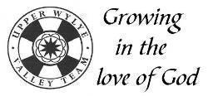

Team Rector

**Contents**

|  |  |
| --- | --- |
| **Further information and timeline** | **1** |
| **Foreword -** *A statement from The Bishop of Ramsbury* | **2** |
| **An Overview & Welcome** | **3-4** |
| **Our Churches**  **Our Team and Who We Are**  **Our Strengths & Challenges**  **Our New Team Rector -** *Job & Person Specification*  **The Upper Wylye Valley Team Area**  **Life in Our Church Community**  **Life in our villages**  **Conclusion** | **5**  **6**  **7-8**  **9**  **10**  **11-12**  **13**  **14** |

**Further information and deadline**

If you would like further information, would like to discuss any points relating to the position, or would like an informal chat, please do not hesitate to contact:

* Venerable Alan Jeans, Archdeacon of Sarum   
  ([adsarum@salisbury.anglican.org](mailto:adsarum@salisbury.anglican.org) and Mobile: 07891 651211)
* Katherine Venning (LLM) on behalf of Upper Wylye Valley Team  
  (katherine.venning@gmail.com and 01985 840283‬)

The closing date for applications is 24 June 2025.

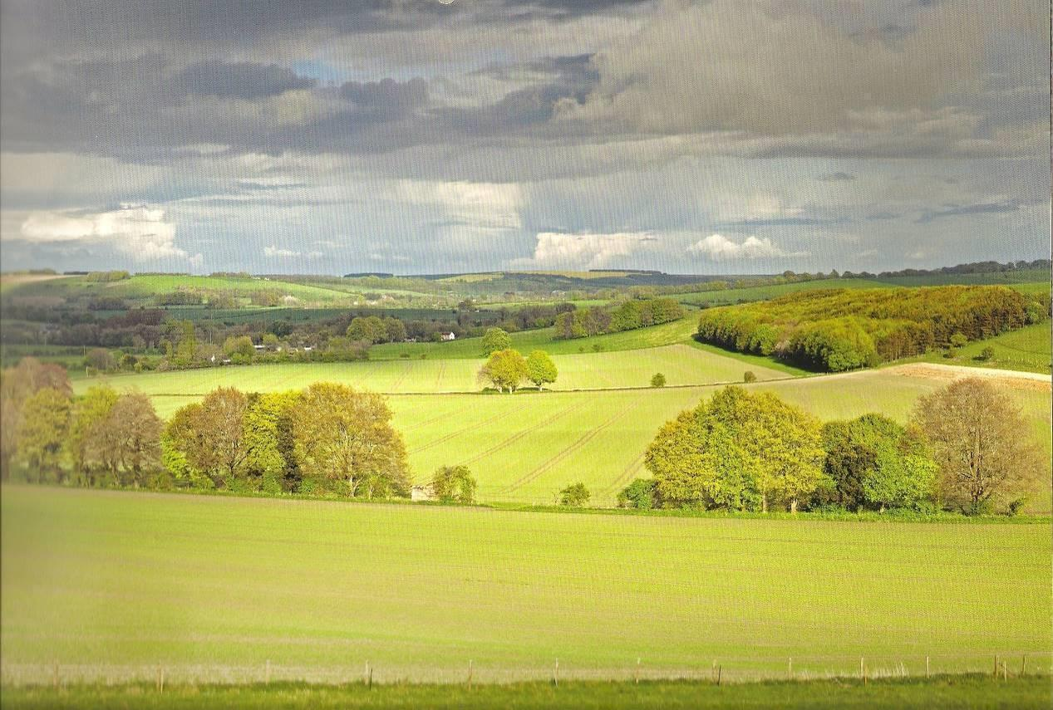

**©Chris Lock**

Welcome!

Thank you for your interest in the post of Rector for the Upper Wylye Valley Team, part of the See of Ramsbury in the Diocese of Salisbury. Advertised alongside our vacancy for Team Vicar in the benefice, this is a super opportunity for forming a new ministry team within one of the most attractive parts of Wiltshire.

I am looking for devoted and visionary clergy, who can inspire and lead our churches in Making Jesus known – our new diocesan vision. While this can appear a timeless landscape, our parishes are constantly changing and face all the challenges and opportunities of life in the 2020s. Because of this, the church must renew its mission and traditions for the contemporary situation.

In the Diocese of Salisbury, we place a high value on the encouragement and pastoral support of our parish clergy and, should God guide you to serve here, you will become part of a committed and collaborative team.

Please contact the Ramsbury office if you need any assistance with your enquiry and be assured of my prayers as you seek the Lord’s will for your future.

*Sincerely in Christ,*



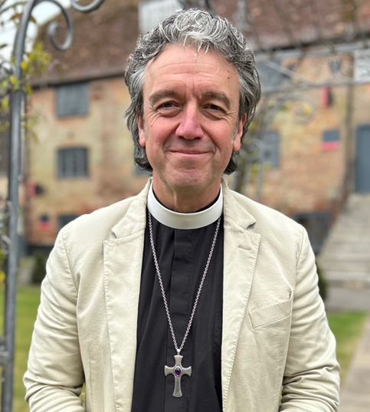

**AN OVERVIEW OF THE UPPER WYLYE VALLEY TEAM**

**YOUR FLOCK**

*The Reverend Lorraine Dobbins writes*:

As Assistant Rural Dean I have had oversight over the Team since the

vacancy. It has been uplifting to witness Churchwardens and other leaders

actively supporting one another and exploring ways to collaborate in

meeting the unique needs of their churches and their communities. I am

especially encouraged by the initial steps they have taken in discerning

missional priorities . There are some wonderfully committed people who

are active in the service of Making Jesus Known in the Upper Wylye Valley.

*The Reverend Jonathan Hiscox writes:*

I am now a non-stipendiary priest in the UWVT having previously been the

incumbent of parishes in both Salisbury, and Bath & Wells. I am “spiritually

excited” by this team. I have witnessed a willingness to work collaboratively

among so many people across the parishes. There is a growing and

blossoming awareness of God and the people in the team (LLMs,

LPAs, LWLs, Churchwardens etc.) are using their wide range of gifts and

skills in so many different areas of ministry. The Team also funds an

excellent part-time team administrator.

**YOUR CHURCHES**

There are nine, plus one looked after by the Church Conservation Trust.

However, they are close to each other in a beautiful valley. There is a

rectory and a vicarage either of which you may choose to live in and both

are within six miles of all the churches.

**SERVICE VARIETY**

We have a pattern of services to suit all comers. Traditional BCP through to

Café Church and a Plough Sunday service in a barn amongst the tractors, combine harvesters and animals. Most of these services are led by the two LLMs and the strong LWL team.

**OUR SCHOOLS**

There are three excellent C of E Primary Schools which are supported with

Open the Book and all have services in their churches at appropriate times.

We look forward to welcoming you.

**WELCOME**

It could be you! Thank you for your interest in the Upper Wylye Valley benefice.

We have found the vacancy challenging, but also an exciting opportunity for growth and would welcome the chance to continue on this path, guided by a new clergy team of Rector and Team Vicar.

Mission Planning work is ongoing. The principal points that have been identified are:-

* A willingness across the Benefice for change where needed
* Enabling the clergy team to achieve a balance between ministry, mission and management through the provision of appropriate administrative support
* Recruiting and training more Lay Worship Leaders (LWLs) and Lay Pastoral Assistants (LPAs)
* Employing a wider variety of services where the laity will play a major part
* More effective use of IT, social media and other forms of communication
* Consideration of new models for PCCs

***Do not remember the former things or consider the things of old.I am about to do a new thing; now it springs forth, do you not perceive it? I will make a way in the wilderness and rivers in the desert.   
Isaiah 43. 18-19***

**OUR CHURCHES**

The team area is compact. Its spine is the A36 in the Wylye Valley. The map below shows our 10 churches that lie within our 8 parishes.

*Diagram, engineering drawing    
    
*

Pictures, a short history and a description of the character of all our churches and their associated villages, together with contact details for Churchwardens, can be found on the [upperwylyevalleyteam.com](https://www.upperwylyevalleyteam.com/our-churches/) website.

***I was glad when they said to me, let us go to the house of the Lord.'   
Psalm 122:1***

**OUR TEAM AND WHO WE ARE**

Our Church community, based on electoral roll information, is about 360 and was led initially during the vacancy by our Team Vicar, Revd Clifford Stride, who was appointed in 2016 and lived in the Vicarage in Codford, which he occupied on a house-for-duty basis until his retirement at the end of February 2024. A Team Vicar is now being sought in parallel with a Rector.

At present the only licenced clergy within the benefice is our associate priest, Revd Jonathan Hiscox, who conducts services on three Sundays a month only, due to full-time work commitments. He is supported by our two Licensed Lay Ministers, Katherine Venning, who trained as a Reader more than 30 years ago, and Barbara Luscombe, who was licenced in September 2024. Both are licenced to lead non-Eucharistic services and take funerals. Katherine runs the Team Choir and also now provides the local leadership of and coordination within the benefice, supported by the Assistant Rural Dean, Revd Lorraine Dobbins. There are six enthusiastic Lay Worship Leaders (LWLs) and two Lay Pastoral Assistants (LPAs). The whole team is ably supported by an efficient, part-time Team Administrator.

 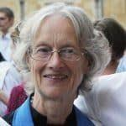 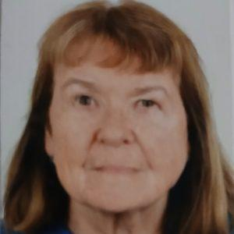

***Jonathan Katherine Barbara***

We recognise that some of our parishes are struggling to find enough volunteers to serve on their PCCs. Most have only one churchwarden and two have no one formally in post but the responsibilities continue to be discharged by volunteers. Our track record of share payment is strong.

***Blessed is the one……………….whose delight is in the law of the Lord and who meditates on his law day and night. That person is like a tree planted by streams of water, which yields its fruit in season and whose leaf does not wither - whatever they do prospers.   
Psalm 1: 1-3***

**OUR STRENGTHS**

1. A supportive team of clergy, LWLs, LPAs and laity.

2. Friendly congregations looking forward to the leadership of their Rector.

3. Mission to the young via the three church Primary Schools through Open the Book, collective worship and serving as foundation governors.

4. A willingness to form groups to address pan-benefice issues.

5. Devolved groups that meet as necessary, namely the Churchwardens/Church Representatives, Treasurers, and LWLs and LPAs.

6. A Team Choir led by a Licensed Lay Minister.

7. The support of an effective part-time Team Administrator.

8. Our generally sound finances and, in several instances, supportive Friends groups resulting in well-maintained buildings and some exciting projects to improve church facilities for use by both church and community.

9. Our positivity, demonstrated during the vacancy and our resilience and adaptability shown during Covid.

10. A rural area of outstanding natural beauty, but within easy reach of cities including Salisbury and Bath with some good local schools at both primary and secondary level.

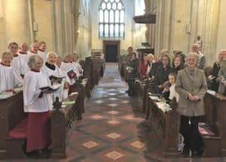

**OUR CHALLENGES**

1. The lack of licensed clergy to support the Rector.

2. Our faithful congregations are getting older and a bit smaller.

~~3~~. Becoming better at praying together and becoming better disciples and followers of Jesus.

4. Implementing at local level the Salisbury Diocese vision of ‘Making Jesus known’ by sharing the good news with those who have no knowledge of the gospel.

5. Turning the affection our parishioners hold for our church buildings into faith and worship.

6. Providing regular collective worship at three church schools and maintaining/developing Open the Book participation. Engaging with the young once they have moved up to secondary school and reaching out to a generation of parents who have not known faith.

7. Encouraging more LPAs to assist with pastoral care and to be the eyes and ears of the clergy.

8. Managing our limited time available and using our God-given gifts effectively.

9. Encouraging younger people to join our PCCs and, in time, to take on responsible roles.

***Now there are varieties of gifts, but the same Spirit; and there are varieties of services, but the same Lord; and there are varieties of activities, but it is the same God who activates all of them in everyone. To each is given the manifestation of the Spirit for the common good.   
1 Corinthians 12.4-7***

**OUR NEW RECTOR**

**Job Description**

**We are seeking someone who will;**

1. Help us to grow spiritually both as individuals and communities.
2. Enable and encourage us to be the people of God in the Upper Wylye Valley.
3. Lead our ordained ministers, LLMs and our teams of Lay Worship Leaders and Lay Pastoral Assistants.
4. Be willing to make a commitment to live alongside us in the Upper Wylye Valley, to get to know us and care for us.
5. To take an active role in sustaining and building on the existing good links between our three church primary schools and to be prepared to take on an active role as a Governor of at least one school.

**Person Specification**

**We would like our Rector to**

* challenge us all to deepen our faith and discipleship
* be comfortable with traditional liturgies but also keen to help us make worship attractive and accessible to those unfamiliar with formal services and music.
* help us draw in those on the fringes of our churches, especially all those who only attend services at Christmas, Easter and rural celebrations, including younger families
* be willing to carry out pastoral visiting in homes and to meet with people informally at their work or through social events.

***Be shepherds of God’s flock that is under your care, watching over them—not because you must, but because you are willing, as God wants you to be; not pursuing dishonest gain, but eager to serve; not lording it over those entrusted to you, but being examples to the flock.   
1 Peter 5.2-3***

**THE UPPER WYLYE VALLEY TEAM AREA**

The Team area is just 6 miles long and 1½ miles wide, running down the Wylye valley with Salisbury Plain to the north and the chalk downs and forestry of Great Ridge to the south. The villages vary in size from Codford (with almost 1000 residents) to Sherrington (about 60). Most of the benefice lies within the Cranborne Chase Area of Outstanding Natural Beauty (AONB).

According to the 2021 census, the total population in the Team area is about 2,800 adults and 475 aged 18 and under. There are three good Church primary schools (in Codford, Heytesbury and Sutton Veny) with a total of approximately 370 pupils. Most move on to the large and successful secondary, Kingdown School, in Warminster, or alternatively they can gain places in an excellent choice of schools in Salisbury.

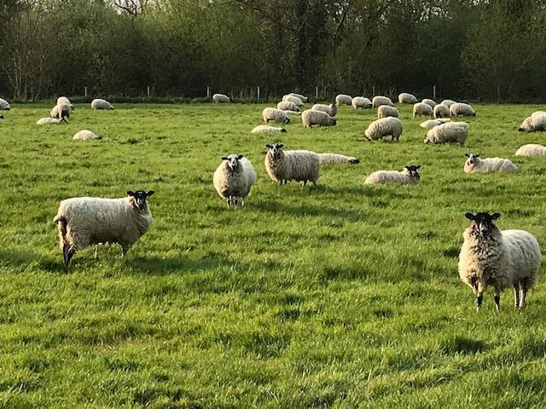

Farming is important and the farms are mostly large and mixed. There is some housing tied to the industry and there are a growing number of small businesses operating from industrial units, mainly around Codford and Sutton Veny.

Some of our residents are employed by the Army around Salisbury Plain, others commute or work from home. Accommodation is mixed, ranging from social housing to large properties. House prices are high and, even with a significant quantity of social and private rented housing, there is still a shortage of housing for the young, who may have to move into Warminster or other local towns to find somewhere to live. More low-cost housing is needed in these villages and there are pockets of real rural poverty requiring social support. There is a fair proportion of retired people.

Codford and Heytesbury have local shopping facilities, including Post Offices. The other villages either make use of these or travel the relatively short distance to Warminster, the nearby, medium-sized town.

Further general information, extracted from a range of data sets, about Wiltshire and the Warminster Community area (including the Joint Strategic Needs Assessment) can be found via the link below:

<https://www.wiltshireintelligence.org.uk/cajsna/warminster/>

**LIFE IN OUR CHURCH COMMUNITY**

**SERVICES**

The current [timetable of services](https://www.upperwylyevalleyteam.com/worship/services/) is available on the website. It encompasses a wide variety of styles of worship, from the Book of Common Prayer through Common Worship to Fresh Expressions. Regular services have generally small but committed congregations. At Christmas, Easter, Harvest and special occasions, such as Remembrance, our churches are well attended. We have strong historical links with the Australian and New Zealand armed forces and mark ANZAC Day in our churches and schools. There are beautifully maintained ANZAC cemeteries in Sutton Veny and Codford which are the settings for a dawn service on ANZAC Day in Codford and Sutton Veny school’s annual ANZAC service.

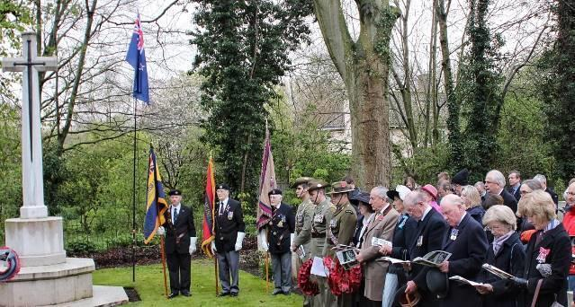 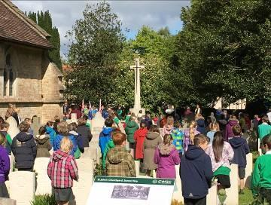

***ANZAC Commemorations***

As rural parishes, we enjoy making the most of Plough Sunday and Rogation Sunday. Together with Messy and Muddy church experimentation, these are usually family focussed services, outside or in a barn, with plenty of visual aids in the form of tractors, animals and grain stores. There is frequently a crossover between a broad range of community and church-based activities. The weekly community café in Codford and the monthly equivalent in Sutton Veny, are run by both churchgoers and non-churchgoers and give us important contact with a wider group of parishioners.

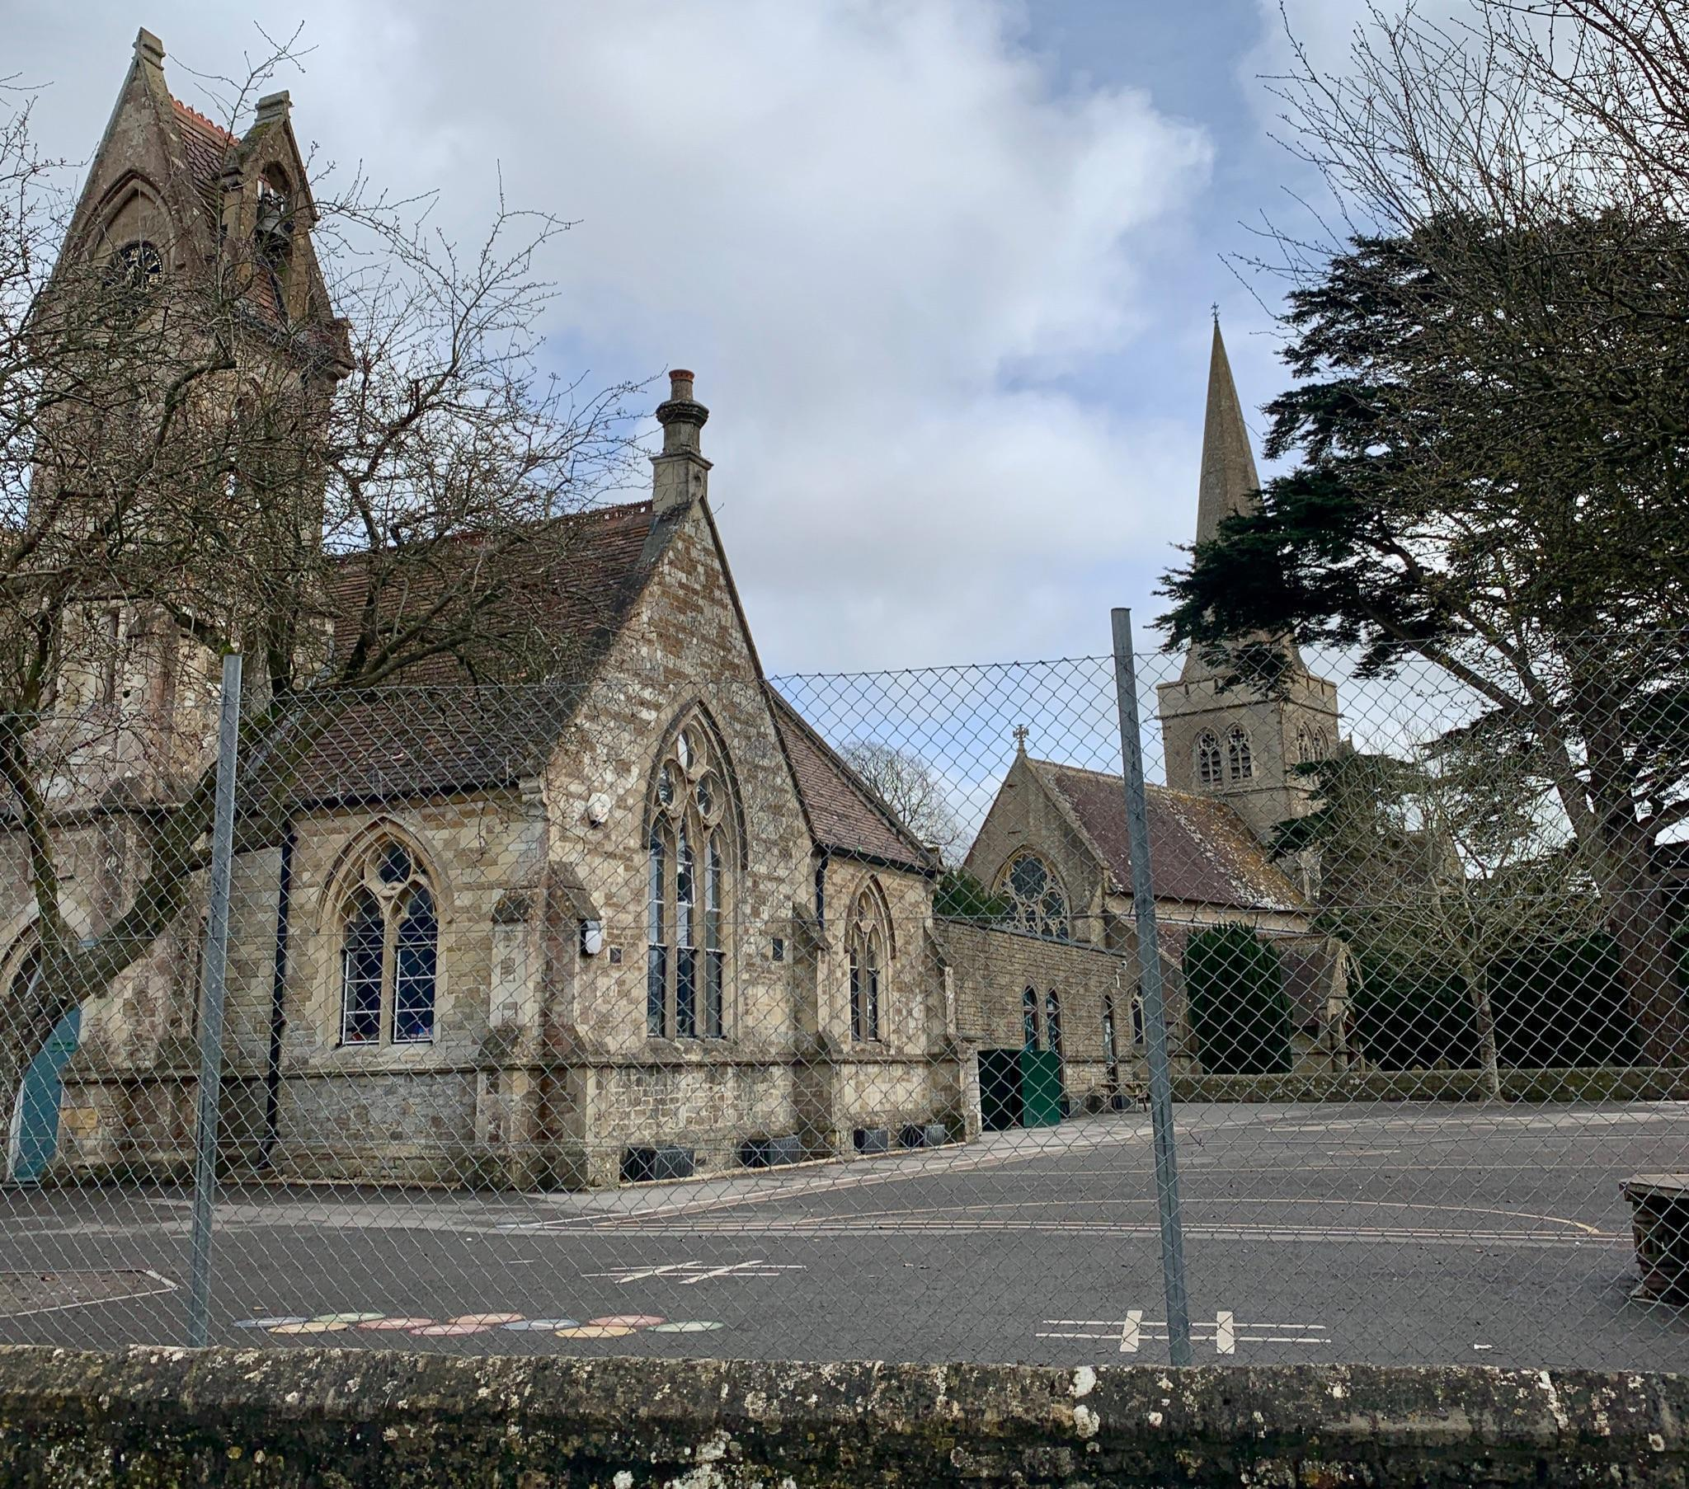We recognise that for many people their only experience of church is for Occasional Offices and we are alert to the need to make sure that their experience at these events encourages them to return. The statistics for mission figures for 2024 are shown below.

Baptisms 8  
Weddings 5  
Wedding Blessings 0  
Funeral service in Church 15  
Memorial service in Church 6  
Funeral Service in Crematorium 7  
Committal of body in Church 10  
Committal of ashes in Church 8  
**Total Services 59** (85 in 2023)

**MIDWEEK ACTIVITIES**

Throughout the year we have regular midweek activities, Bible Study groups and more informal house groups. The programme varies with the season so that we can include Advent discussions, Lent lunches, Holy Week and Maundy Thursday services and in the summer Pimms and Hymns, concerts and evening gatherings. The choir meets weekly and there has been recent growth in the group of bell ringers who support all our churches when bells are required. In addition to the already mentioned Community Café meetings, a knit and natter group meets in Ginny’s Cafe in Boyton. During the autumn and winter months, there is a monthly Men’s Fellowship Breakfast meeting in a local pub with visiting speakers. The Friends of the Churches hold occasional fundraising evenings with speakers on a wide variety of topics.

**COMMUNICATIONS – WEBSITE, SOCIAL MEDIA & NEWSLETTERS**

The UWVT website is maintained in-house by a volunteer. Parish News is a monthly publication distributed free to every house in the benefice and is available on the Upper Wylye Valley Team [website](https://www.upperwylyevalleyteam.com/team/parish-news/). The monthly [Sutton Veny Village Newsletter](https://www.suttonveny.co.uk/village-matters/village-hall-newsletter/) is also delivered free to every house in the village and the [Codford Community](https://www.codfordcommunity.co.uk/) website has recently been established to provide an online source of news and events. Social media (Facebook, Twitter etc) are channels that offer potential but are not currently exploited.

**BUILDINGS** **AND SURROUNDINGS**.

**Eco Church** – Since 2016four of our churches have registered with Eco Church. Three have attained the Bronze standard and Codford St Mary has Silver. Several churches have projects in various states of maturity to improve their facilities.

**BEYOND THE BENEFICE BOUNDARIES.**

Church members are involved in wider ventures such as prison ministry, Warminster Food Bank, Cornerstone Advice Centre or Alabaré, a local Christian charity supporting the homeless. Through the Salisbury Diocese link with the Sudans we link with Maridi Diocese in South Sudan. Enthusiastic local historians ensure that we have a steady stream of visitors from Australia and New Zealand to the ANZAC cemeteries, they bring a fresh perspective on our shared history and are welcome visitors to our churches.



**THE HOSPITAL OF ST JOHN** in Heytesbury High Street was founded as an almshouse in 1472. It is now home to 50 residents living independently in 30 units and is run by a board of trustees. It has a part time chaplain who is not part of the Upper Wylye Valley ministry team.

***Is anyone among you in trouble? Let them pray. Is anyone happy? Let them sing songs of praise. Is anyone among you sick? Let them call the elders of the church to pray over them and anoint them with oil in the name of the Lord.   
James 5. 13-14***

**LIFE IN OUR VILLAGES**

The Rectory is a four-bedroomed modern house on a quiet back lane in Sutton Veny. As well as two reception rooms and kitchen, there is a separate study. The good-sized garden also has a rear gate leading to the playing fields, the village hall, the school and the church.

The Vicarage in Codford, behind St Peter’s Church, was the base for the Team Vicar and is currently let. Potentially, the new Rector could have a choice of property in which to live.

Codford has two churches and its amenities include the GP Surgery for our area (with excellent doctors and nurses), a veterinary practice, a theatre with regular amateur productions and films, a large village hall with social club, a playing field with tennis courts, a pre-school, the primary school, as well as the Budgens shop, post office and garage/filling station. The pub is currently operating as a tea shop, but the village hall has a bar.

*The Rectory at Sutton Veny*

The other villages in the Team have many other facilities including the primary school, a popular pre-school and pubs in Heytesbury and Upton Lovell, the Ginger Piggery (Ginny’s Cafe and craft shops) in Boyton and the smaller village halls in Corton, Upton Lovell and Norton Bavant.

There are secondary schools in Warminster and Westbury, and a wide choice in Salisbury. There are also independent schools nearby.

*The Vicarage at Codford*

There is a two-hourly bus service along the A36 to Salisbury and, in the other direction, to Warminster and Bath. The train service from Warminster, north to Westbury, Trowbridge and Bath, and south to Salisbury and Southampton is hourly, and there are regular trains to London and further afield from Salisbury (to Waterloo) and from Westbury and Bath (to Paddington). There is also a good and fast coach service to London that stops in Codford and Warminster.

**CONCLUSION**

**We conclude by encouraging you to come and visit us, informally at first and then through an interview. Ultimately, we place this great matter in God’s hands:**

**TEAM PRAYER OF THE UWVT 2023 AT A TIME OF VACANCY**

Heavenly Father, we ask that you help us to share responsibility, grow in faith, love one another, care for those in need, reach out to others and welcome newcomers.  Lord Jesus, guard and grow this church as we serve you together in this period without a Rector or Team Vicar.  Please guide those who are seeking the right minister for us and those who are seeking the right church for their ministry, so that together we may discover your way for the future and see your kingdom grow.  Amen.

**THE DIOCESAN VISION**

We aspire to live up to the five priorities of the new diocesan vision of Making Jesus known.

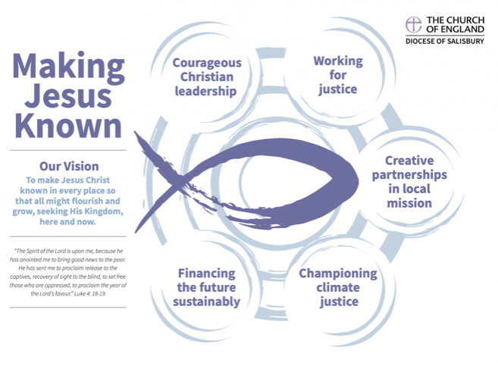

***Jesus said, 'Go therefore and make disciples of all nations, baptising them in the name of the Father, and of the Son and of the Holy Spirit, and teaching them to obey everything that I have commanded you. And remember, I am with you always, to the end of the age.'***

***Matthew 28: 19-20.***