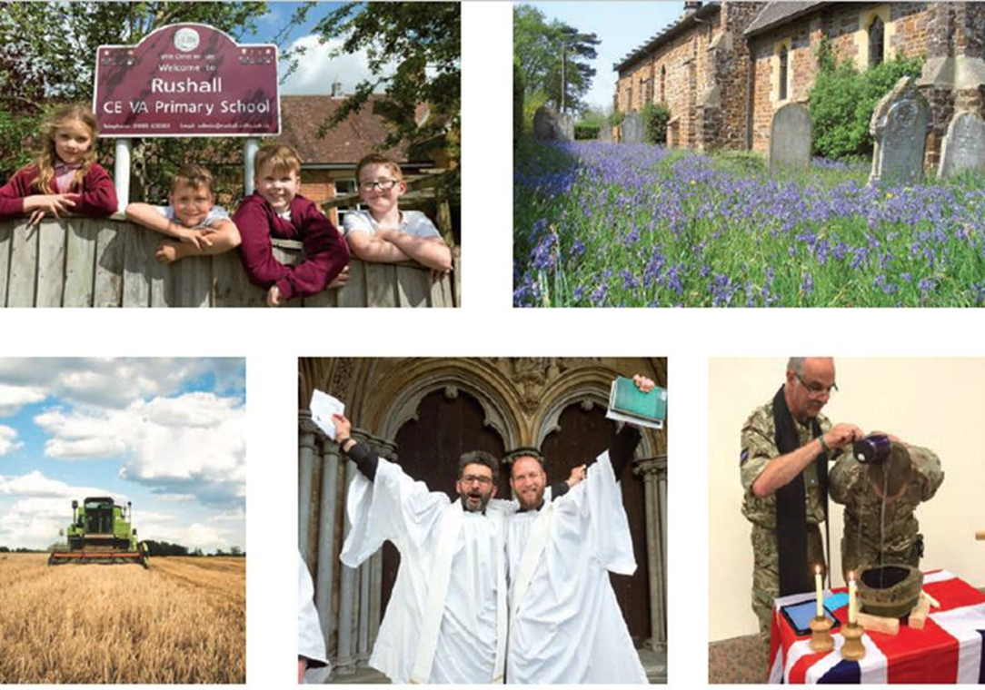

Application Information

Ministry Formation Resource Officer

21 October 2022

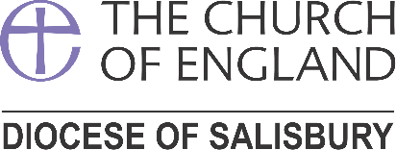

Ministry Formation Resource Officer

Thank you for your interest in the role of Ministry Formation Resource Officer

This half time role will involve you in one of the most energising and rewarding ministries in the whole of the Church of England.

The ministry Formation team are committed to enabling all God’s people to flourish and make the very best contribution they can in shaping church leaders to meet our contemporary challenges and growing the Kingdom of God. Your part in this is to work with the newly ordained. Your relationship with curates will begin when you witness them being ordained deacon in Salisbury cathedral. This live-changing commitment is matched with a commission from the whole church of Christ for deacons to serve as heralds who are … to proclaim the gospel in word and deed, as agents of God’s purposes of love. They are to serve the community in which they are set, bringing to the Church the needs and hopes of all the people. They are to work with their fellow members in searching out the poor and weak, the sick and lonely and those who are oppressed and powerless, reaching into the forgotten corners of the world, that the love of God may be made visible.

It will be your job, working closely with the Ministry Formation Team Leader to shape each generation of deacons to live out this high calling as leaders in the church. You will see that through carefully developing good relationships with Training Incumbents and curates the process of Initial Ministerial Education (IME) is transformational and blesses the church with leaders confident in ministry and mission.

Your will need to bring your finest administrative attention to the processes that are in place (but always evolving) to ensure both the curate and the wider Church have full confidence in the training and formation offered. Your experience of training others (within or outside the church) will be called upon as will your own particular bundle of gifts and dispositions. We will welcome your previous experience of being part of team where you have taken responsibility and contributed to the collective wisdom for the good of all.

If you are excited (and possibly slightly daunted) by this, then please ring me for an informal conversation or when you are ready, I will be pleased to receive your application.

Grace and peace in your discernment of the next step for you.

Revd Nigel Done
DDO and Ministry Formation Team leader

About the Team

Ministry Formation falls within the Mission, Ministry and Communications Team at the Salisbury Diocese. The Team is looking for a colleague to work closely with the Ministry Formation Team Leader and share responsibility for overseeing the Assessment in Curacy and running the Initial Ministerial Education (IME) programme for curates. This post is a half time vacancy.

You will be part of a lively and creative team, and part of the wider diocesan staff at a time of significant change and challenge in the diocese.

We offer flexible work arrangements, with availability to be located at either Sarum College, Salisbury and/or frequent or home working options.

If you wish to have an informal discussions about this post, please contact Revd. Nigel Done (nigel.done@salisbury.anglican.org).

Applications
Applications must be received by 9 November 2022. As part of your application please submit the following:
- The Application Form, including signed declaration
- Response to the Application Questions in Microsoft Word, no more than 500 words
- A current CV

Please also complete our equal opportunities monitoring form which can be found here:
Monitoring Form

A covering letter is not mandatory and if included, should be no more than one side of A4. Please return applications by email to hradmin@salisbury.anglican.org .

Shortlisting
To ensure the fairness of the selection process, shortlisting will be based upon the information which you provide in your application and assumptions will not be made about your experience or skills. We will look for demonstrable evidence that you meet the criteria set out in the person specification. A copy of our privacy policy for job applicants can be downloaded from our website HERE.

Interviews
Interviews will take place from Wednesday 18th November 2022 at Church house. 99 Crane Street. Further details regarding the interview process will be communicated at the time applicants are invited for interview.

Contact details

For any queries, please contact our HR Team:

Natalie Morton, Telephone (main line): 01722 411922 Email: hradmin@salisbury.anglican.org

The Declaration given by the bishop to the deacons in The ordinal: Common Worship (2000)

