The Parish Church of Salisbury St. Martin
Salisbury, Wiltshire

PARISH PROFILE

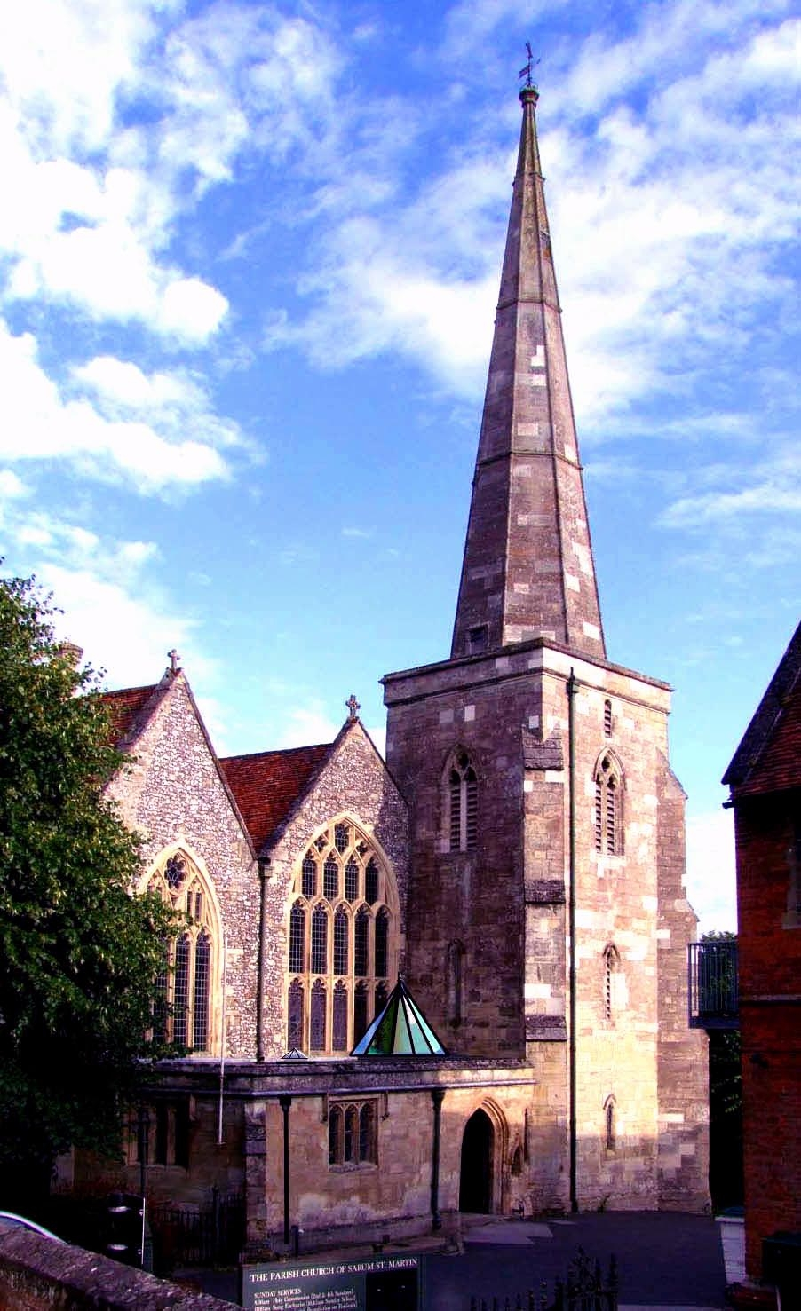

Welcome to Saint Martin's, Salisbury, a parish of long-standing catholic tradition, ministering to a diverse parish on the east of the city, supported by a dedicated team eager to grow in faith and fulfil its purpose of spreading abroad the love of God.

From the Bishop of Ramsbury

Thank you for your interest in the post of Interim Parish Priest of St Martin, Salisbury, within the Diocese of Salisbury: a shared appointment with the See of Oswestry, as part of our mutual flourishing. The new priest will also be responsible for the cure of St Peter, Devizes, forty minutes’ drive across Salisbury Plain.

The incumbent of St Martin’s will be at the heart of our cathedral city, serving a mixed community that contains a significant population of young people attending Wiltshire College & University Centre, situated within the parish. They will take part in an active deanery representing the range of Anglican traditions, with a renewed desire to co-operate in local mission.

In the Diocese of Salisbury, we place a high value on the encouragement and pastoral support of our parish clergy and, should God guide you to serve here, you will become part of a committed and collaborative team. The See of Ramsbury office has recently moved to Devizes, close to St Peter’s parish.

Please contact the Archdeacon of Wilts, The Venerable Louise Ellis, or my PA, Lynne Archer, if you need any assistance with your enquiry - and be assured of my prayers as you seek the Lord’s will for your future.

Sincerely in Christ,

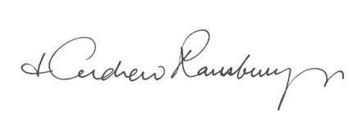
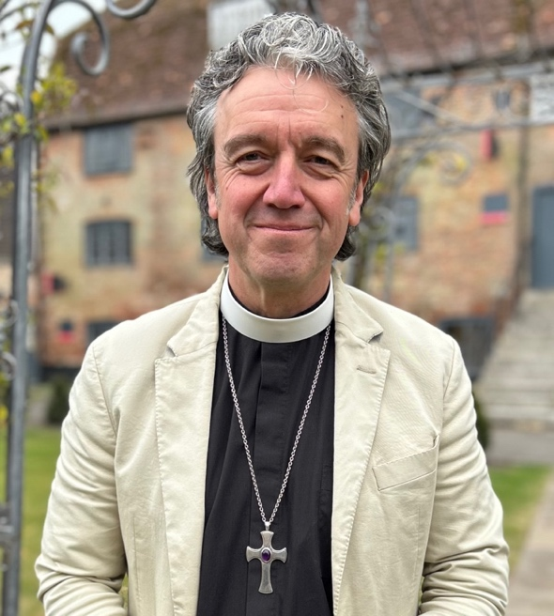

From the Bishop of Oswestry

The Catholic Faith as the Church of England has received it is deeply embedded in S. Martin’s, Salisbury and has been so for many generations. The need now, in this generation, is for the historic Faith to be renewed in power and the Holy Spirit. This must be on your heart. You will be a priest who is zealous for the Catholic Faith and for its dynamic communication; whose pastoral ministry to all is gentle and devoted; whose celebration of the sacraments expresses profound reverence for the Lord; and an evangelizer whose ministry leads the Church out beyond herself into the world and so stimulates her numerical growth.

The people of S. Martin's are warm and loving, and they deserve a Parish Priest who is no less than they are. If appointed, you will enter the ecclesial life of the See of Oswestry at an exciting time of broader renewal in the Catholic Movement, and you will join a Diocese which supports its parishes and wants to see them flourish and thrive. Pray to the Lord of the Harvest that he may send you into this harvest.

✠Paul Oswestriensis
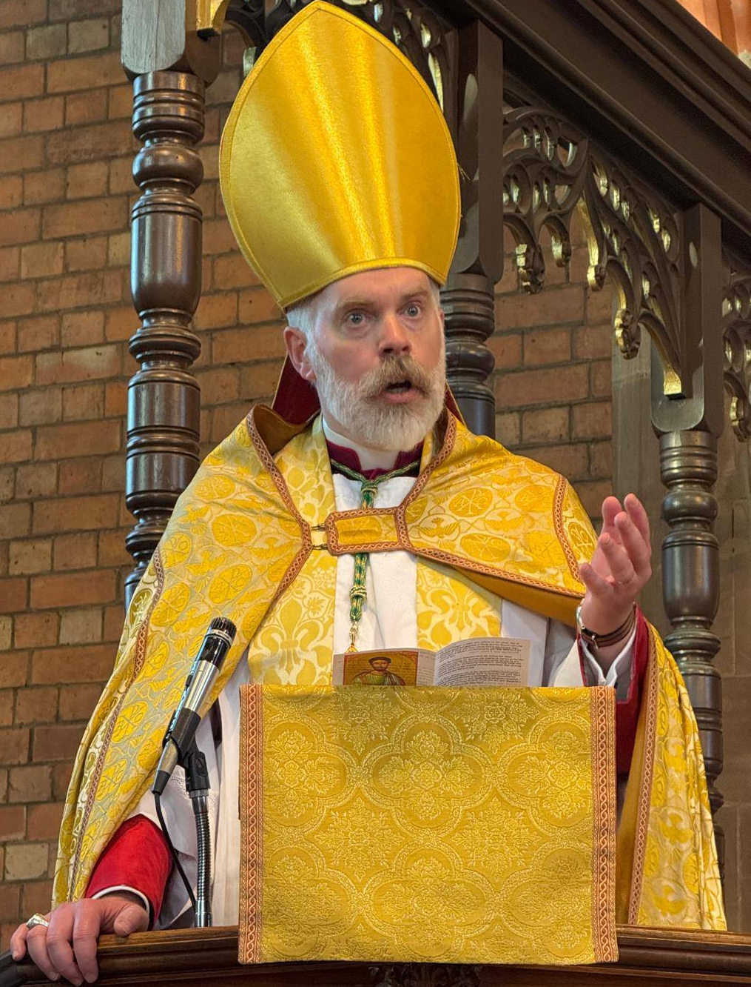

The Churchwardens, PCC and congregation of Saint Martin's are praying for a parish priest to minister to them and to the local community.
Are you being called by God to be our new parish priest?
We need a priest, affiliated to the Society of St Wilfrid and St Hilda, with a profound spirituality who has a burning desire to spread God’s word in our parish; someone with strength of mind who has an outgoing personality, together with a sense of humour. He should be able to recognise the need for pastoral care in his own congregation and parish. He must be able to connect and relate to all comers, offering them guidance with wisdom and love. He must lead and work closely with an enthusiastic team of laity, enjoying the work and thriving on success.
Our prayers are for someone whose life and ministry are rooted in prayer and the Sacraments; someone who is both a sensitive pastor and a visionary leader, and who will:
- work with the churchwardens, PCC and the congregation to enable this church to grow.
- build on our catholic heritage and what is good here, while helping us to identify areas for development, growth and outreach.
- develop more fully the spiritual life of the church.
- cultivate strong relationships between church and community and be available to those outside the church congregation.
- enjoy developing closer links with our VA Primary Academy, Salisbury Sixth Form College, and Wiltshire College and University Centre.
- minister to the housebound and the many local nursing and care homes in our parish.
- work supportively and closely with the other Society parishes in our Diocese.
- be an active partner in the wider ministry of the Deanery.
- be comfortable with delegating.
- support and develop both the use of the church for concerts and other musical events, and the work of the St Martin’s Centre.
We offer:
- a team able to support you in the challenging tasks ahead.
- a loyal congregation drawn from a wide area and slowly growing in number.
- a people trusting firmly in the Holy Spirit who are positive about the traditional Catholic life and practice, held together in mutual love and determination.
- a welcoming family atmosphere founded on the love and guidance of Jesus Christ.
- a strong musical tradition with a commitment to excellent liturgy.
- a beautiful, well-maintained Church building steeped in history and musical wealth.
- an adjoining Church Centre with outstanding amenities.
- a modern Rectory sited adjacent to the Church.
- sound finances, thanks to historical endowments and prudent investments.

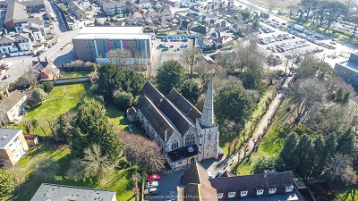

The Parish Profile

The Parish
The parish occupies the south east of the city, and includes about one-third of the historic centre - the other two-thirds being the Cathedral itself, and the parish of St Thomas with St Edmund. The parish today is a mixture of old city, urban priority, comfortable suburb and water meadows.

Safeguarding
Sarum St. Martin takes its responsibilities surrounding the safeguarding of children, young people, and adults who may be at risk very seriously, and works in partnership with the Diocese of Salisbury to ensure that we work in accordance with best practice at all times.

St. Martin's VA Primary Academy
The school is a member of the Diocese of Salisbury Academy Trust and a thriving one-form entry primary in the heart of Salisbury city centre. We are one of the most diverse schools in the county and proudly celebrate the many nationalities, religions and cultures that pass through our doors every day.
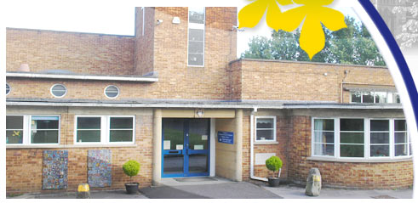
School photograph courtesy of St. Martin’s School website

School Worship in Church
The Primary School come into church for services at Harvest, St Martin’s Day, Christmas, Lent and Easter, and School Leavers at the end of the summer term.

Further Education
To the south of the Churchyard lies Wiltshire College and University Centre, which offers students a wide and variable curriculum and has residential on-site campus accommodation for up to 90 students of ages 18+ engaged in Higher Education courses. At present there is no college chaplain and, therefore, these young adults need our presence amongst them.
Salisbury Sixth Form College is also located in the parish.

Local commerce
A little further South on the Southampton Road is a business park which includes Tesco and Lidl supermarkets, B&Q, Wickes, Dunelm, Halfords and other national business premises.

Ministry to the sick and housebound
There are several residential homes and nursing homes concentrated in the parish, which serve the whole city. These need to be ministered to by their local priest from time to time.

Social Concern
The parish includes the area of greatest social need in the city, and indeed in the whole of Wiltshire. The Friary, a tightly concentrated social housing estate, although not the largest, is probably the most socially deprived. Unemployment, debt and family breakdown are the most common problems. This is a priority area where support is needed and financial and practical help can be administered. For too long we have not been able to minister to them in a meaningful way and this could change, using a team led by the parish priest.
There is a women's refuge in the parish which receives spiritual help and charitable aid from St. Martin’s.
Salisbury Samaritans has its headquarters in the parish too. It should be known to them that we are near and able to be called upon when needed.
A few hundred yards to the North lies Alabaré Place, a hostel for the homeless, able to accommodate up to 30 persons, and where the residents can benefit from advice, education and move on facilities. A Drop-in Centre for the homeless also functions in this building.

St Martin's Church
There has been a place of worship on the site for well over 900 years. The chancel of the present church predates the Cathedral by about 50 years; the nave was arcaded in the 15th century and the north and south aisles added. It is spacious, light and, generally, in good repair.
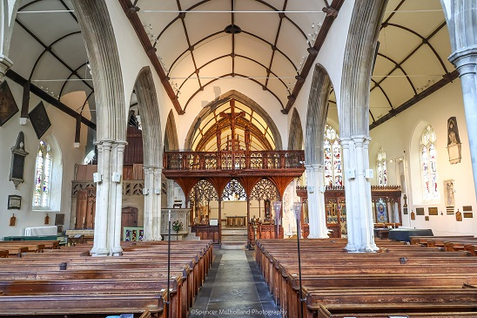
A re-ordering of the Sanctuary in 2006 included a new award-winning altar.
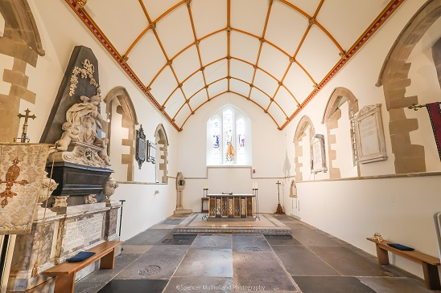
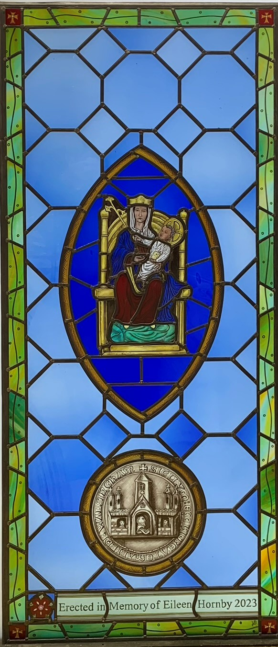
The Lady Chapel
The Church of Sarum St. Martin has recently completed the cleaning and restoration of our Lady Chapel. This was carried out by Stephen Bellion, whose work can be seen in many places within the Shrine Church of Our Lady of Walsingham. At the same time as this work was carried, out the decision was made to erect a memorial to a late member of the congregation, Miss Eileen Hornby. The memorial takes the form of a glass panel which was then fixed into the screen of the Lady Chapel.
Sarum St. Martin has a long association with the Shrine, through parish youth and family pilgrimages and so, when contemplating what form the memorial would take, it seemed obvious Our Lady of Walsingham should be the focus as we did not have a visible Walsingham Shrine in the Church. As can be seen, Our Lady of Walsingham is in a mandorla in the centre of the panel with the reverse of the ancient seal of the Shrine depicted underneath.
The work was carried out at Salisbury Cathedral Stained Glass Workshop by Victoria Burton, using what Sam Kelly, the supervisor of the Workshop said were the final pieces of English coloured glass in the workshop.
Those who have an opportunity to see the panel in place all say that it looks as if it has been there for hundreds of years. We plan to establish a cell of OLW at St Martin’s in the near future.
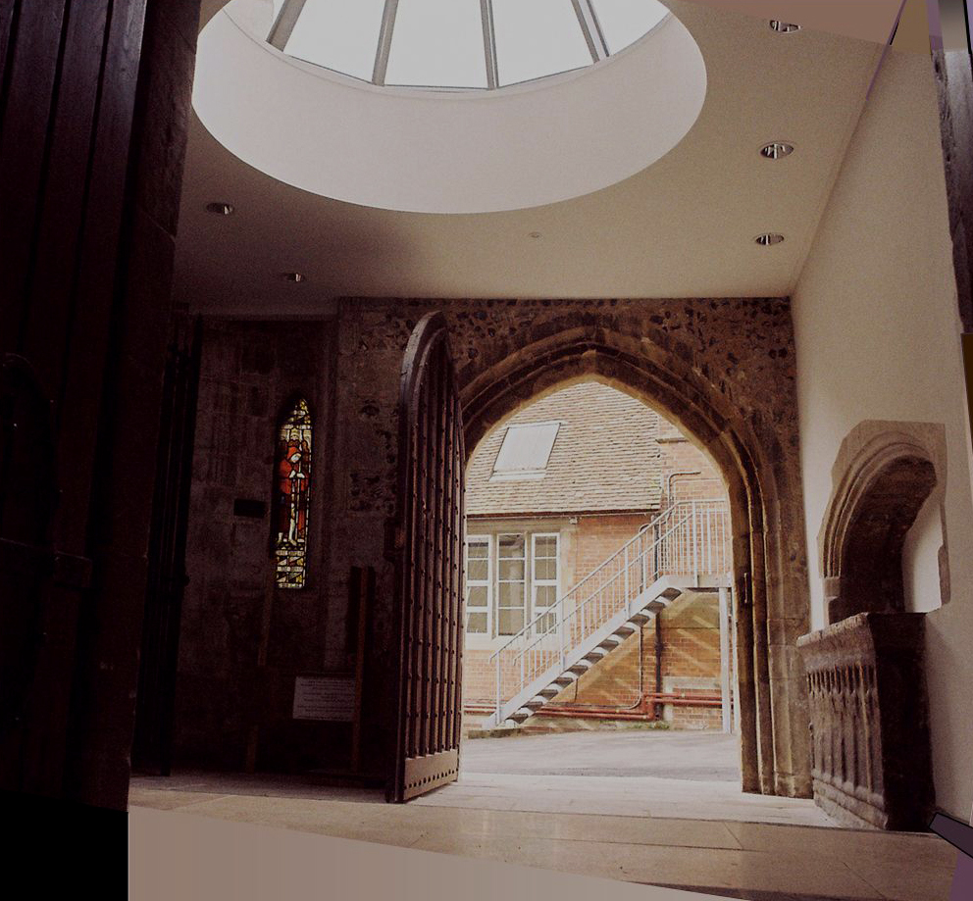

The Porch
In 2011 the front porch and North entrance were beautifully re-ordered to include a glass-domed roof, a parish office and toilet facilities.

Worship
Sundays Sung Eucharist (average 30 communicants) 10.30am
Holy Days Sung Eucharist 7.30pm
All Eucharists are Common Worship.

Music
Superb two manual Hill Organ 1868
Saxon Aldred Chamber Organ 1985
Yamaha C3 Grand Piano
Harpsichord
New English Folk Mass, Harwood: St Martin’s Mass, Worth Abbey Mass, Greening Mass, Revised English Hymnal and Celebration Hymnal
St Martin's musical wealth lies in its well-ordered liturgy and worship. A small group, the ‘St. Martin's Singers’, contribute responsorial psalms and motets to the Sunday Eucharist each week. Musical friends are invited to augment the choir at major festivals. The congregation also sings with confidence.
Saint Martin's has an excellent acoustic and this, combined with its quiet location, has led to an increasing demand for its use as a venue for many concerts as well as for recordings. In addition, the church is the venue for Trinity College London music exams in Salisbury. Bookings and recordings are handled by two dedicated volunteers.

Bells
There is a fine ring of eight bells, which are rung on Sunday mornings and evenings. An established team of ringers practises weekly.

Church Affiliations
Church Union - upholding catholic doctrine, worship, order and discipline of the Church of England.
Forward in Faith – The Parish has recently re-visited and reaffirmed a Resolution under the House of Bishops’ Declaration on the Ministry of Bishops and Priests, and is under the oversight of the Bishop of Oswestry.
The Society of St Wilfrid and St Hilda
Deanery Synod – we have a parish representative who regularly attends the DS meetings and reports back to the PCC.
(Please see Appendix (i) for more details on the Deanery and Salisbury Diocese.)

Parish Staff
The Parish is served by a paid part-time Administrator.

Electoral Roll 2025
57 members

Church Council
The Parochial Church Council has nine members, including 1 Deanery Synod.

Church Finance
There is an established Stewardship scheme including planned giving by weekly envelopes and covenants. The parish regularly pays the Deanery Share in full.
The church building is well endowed and there are other sources of income from bequests. Not less than ten per cent of parish income is given to missions and charities, both local and worldwide. (Please see Appendix (ii) for the 2025 financial statement.)

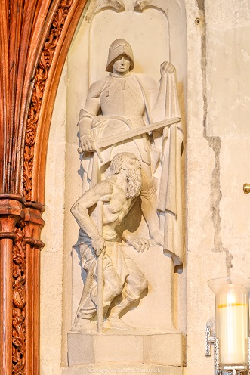
Church Organisations
Servers - A team of servers serve at all sung services.
Bellringers – see above.
Singers – see above.

Literature
The Parish Pew Sheet gives notices of services, meetings and activities and is produced by the Administrator.
Guide to the Church - A guide is available for visitors to the church.

Church and Other Charities
St Martin's has a number of small charities which make grants to young people, as well as the elderly. The Churchwardens hold a larger fund, used at their discretion, for the relief of those in need.

Rectory
This is a modern, recently refurbished house, about 50 years old, conveniently located and comfortable, with separate garage and ample parking for several cars.

Church Owned Properties
Houses - The parish owns two houses within the parish which are rented out to tenants.
St Martin’s Centre - The old Infant School building has been converted into the Church Centre with meeting rooms, a fit-for-purpose office, a well fitted out kitchen and two medium size halls (easily converted to one large hall), and separate toilets for ladies and gents; the entrance hall has access to the disabled toilet.
Many local organisations hire the two halls on a very regular basis for varied activities. These include: yoga, health education classes, music groups, etc. and, at specific times, Trinity College London use it as a waiting / warm-up room for music exams in church, and ‘Celebrate Voice’ (a local organisation holding an annual 10-day festival each October) for opera rehearsals. There is an upright piano in the Church Centre.
The main body of the building fronting the street (60% ) is occupied by English in Salisbury, a school of English for foreign students.

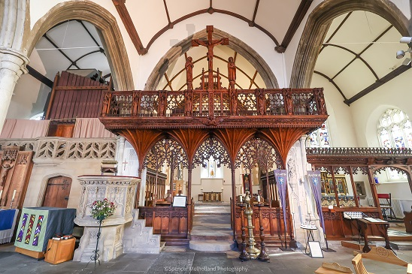

Appendix: Sarum St Martin’s Financial Profile
Financial statement for year ending 31st December 2024
General: The PCC accounts show a surplus for the year of £88,416 against a deficit figure of £10,312 for 2023, this due to increased revenue from Hire and increased concert activity and less outlay on maintenance.
Total receipts for the year amounted to £191,841 consisting of £24,646 from voluntary income (collections and donations, etc.), £29,872 from hall hire, rent from Centre and houses, plus fees from concerts in the church. Planned giving was on a par with 2023; income from hall hire had increased during the year by £3,204, as had concerts in the church. Dividends from PCC investments amounted to £15,267 and was higher than 2023 by just £1,000. Rental from the two houses remained the same at £12,500 for the year.
Payments were down by £25,041 to £103,425, consisting of £5,539 for charitable giving, £71,697 for church running costs, £10,254 for office and admin costs plus £15,935 expenditure on the Centre and two houses, a reduction of £11,687 from the 2023 costs.
The Monetary assets (PCC investment values) total £696,492 for the year, which is higher than 2023 by £101,026. Other St. Martin’s investments are considerable: this includes substantial funds restricted to the fabric of the church and other buildings owned by the Church or Fabric Estates Charity or PCC. The Bank balances total as at 31 December 2024 was £163,141.
Summary: The church still remains financially sound and, in accordance with the 2024 forecast, the investments gained substantially during the year. Utility costs are monitored regularly due to the continued rises in gas and electricity, but I am pleased to report that income from the Centre and church concerts is increasing; sadly, voluntary income is declining. However, with our investments and income from hire and rent, we can look forward to a healthier financial status in 2025.
Robert Hayes, Treasurer

