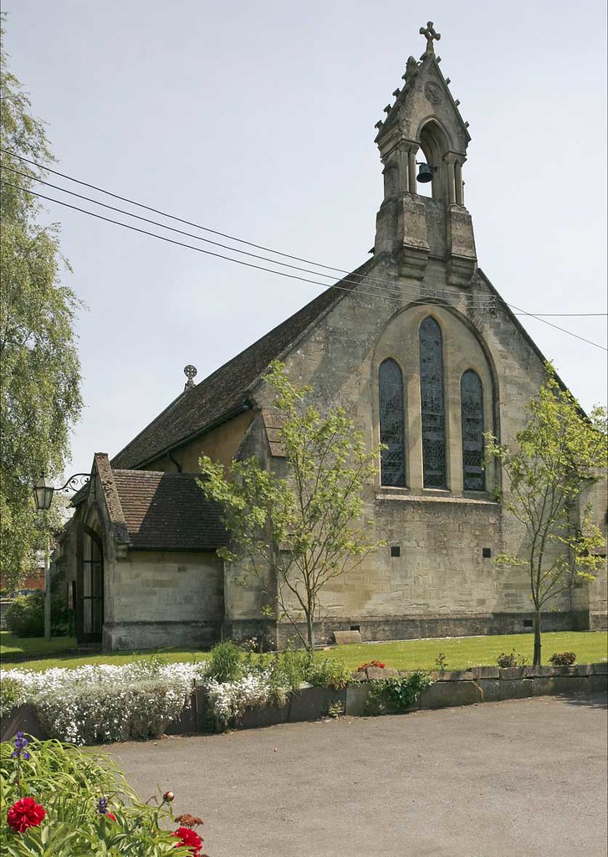
St Peter’s, Devizes

Parish Profile
July 2025
CONTENTS

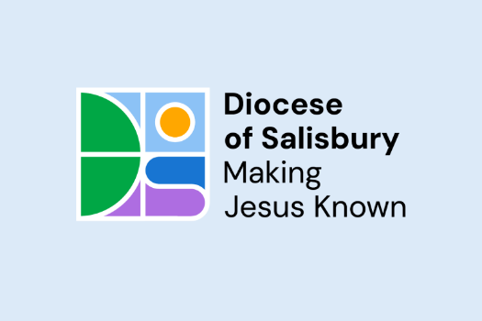
The Bishop of Ramsbury page 3
The Bishop of Oswestry page 4

Challenge page 5
The Role and Person page 5
What we have to offer page 6

Leadership page 6

The Parish page 7
What is Happening Already page 8
Parish Statistics page 8
Worship page 8
Music page 8
Congregation page 8

Buildings page 10

Churchyards page 10
Finance page 10
The Vicarage page 10
The Area page 12

THE BISHOP OF RAMSBURY

Thank you for your interest in the post of Interim Parish Priest of St Peter, Devizes, within the Diocese of Salisbury: a shared appointment with the See of Oswestry, as part of our mutual flourishing. The appointed priest will also be responsible for the cure of St Martin, Salisbury, where we anticipate them taking up residence.

While Wiltshire can appear a timeless landscape, our parishes are constantly changing to meet the needs of their people, and to proclaim afresh the good news of God in Christ. As part of a co-operative deanery chapter, the new incumbent St Peter’s will serve a market town full of character and heart, with much willingness to grow among this faithful congregation. In the Diocese of Salisbury, we place a high value on the encouragement and pastoral support of our parish clergy and, should God guide you to serve here, you will become part of a committed and collaborative team - with the See of Ramsbury office recently moved nearby.

Please contact the Archdeacon of Wilts, The Venerable Louise Ellis, or my PA, Lynne Archer, if you need any assistance with your enquiry - and be assured of my prayers as you seek the Lord’s will for your future.

Sincerely in Christ,
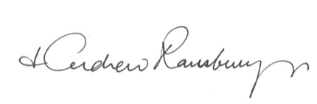
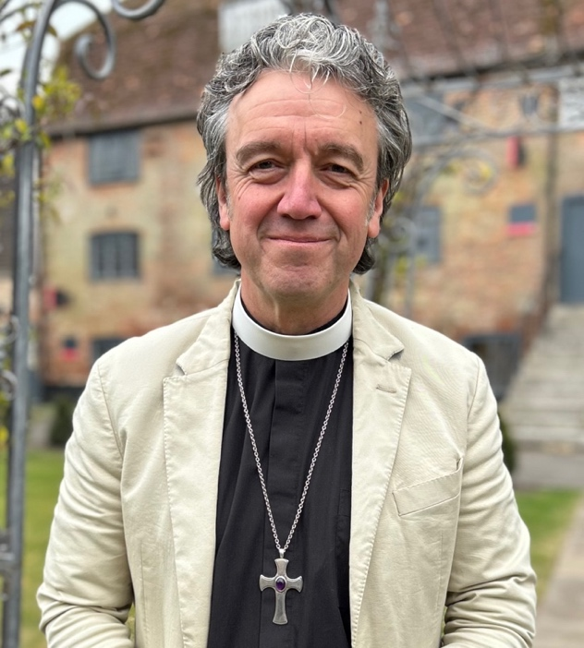
THE BISHOP OF OSWESTRY
The Catholic Faith as the Church of England has received it is deeply embedded in S. Peter's Devizes and has been so for many generations. The need now, in this generation, is for the historic Faith to be renewed in power and the Holy Spirit. This must be on your heart. You will be a priest who is zealous for the Catholic Faith and for its dynamic communication; whose pastoral ministry to all is gentle and devoted; whose celebration of the sacraments expresses profound reverence for the Lord; and an evangelizer whose ministry leads the Church out beyond herself into the world and so stimulates her numerical growth.

The people of S. Peter's are warm and loving, and they deserve a Parish Priest who is no less than they are. If appointed, you will enter the ecclesial life of the See of Oswestry at an exciting time of broader renewal in the Catholic Movement, and you will join a Diocese which supports its parishes and wants to see them flourish and thrive. Pray to the Lord of the Harvest that he may send you into this harvest.

✠Paul Oswestriensis
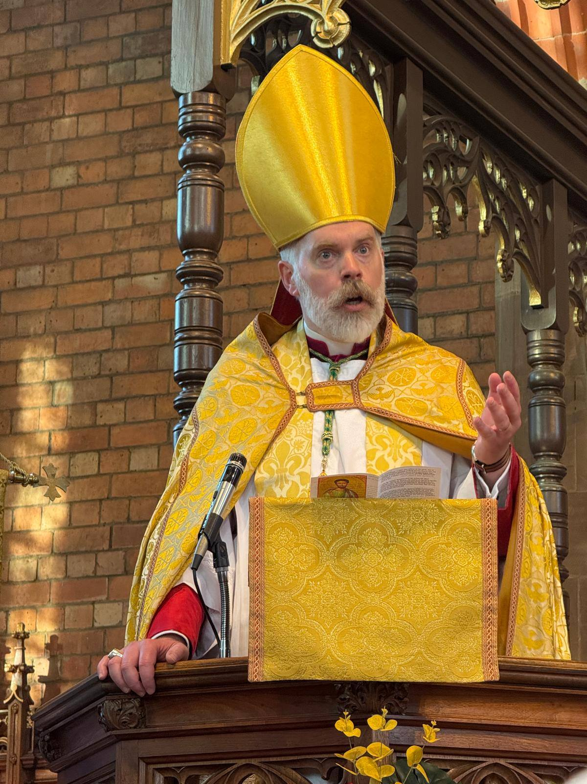

THE CONTEXT & CHALLENGE
St Peter’s has spent half of the last 25 years in interregnum and has been vacant since the retirement of their last incumbent six years ago. Our last stipendiary priest retired in 1999, since which time the parish has been served on a part-time House-for-Duty basis.
The Parish has been served faithfully by a number of retired and other licensed clergy over the last decade which has maintained a pattern of Eucharistic worship. Whilst the congregation has been well cared for there has been much reduced capacity in terms of mission and outreach.
With St Martin’s, Salisbury also falling vacant the decision has been made to bring these two parishes together under the shared leadership of a full-time stipendiary Priest based in Salisbury. Both churches are under the pastoral and sacramental oversight of the Bishop of Oswestry having passed a Resolution under the House of Bishops Declaration. It is the hope of all concerned that the presence of strategic leadership for the two churches will enable a period of renewal and, ultimately, growth.

THE ROLE & THE PERSON
St Peter’s new priest will be:
- a priest affiliated to The Society of St Wilfrid and St Hilda
- prayerful and pastoral
- approachable and outgoing
- missionally creative
- willing to knock on doors and be the public face of St Peter’s locally and in the Bath Road especially
- able to delegate and resource the laity
- able to teach the Catholic Faith as the Church of England has received it
- an encourager; able to build our sense of self-confidence for the task ahead
- Able to manage their time effectively
- Unphased by doing something new; nor by the distance between the two centres of this new Affinity Grouping
- Able to support us in our ongoing work of embedding effectively the safeguarding of children and vulnerable adults in our church life, so that we are fully compliant with Diocesan policies and protocols
- Enthusiastic about working collaboratively across both parishes and with other parishes in the Thames Valley & The West region of the See of Oswestry, and especially the churches in Swindon and Bath which are not far from us albeit in different dioceses, and the other Oswestry Parishes in the Diocese of Salisbury
- Willing to live out the Five Guiding Principles; and diligent in attending Clergy Chapter and Deanery Synods in Devizes and Salisbury sufficiently often to engage openly and warmly in areas of common concern with other local churches, including with ecumenical partners
- Will attend local SSC or Oswestry Clergy gatherings, both for their own spiritual wellbeing, as well as for the upbuilding of and support for, geographically isolated colleagues.
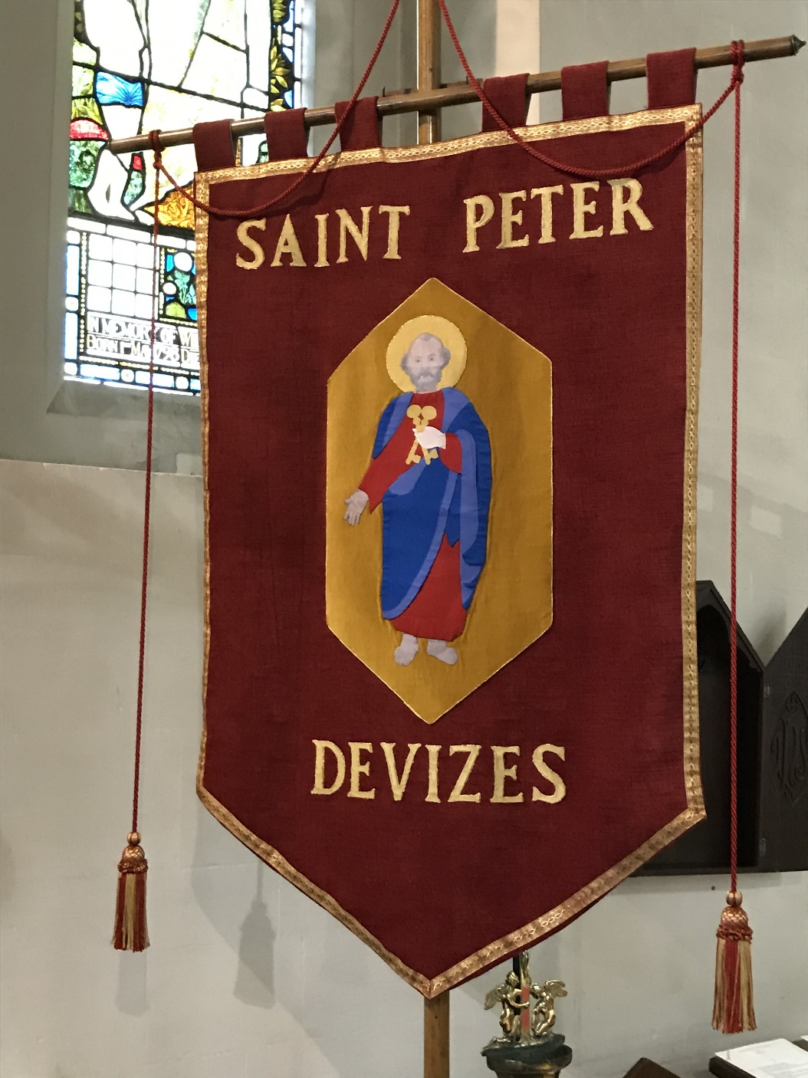
WHAT WE
HAVE TO OFFER

The laity are:
- Faithful
- Determined
- Committed
- Resilient
- Hard working
- Prayerful
- Welcoming
- Friendly
- Supportive
There is a sense of hope for the future in spite of the real challenges we face, and the congregation will offer their new Priest their unequivocal support.
We will encourage you to be careful about taking your allotted time off, and periods of annual retreat and annual leave.

THE LEADERSHIP
The Parish is very ably led by Churchwarden Geoffrey Pritchard and a small but effective PCC.
There are two dedicated sacristans and someone leads the team which ensure the church is decorated on Sundays and at festivals.

THE PARISH
St Peter’s lies on the western side of the town either side of the Bath Road.
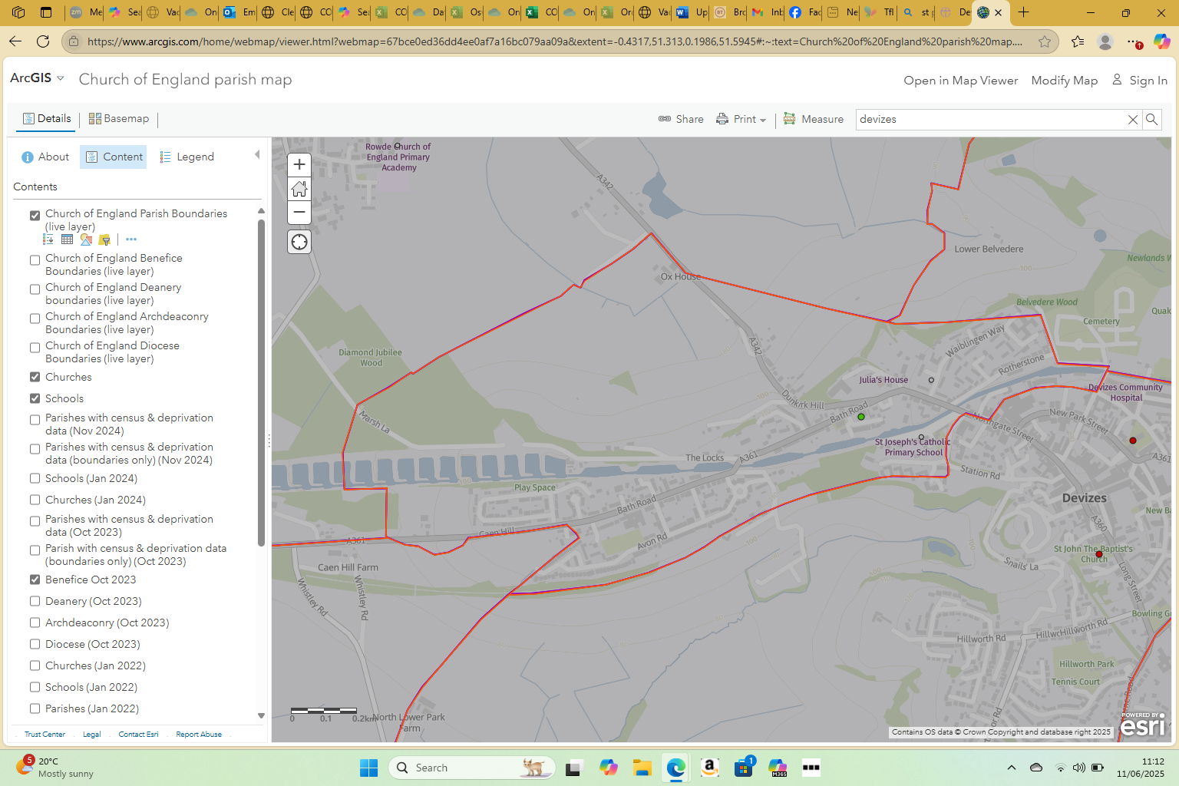
Deprivation rank (1=most deprived, 12,178=least deprived), 3,499
Parish population (2021 census), 2,095 Parish number of occupied households, 1,072
Area (square miles), 0.5 Population density (people per square mile), 4,016

% aged 0-4, 4.1 % aged 5-19, 13.3 % aged 20-29, 9.9
% aged 30-44, 15.7 % aged 45-69, 37.1 % aged 70 and over, 20.0

% Asian ethnicity, 1.1 % Black ethnicity, 0.5 % Mixed ethnicity, 1.6
% White ethnicity, 96.1 % Other ethnicity, 0.8
% Buddhist, 0.2 % Christian, 52.3 % Hindu, 0.1
% Jewish, 0.2 % Muslim, 1.1 % Sikh, 0.0
% Other religion, 0.9 % No religion, 40.5
% Religion not stated, 4.7
Rural/Urban classification, Urban % Area urban, 52.3
SOCIAL LIFE
We socialise well in church with coffee and drinks after Mass.
We always have social gatherings after special services and for special occasions including occasional Bring and Share meals, and always when the Bishop comes!

PARISH STATISTICS
The Electoral Roll is currently: 35
On a typical Sunday we expect to see around 20 people at Mass
2024:
Weddings 0 Funerals 3 Baptisms 1

WORSHIP
Sunday Mass is currently offered every Sunday at 10.00am. A Eucharist is also currently offered once during the week wherever possible.
Major feasts and festivals including Holy Week, are kept with due solemnity.
We have been blessed to have the support of a number of retired clergy led by Fr Christopher Chiplin.

MUSIC
Traditional hymns are sung and the Parish benefits from an excellent Organist and a small robed choir.

CONGREGATION
Roughly half of the congregation live in the Parish with the remainder largely living elsewhere including in Devizes or Rowde. The congregation is largely retired.

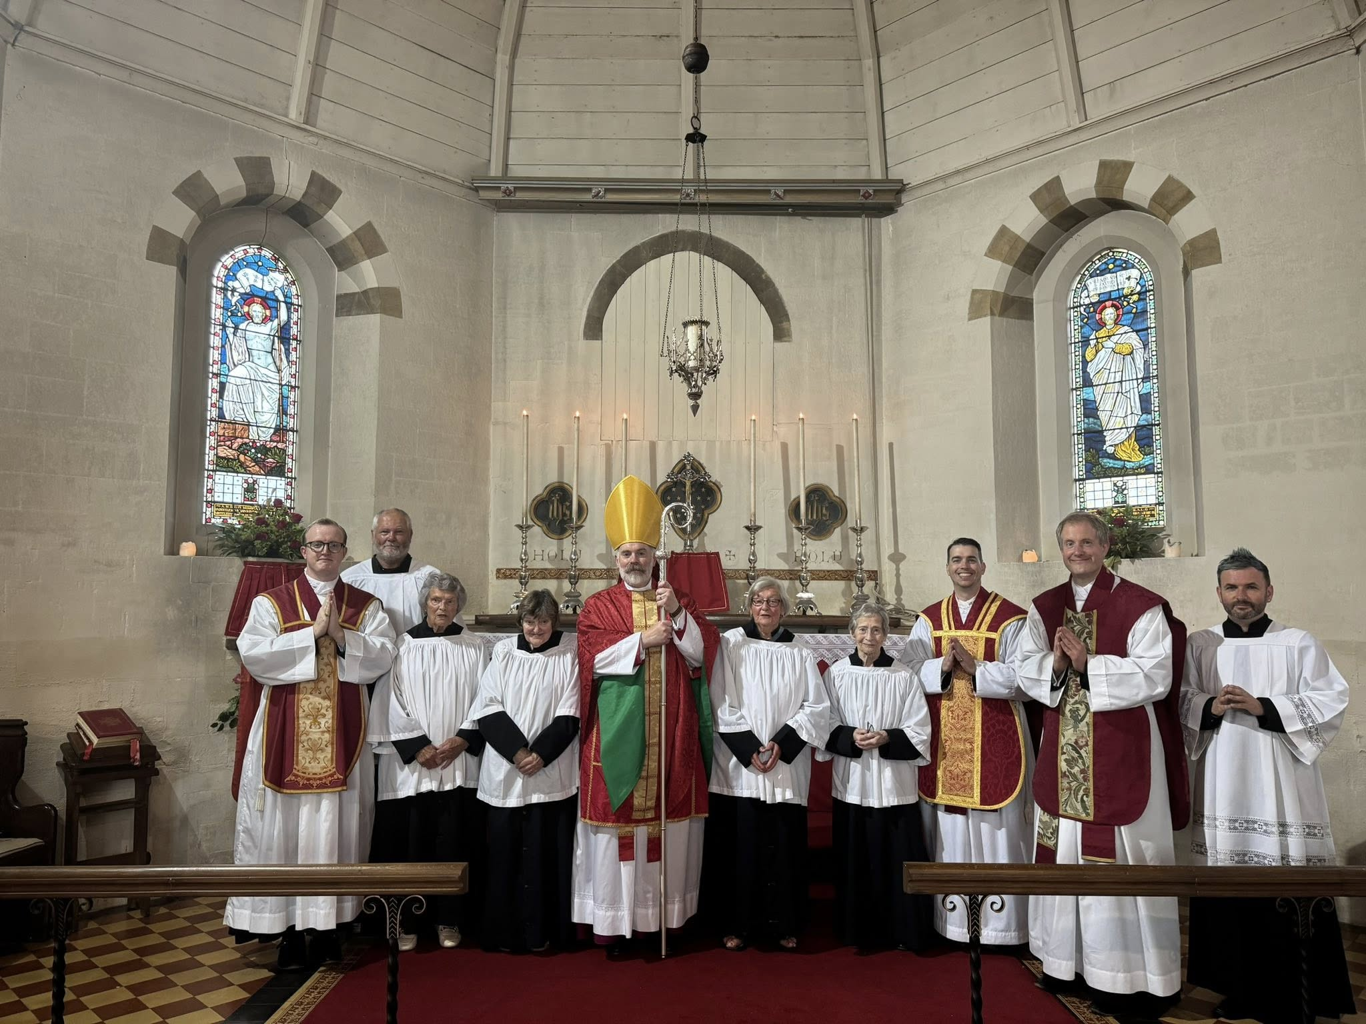

The Clergy of nearby Swindon New Town Parish supported the 2025 Patronal Festival
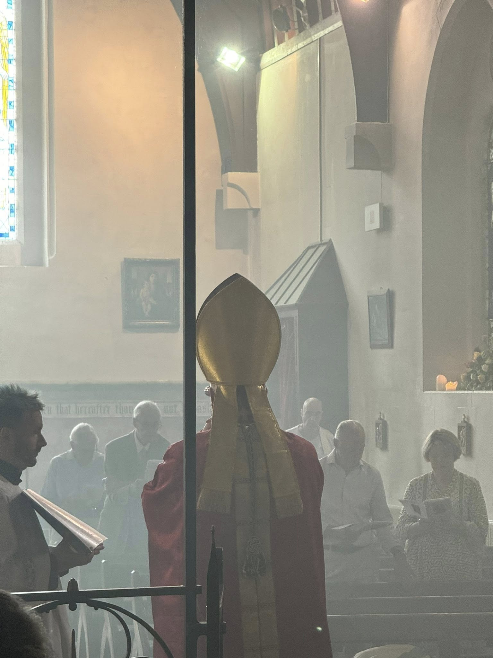

Some of the congregation glimpsed through the incense at the Patronal Festival
BUILDINGS
The church is located on the south side of Bath Road (A361) and can be reached by foot via a footpath directly off the roadside pavement. There is no direct vehicular access to the site, however, there is informal off-road parking to the southwest, again accessed directly off Bath Road. It is understood that the church was built between 1865 to 1866, under the guidance of Rev. Dowding (Vicar of St. James’s Church, Devizes), who believed that the town required another church that was nearer to the canal and surrounding industries. The building was further extended some twenty years later with the addition of the south aisle and organ chamber.
Pevsner, in the “Buildings of England” (Wiltshire, 2nd Edition, 1975) describes the church as follows:
ST PETER, Bath Road. 1866-7 by Slater & Carpenter. S aisle 1884. Nave and chancel and polygonal apse. Simple C13 style. The capitals of the arcade and the corbels for the roof cannot have been intended to remain just cut blocks. Was carving intended? It is true that starkness characterizes the church throughout, e.g. no cusping at all in the windows. Only the bellcote is busier.
Internally the main body of the church consists of a nave, chancel and south aisle (with the Lady Chapel and Vestry at its east end). A north porch projects from the northwest end of the nave; a choir vestry is tucked in the southeast corner between the south aisle and vestry; and a boiler house projects off the southwest corner of the south aisle (a former boiler house is located externally to the east side of the organ chamber). The Church of St. Peter was identified as a Grade II listed building on 9th April 1954.
A recent Quinquennial Report lists only nine items as being in category A and B all of which are minor and inexpensive.

CHURCHYARD
The Church is encompassed on all sides by the Churchyard, although it is tighter to its east boundary, where there is a pavement leading to the new and converted residential properties beyond. It is well maintained and includes areas of planted flower beds. Cremated remains are still interred within the churchyard, and the public Devizes Cemetery is only located roughly 3⁄4mile to the northeast. It is maintained by a contractor.
There is a C20th War Memorial to the northwest side of the church, which is separately listed Grade II.

FINANCE
Full accounts can be presented of request. The PCC have £60K in investments.

THE VICARAGE
Our incumbent will live in Salisbury and St Peter’s Vicarage will continue to be let by the Diocese.

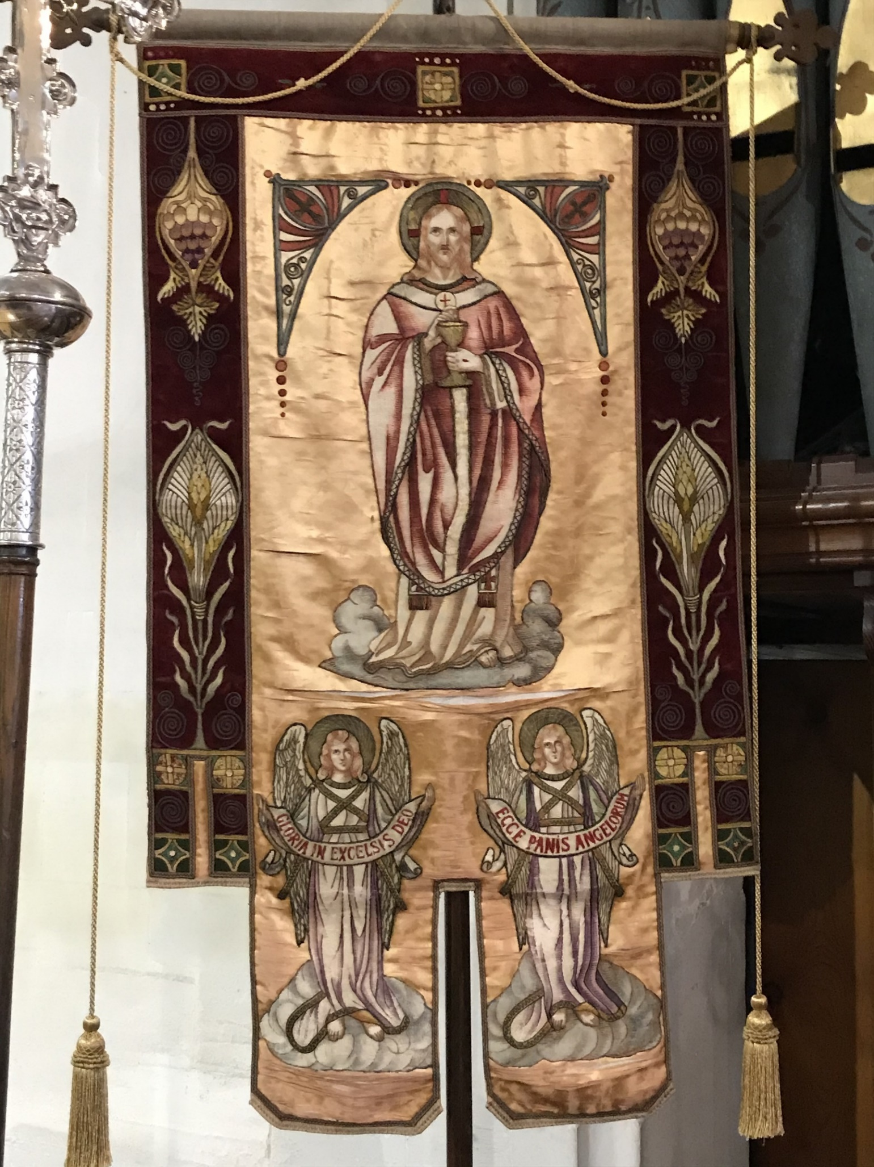

THE AREA
Devizes is a market town and civil parish in Wiltshire, England. It developed around Devizes Castle, an 11th-century Norman castle, and received a charter in 1141. The castle was besieged during the Anarchy, a 12th-century civil war between Stephen of England and Empress Matilda, and again during the English Civil War when the Cavaliers lifted the siege at the Battle of Roundway Down and the Parliamentarian Army of the West under Sir William Waller was routed. Devizes remained under Royalist control until 1645, when Oliver Cromwell attacked and forced the Royalists to surrender. The castle was destroyed in 1648 on the orders of Parliament, and today little remains of it.
From the 16th century Devizes became known for its textiles, and by the early 18th century it held the largest corn market in the West Country, constructing the Corn Exchange in 1857. In the 18th century, brewing, curing of tobacco, and snuff-making were established. The Wadworth Brewery was founded in the town in 1875.
Standing at the west edge of the Vale of Pewsey, Devizes is about 10.5 miles southeast of Chippenham and 11 miles north-east of the county town of Trowbridge. The town has nearly five hundred listed buildings, some notable churches, a town hall and an attractive green in the centre.
Economy
Devizes has always been a market town and the market square is still used for that purpose every Thursday, and for farmers' markets on the first Saturday of each month. Indoor traders set up each day in the historic Shambles, off the market square.
There are over 70 independent retailers in the town centre, many around the Market Place, Little Brittox and Brittox (both pedestrianised), and in Sidmouth Street. At the town's wharf on the canal, the Kennet and Avon Canal Trust has a small museum and cafe. Construction of the new Devizes Health Centre, a 1,588 m2 (17,090 sq ft), two-storey building, began in 2021. This will replace the services at Devizes Community Hospital and provide a range of outpatient and GP services.
Culture
There is a lively arts and culture community in the town, with the Arts Council funded Devizes International Street Festival attracting thousands to the town for two weeks leading up to August Bank Holiday each year, beginning with a long-standing "confetti battle" where, at a given signal – usually cannons firing confetti hundreds of metres into the air – the public are invited into the Market Place to throw as much confetti as possible at one another.
The annual Devizes Arts Festival has a broad spectrum of musical events, poets and authors, literary talks, comedians and other performers. Each autumn, the Devizes Food and Drink Festival includes opportunities to dine in unusual places. There is an active thespian community that performs at the Wharf Theatre, a former warehouse alongside canal.

Media
The local radio stations are BBC Radio Wiltshire and Fantasy Radio, a local community radio station. The Gazette and Herald is the town's local weekly newspaper.
Transport
Today the nearest railway stations are at Melksham, Chippenham and Pewsey.
There are regular bus connections to Swindon (via Avebury), Trowbridge, Salisbury, Bath and Chippenham, each of which have rail services. Devizes also has a daily National Express coach service to and from London Victoria, via Heathrow Airport. There is a regular bus service to and from Stonehenge.
Devizes is approximately 15 miles from the M4. Several main roads pass through the town, including the A360, A361 and A342.
The Kennet and Avon Canal was built under the direction of John Rennie between 1794 and 1810, linking Devizes with Bristol and London. Near Devizes the canal rises 237 feet (72 m) by means of 29 locks, 16 of them in a straight line at Caen Hill. In the early days the canal was lit by gas lights at night, enabling boats to negotiate the locks at any time of day. The canal fell into disuse after the coming of the railways in the 1840s, but was restored between 1970 and 2003 for leisure uses. The Kennet and Avon Canal Trust run a museum at The Wharf in Devizes. The town is the starting point of the annual Devizes to Westminster International Canoe Marathon.
National Cycle Route 4 follows the canal towpath through the town.
Education
Devizes School, a secondary school with a sixth form, takes pupils from the town and surrounding area. It is situated in the grounds of the Southbroom House Estate and the Grade II listed house forms its administrative offices.
Downland School is a Community Special School for boys aged 11–16.
Devizes has six primary schools: St Joseph's Catholic Primary School, Southbroom St James Academy, Southbroom Infants' School, Wansdyke Community School, Nursteed Community Primary School and The Trinity CofE (VA) Primary School. Nearby is Rowde CofE Primary Academy in the adjacent village of Rowde.
There are a number of private schools.
The closest university is the University of Bath.

