Preparing to be commissioned

Written Reflection

We hope you will want to keep your copy of the Lay Worship Leader training material for future reference together with your preparation material for each session and any notes you took during the course. They are for your own use.

Right at the beginning of the ‘Taster’ Session we asked the question: ‘Is God calling me to be a Lay Worship Leader?’ Becoming a Lay Worship Leader is not just about taking on a responsibility or doing a job but it is about responding to a call to ministry. Hopefully taking part in the course has helped you to reflect further on this and to reach a deeper insight into whether or not you feel called to serve the Church in this way. | 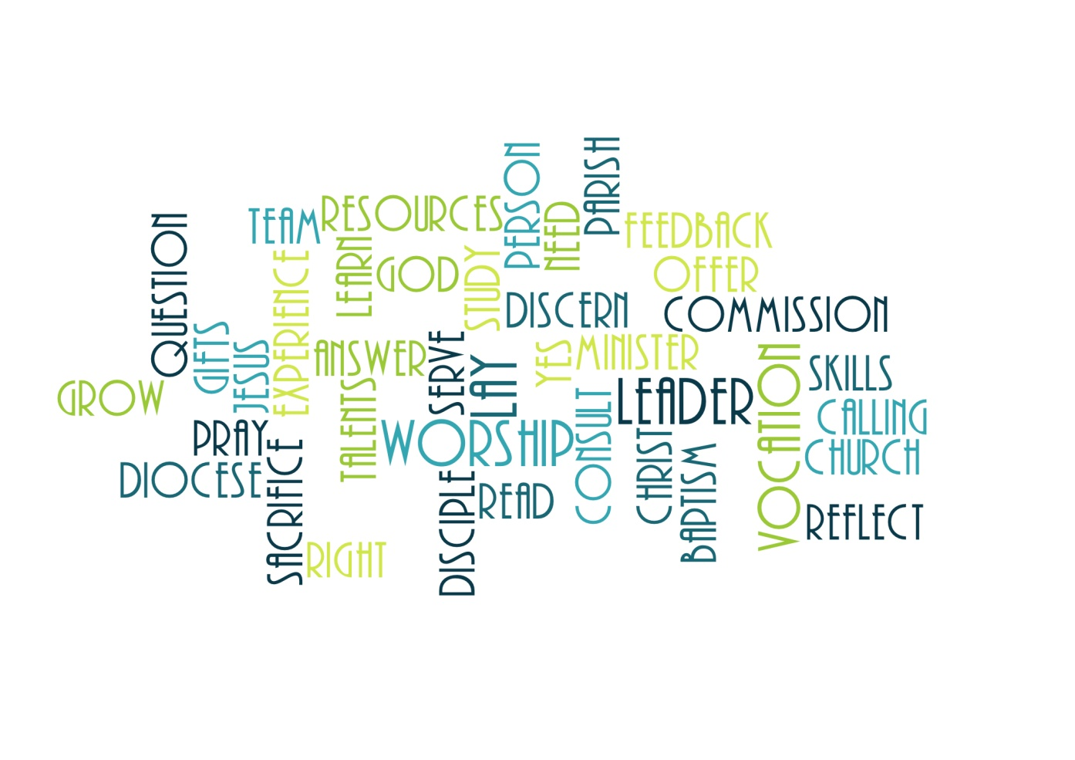
Before you apply to be commissioned we invite you to prepare a written reflection on ‘Why I believe God is calling me to the ministry of a Lay Worship Leader’. This should be between 1 -2 sides of A4 and is for you to share with your incumbent and others if you wish, so that you and your incumbent can decide whether it is now right for you to proceed. We also ask you to send in a copy to the LDM Team Office with your Ministry Specification and Request to Commission.

Ministry Specification

The template for a Ministry Specification is included here and is also available separately in a Word version on the Diocesan website. You can submit it electronically or by post as hard copy.

The purpose of the Ministry Specification is to scope and agree what kind of ministry you will exercise. It is important that you, your incumbent, the PCC, and members of the worshipping community all understand what the expectations are. The Ministry Specification is to ensure that your ministry is regularly used but not over used, that you are appropriately supported through supervision and opportunities to carry on learning, and that your Commission is kept up to date.

Exactly what you are asked to do week by week is for you to negotiate with your incumbent and it may well be that your ministry evolves and changes over time. If the nature of your ministry changes in any major way you should draw up a fresh Ministry Specification but otherwise it is fine to renew it every three years when you send in your request to be re commissioned

Request to Commission

The template for a Request to Commission a Lay Worship Leader is included here and is also available separately in a Word version on the Diocesan website. You can submit it electronically or by post as hard copy. Your Commission is renewable every three years.

