DSSAN Spiritual Accompanier Recruitment Flow Chart
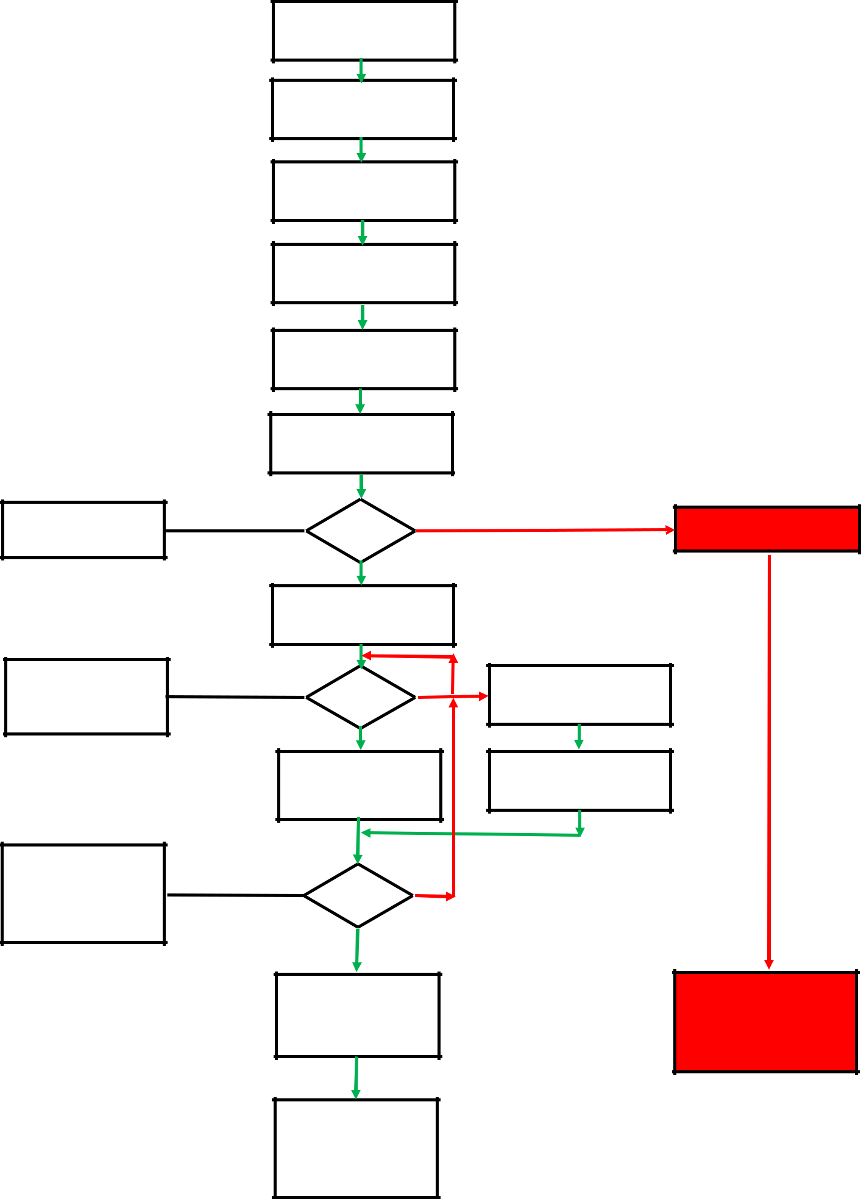

Expression of interest received

from potential accompanier

Is applicant able to meet

criteria?

Licensed, beneficed or PtO clergy or LLM; or LPA, LWL in Salisbury Diocese?

Confirm applicants actions completed and where necessary recorded on
SALDIMS

Send Guidelines and

Application Form

Application Received

Request references

References received

Conversation with applicant

Action points recorded and

sent to applicant

Add to spreadsheet as

probationer

Applicant addresses action

points raised at

conversation

Transfer applicant to

active list and amend

SALDIMS

Acceptance letter

sent to applicant.

Reject and issue letter declining

application

Request DBS and C1 action by Safe-

guarding team and applicant

Receive report of DBS and C1

action completed from applicant

Reject and remove from

probationer list.

Inform applicant.

